Blockchain

Index

|  |  |  |  |
| --- | --- | --- | --- |
| **Sr. No** | **Title** | **Date** | **Sign** |
| 1. | A . simple client class that generates the private and public keys by using the built-in Python RSA algorithm and test it.  B. Create multiple transactions and display them  C. Create a transaction class to send and receive money and test it.  D. Create a blockchain, a genesis block and execute it.  E. Create a mining function and test it.  F. Add blocks to the miner and dump the blockchain. |  |  |
| 2. | write a solidity program for variables, operators, loops, decision making and string. |  |  |
| 3. | A. write a solidity program for string, arrays, enums, structure & mappings.  B. write a solidity program for function, view function, pure function & fallback function. |  |  |
| 4. | A. write a solidity program for function overloading, mathematical function & cryptographic functions  B. write a solidity program for contract, inheritance, constructors, abstract contracts, interfaces, libraries, assembly, events, error handling |  |  |
| 5. | Install hyperledger-Irhoa |  |  |
| 6. | Demonstrate the running of the blockchain node. |  |  |
| 7. | Demonstrate the running of the blockchain node. |  |  |
| 8. | Demonstrate the use of Bitcoin Core API. |  |  |
| 9. | Build Dapps with angular[using truffle and ganache cli |  |  |

**Practical 1**

**A. A simple client class that generates the private and public keys by using the built-in Python RSA algorithm and test it.**

After Creating Ubuntu VM-> Login -> Open Terminal -> Install below packages

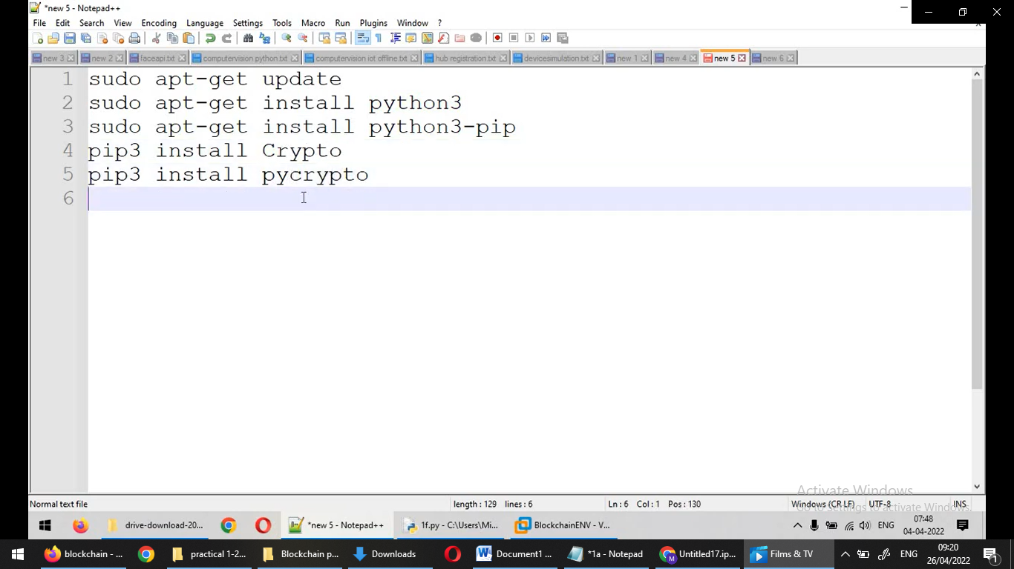

**Code :**

pip3 install Crypto

pip3 install pycrypto

import hashlib

import random

import binascii

import datetime

import collections

from Crypto.PublicKey import RSA

from Crypto import Random

from Crypto.Cipher import PKCS1_v1_5

class Client:

   def __init__(self):

      random = Random.new().read

      self._private_key = RSA.generate(1024, random)

      self._public_key = self._private_key.publickey()

      self._signer = PKCS1_v1_5.new(self._private_key)

   @property

   def identity(self):

      return binascii.hexlify(self._public_key.exportKey(format='DER')).decode('ascii

Dinesh = Client()

print ("sender ",Dinesh.identity)

Output:

sender 30819f300d06092a864886f………

**B. Create multiple transactions and display them**

**Code:**

import hashlib

import binascii

import datetime

import collections

from Crypto.PublicKey import RSA

from Crypto import Random

from Crypto.Cipher import PKCS1_v1_5

from collections import OrderedDict

import Crypto

import Crypto.Random

from Crypto.Hash import SHA

from Crypto.Signature import PKCS1_v1_5

class Client:

    def __init__(self):

      random = Random.new().read

      self._private_key = RSA.generate(1024, random)

      self._public_key = self._private_key.publickey()

      self._signer = PKCS1_v1_5.new(self._private_key)

    @property

    def identity(self):

      return binascii.hexlify(self._public_key.exportKey(format='DER')).decode('ascii')

class Transaction:

    def __init__(self, sender, recipient, value):

       self.sender = sender

       self.recipient = recipient

       self.value = value

       self.time = datetime.datetime.now()

    def to_dict(self):

       if self.sender == "Genesis":

          identity = "Genesis"

       else:

          identity = self.sender.identity

       return collections.OrderedDict({

          'sender': identity,

          'recipient': self.recipient,

          'value': self.value,

          'time' : self.time})

    def sign_transaction(self):

       private_key = self.sender._private_key

       signer = PKCS1_v1_5.new(private_key)

       h = SHA.new(str(self.to_dict()).encode('utf8'))

       return binascii.hexlify(signer.sign(h)).decode('ascii')

def display_transaction(transaction):

       #for transaction in transactions:

       dict = transaction.to_dict()

       print ("sender: " + dict['sender'])

       print ('-----')

       print ("recipient: " + dict['recipient'])

       print ('-----')

       print ("value: " + str(dict['value']))

       print ('-----')

       print ("time: " + str(dict['time']))

       print ('-----')

transactions = []

A = Client()

B = Client()

t1 = Transaction(

   A,

   B.identity,

   15.0

)

t1.sign_transaction()

display_transaction (t1)

Output:

sender: 30819f300d0609…….

-----

recipient: 30819f300d06…..

-----

value: 15.0

-----

time: 2022-04-26 04:00:21.070283

-----

**C. Create a transaction class to send and receive money and test it**

**Code:**

# following imports are required by PKI

import hashlib

import binascii

import datetime

import collections

from Crypto.PublicKey import RSA

from Crypto import Random

from Crypto.Cipher import PKCS1_v1_5

from collections import OrderedDict

import Crypto

import Crypto.Random

from Crypto.Hash import SHA

from Crypto.Signature import PKCS1_v1_5

class Client:

    def __init__(self):

      random = Random.new().read

      self._private_key = RSA.generate(1024, random)

      self._public_key = self._private_key.publickey()

      self._signer = PKCS1_v1_5.new(self._private_key)

    @property

    def identity(self):

      return binascii.hexlify(self._public_key.exportKey(format='DER')).decode('ascii')

class Transaction:

    def __init__(self, sender, recipient, value):

       self.sender = sender

       self.recipient = recipient

       self.value = value

       self.time = datetime.datetime.now()

    def to_dict(self):

       if self.sender == "Genesis":

          identity = "Genesis"

       else:

          identity = self.sender.identity

       return collections.OrderedDict({

          'sender': identity,

          'recipient': self.recipient,

          'value': self.value,

          'time' : self.time})

    def sign_transaction(self):

       private_key = self.sender._private_key

       signer = PKCS1_v1_5.new(private_key)

       h = SHA.new(str(self.to_dict()).encode('utf8'))

       return binascii.hexlify(signer.sign(h)).decode('ascii')

def display_transaction(transaction):

       #for transaction in transactions:

       dict = transaction.to_dict()

       print ("sender: " + dict['sender'])

       print ('-----')

       print ("recipient: " + dict['recipient'])

       print ('-----')

       print ("value: " + str(dict['value']))

       print ('-----')

       print ("time: " + str(dict['time']))

       print ('-----')

transactions = []

Dinesh = Client()

Ramesh = Client()

Suresh = Client()

t1 = Transaction(

   Dinesh,

   Ramesh.identity,

   15.0

)

t1.sign_transaction()

transactions.append(t1)

t2 = Transaction(

   Ramesh,

   Suresh.identity,

   25.0

)

t2.sign_transaction()

transactions.append(t2)

t3 = Transaction(

   Ramesh,

   Suresh.identity,

   200.0

)

t3.sign_transaction()

transactions.append(t3)

tn=1

for t in transactions:

   print("Transaction #",tn)

   display_transaction (t)

   tn=tn+1

   print ('--------------')

Output:

Transaction # 1

sender: 30819f300d060…

-----

recipient: 30819f300d02a864….

-----

value: 15.0

-----

time: 2022-04-26 04:07:59.162213

-----

--------------

Transaction # 2

sender: 30819f300d06092a8…..

-----

recipient: 30819f300d06092a8…..

-----

value: 25.0

-----

time: 2022-04-26 04:07:59.165396

-----

--------------

Transaction # 3

sender: 30819f300d06092a8648….

-----

recipient: 30819f300d06092a86488…

-----

value: 200.0

-----

time: 2022-04-26 04:07:59.168579

-----

--------------

**D. Create a blockchain, a genesis block and execute it.**

**Code:**

import hashlib

import binascii

import datetime

import collections

from Crypto.PublicKey import RSA

from Crypto import Random

from Crypto.Cipher import PKCS1_v1_5

from collections import OrderedDict

import Crypto

import Crypto.Random

from Crypto.Hash import SHA

from Crypto.Signature import PKCS1_v1_5

class Client:

    def __init__(self):

      random = Random.new().read

      self._private_key = RSA.generate(1024, random)

      self._public_key = self._private_key.publickey()

      self._signer = PKCS1_v1_5.new(self._private_key)

    @property

    def identity(self):

      return binascii.hexlify(self._public_key.exportKey(format='DER')).decode('ascii')

class Transaction:

    def __init__(self, sender, recipient, value):

       self.sender = sender

       self.recipient = recipient

       self.value = value

       self.time = datetime.datetime.now()

    def to_dict(self):

       if self.sender == "Genesis":

          identity = "Genesis"

       else:

          identity = self.sender.identity

       return collections.OrderedDict({

          'sender': identity,

          'recipient': self.recipient,

          'value': self.value,

          'time' : self.time})

    def sign_transaction(self):

       private_key = self.sender._private_key

       signer = PKCS1_v1_5.new(private_key)

       h = SHA.new(str(self.to_dict()).encode('utf8'))

       return binascii.hexlify(signer.sign(h)).decode('ascii')

def display_transaction(transaction):

       #for transaction in transactions:

       dict = transaction.to_dict()

       print ("sender: " + dict['sender'])

       print ('-----')

       print ("recipient: " + dict['recipient'])

       print ('-----')

       print ("value: " + str(dict['value']))

       print ('-----')

       print ("time: " + str(dict['time']))

       print ('-----')

def dump_blockchain (self):

   print ("Number of blocks in the chain: " + str(len (self)))

   for x in range (len(TPCoins)):

      block_temp = TPCoins[x]

      print ("block # " + str(x))

      for transaction in block_temp.verified_transactions:

         display_transaction (transaction)

         print ('--------------')

      print ('=====================================')

class Block:

   def __init__(self):

      self.verified_transactions = []

      self.previous_block_hash = ""

      self.Nonce = ""

Dinesh = Client()

t0 = Transaction (

   "Genesis",

   Dinesh.identity,

   500.0

)

block0 = Block()

block0.previous_block_hash = None

Nonce = None

block0.verified_transactions.append (t0)

digest = hash (block0)

last_block_hash = digest

TPCoins = []

TPCoins.append (block0)

dump_blockchain(TPCoins)

Output:

Number of blocks in the chain: 1

block # 0

sender: Genesis

-----

recipient: 30819f300d06092…..

-----

value: 500.0

-----

time: 2022-04-26 04:24:05.232662

**E. Create a mining function and test it.**

**Code:**

import hashlib

def sha256(message):

      return hashlib.sha256(message.encode('ascii')).hexdigest()

def mine(message, difficulty=1):

   assert difficulty >= 1

   #if(difficulty <1):

   #        return

   #'1'*2=> '11'

   prefix = '1' * difficulty

   print("prefix",prefix)

   for i in range(1000):

      digest = sha256(str(hash(message)) + str(i))

      print("testing=>"+digest)

      if digest.startswith(prefix):

         print ("after " + str(i) + " iterations found nonce: "+ digest)

         return i #i= nonce value

mine ("test message",2)

Output:

prefix 11

testing=>ab7d1f2b4ba63486a274d7a8c5e4dde793c2d47069ae19ab832dc1177622a182

testing=>cf0a36c4f0c3107cba7a8ebe690db004a01f659bc0aed3b327f01fab0065bf41

testing=>fb0eac040f5f40cd4a39373ca0e6165c07a36db3df510b4c0ad4d45654caeabb

testing=>a298e97de6df74e3856aabbd5aeed9807652d98a9911a6431bdb3bad0ad2a7bd

testing=>7ff8aa3e5b40e1b5bed59ab464c9b98ceff64b2445cc446cc89ecd93330cba1e

…….

testing=>1cddb5b7e9af6eda960e734606c33f0ce676a7e557a22ba4d7b9af557b0c0360

testing=>29d2f56130e7b276b3cfb94687ff3b1d5c79b6dc8238fe259aae1f5af19fd8b2

testing=>3a5f4dcfed5301f36be80fd7d42573b1585ea4ef9037e96853affe66d68f8a04

testing=>ddb4d9dc8c7f20443eedc9ac798aebb2c080cc46926dc0151760e37097bf2dcf

testing=>4fb1010880723ce012526941ae6236260852c8e995583d0d2f65b6f9ff655c61

testing=>11038c5fc4f90108f4198097c76c9af5d38c92b48fe27968eacbd89324fe9d2a

after 21 iterations found nonce: 11038c5fc4f90108f4198097c76c9af5d38c92b48fe27968eacbd89324fe9d2a

21

**F. Add blocks to the miner and dump the blockchain.**

# following imports are required by PKI

import hashlib

import random

import binascii

import datetime

import collections

from Crypto.PublicKey import RSA

from Crypto import Random

from Crypto.Cipher import PKCS1_v1_5

from collections import OrderedDict

import Crypto

import Crypto.Random

from Crypto.Hash import SHA

from Crypto.Signature import PKCS1_v1_5

class Client:

    def __init__(self):

      random = Random.new().read

      self._private_key = RSA.generate(1024, random)

      self._public_key = self._private_key.publickey()

      self._signer = PKCS1_v1_5.new(self._private_key)

    @property

    def identity(self):

      return binascii.hexlify(self._public_key.exportKey(format='DER')).decode('ascii')

class Transaction:

    def __init__(self, sender, recipient, value):

       self.sender = sender

       self.recipient = recipient

       self.value = value

       self.time = datetime.datetime.now()

    def to_dict(self):

       if self.sender == "Genesis":

          identity = "Genesis"

       else:

          identity = self.sender.identity

       return collections.OrderedDict({

          'sender': identity,

          'recipient': self.recipient,

          'value': self.value,

          'time' : self.time})

    def sign_transaction(self):

       private_key = self.sender._private_key

       signer = PKCS1_v1_5.new(private_key)

       h = SHA.new(str(self.to_dict()).encode('utf8'))

       return binascii.hexlify(signer.sign(h)).decode('ascii')

def display_transaction(transaction):

       #for transaction in transactions:

       dict = transaction.to_dict()

       print ("sender: " + dict['sender'])

       print ('-----')

       print ("recipient: " + dict['recipient'])

       print ('-----')

       print ("value: " + str(dict['value']))

       print ('-----')

       print ("time: " + str(dict['time']))

       print ('-----')

def dump_blockchain (self):

   print ("Number of blocks in the chain: " + str(len (self)))

   for x in range (len(TPCoins)):

      block_temp = TPCoins[x]

      print ("block # " + str(x))

      for transaction in block_temp.verified_transactions:

         display_transaction (transaction)

         print ('--------------')

      print ('=====================================')

class Block:

   def __init__(self):

      self.verified_transactions = []

      self.previous_block_hash = ""

      self.Nonce = ""

def sha256(message):

      return hashlib.sha256(message.encode('ascii')).hexdigest()

def mine(message, difficulty=1):

   assert difficulty >= 1

   #if(difficulty <1):

   #        return

   #'1'*3=> '111'

   prefix = '1' * difficulty

   for i in range(1000):

      digest = sha256(str(hash(message)) + str(i))

      if digest.startswith(prefix):

         return i #i= nonce value

A = Client()

B =Client()

C =Client()

t0 = Transaction (

   "Genesis",

   A.identity,

   500.0

)

t1 = Transaction (

   A,

   B.identity,

   40.0

)

t2 = Transaction (

   A,

   C.identity,

   70.0

)

t3 = Transaction (

   B,

   C.identity,

   700.0

)

#blockchain

TPCoins = []

block0 = Block()

block0.previous_block_hash = None

Nonce = None

block0.verified_transactions.append (t0)

digest = hash (block0)

last_block_hash = digest #last_block_hash it is hash of block0

TPCoins.append (block0)

block1 = Block()

block1.previous_block_hash = last_block_hash

block1.verified_transactions.append (t1)

block1.verified_transactions.append (t2)

block1.Nonce=mine (block1, 2)

digest = hash (block1)

last_block_hash = digest

TPCoins.append (block1)

block2 = Block()

block2.previous_block_hash = last_block_hash

block2.verified_transactions.append (t3)

Nonce = mine (block2, 2)

block2.Nonce=mine (block2, 2)

digest = hash (block2)

last_block_hash = digest

TPCoins.append (block2)

dump_blockchain(TPCoins)

Output:

Number of blocks in the chain: 3

block # 0

sender: Genesis

-----

recipient: 30819f300d0609…..

-----

value: 500.0

-----

time: 2022-04-26 04:30:59.070952

-----

--------------

=====================================

block # 1

sender: 30819f300d06092a86…..

-----

recipient: 30819f300d06092a…..

-----

value: 40.0

-----

time: 2022-04-26 04:30:59.071076

-----

--------------

sender: 30819f300d06092a86….

-----

recipient: 30819f300d06092a….

-----

value: 70.0

-----

time: 2022-04-26 04:30:59.071174

-----

--------------

=====================================

block # 2

sender: 30819f300d06092a….

-----

recipient: 30819f300d06092a….

-----

value: 700.0

-----

time: 2022-04-26 04:30:59.071272

-----

--------------

=====================================

**Practical 2**

**AIM: write a solidity program for variables, operators, loops, decision making and string.**

**A)Variables:**

supports three types of variables.

**State Variables** − Variables whose values are permanently stored in a contract storage.

**Local Variables** − Variables whose values are present till function is executing.

**Global Variables** − Special variables exists in the global namespace used to get information about the blockchain.i.e. blockhash(uint blockNumber) returns (bytes32), block.coinbase (address payable), block.difficulty (uint)…..and many more

Step 1: Open this website

<https://remix.ethereum.org/>

Step 2: Create new file – practical.sol

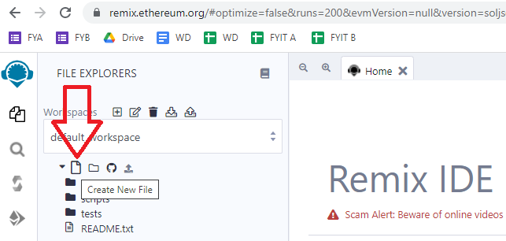

Step 3: Write this program in the new file

///////////////

pragma solidity ^0.5.0;

contract SolidityTest {

uint storedData; // State variable

constructor() public {

storedData = 10;

}

function getResult() public view returns(uint){

uint a = 1; // local variable

uint b = 2;

uint result = a + b;

return result; //access the state variable

}

}

Step 4: Compile contract

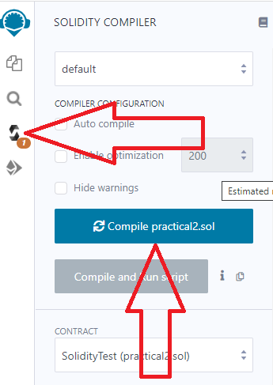

Step 5: Deploy contract

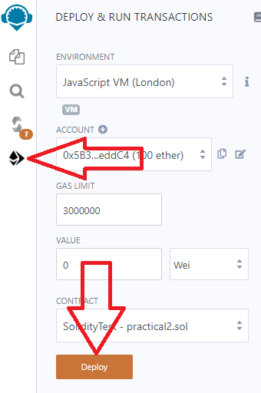

Step 6: Select the contract and click button

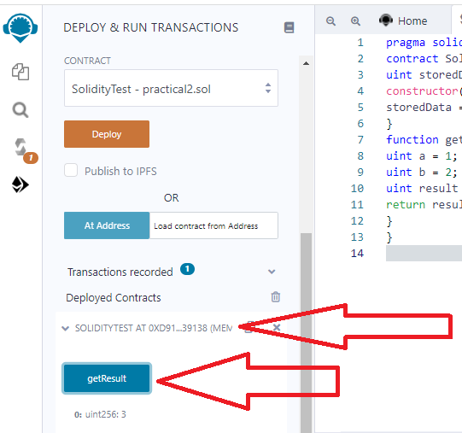

**1.State Variable:**

// Solidity program to

// demonstrate state

// variables

pragma solidity ^0.5.0;

// Creating a contract

contract Solidity_var_Test {

// Declaring a state variable

uint8 public state_var;

// Defining a constructor

constructor() public {

state_var = 16;

}

}

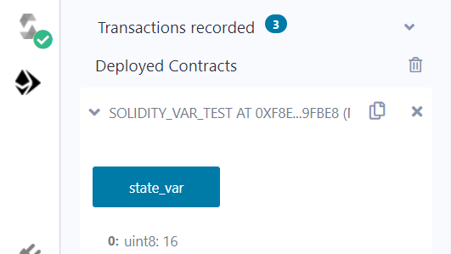

**2.Local Variable:**

// Solidity program to demonstrate

// local variables

pragma solidity ^0.5.0;

// Creating a contract

contract Solidity_var_Test {

// Defining function to show the declaration and

// scope of local variables

function getResult() public view returns(uint){

// Initializing local variables

uint local_var1 = 1;

uint local_var2 = 2;

uint result = local_var1 + local_var2;

// Access the local variable

return result;

}

}

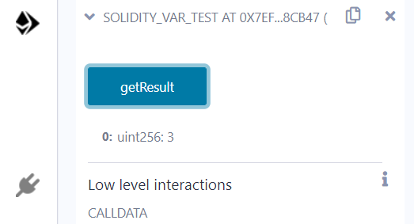

**3.Global variable:**

// Solidity program to

// show Global variables

pragma solidity ^0.5.0;

// Creating a contract

contract Test {

// Defining a variable

address public admin;

// Creating a constructor to

// use Global variable

constructor() public {

admin = msg.sender;

}

}

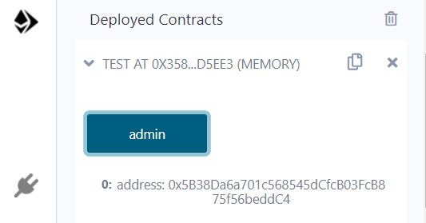

Scope of local variables is limited to function in which they are defined but State variables can have three types of scopes.

**Public** − Public state variables can be accessed internally as well as via messages. For a public state variable, an automatic getter function is generated.

**Internal** − Internal state variables can be accessed only internally from the current contract or contract deriving from it without using this.

**Private** − Private state variables can be accessed only internally from the current contract they are defined not in the derived contract from it.

**B)Operators**

Solidity supports the following types of operators.

Arithmetic Operators

Comparison Operators

Logical (or Relational) Operators

Assignment Operators

Conditional (or ternary) Operators

**1. Arithematic Operator**

// Solidity contract to demonstrate

// Arithematic Operator

pragma solidity ^0.5.0;

// Creating a contract

contract SolidityTest {

// Initializing variables

uint16 public a = 20;

uint16 public b = 10;

// Initializing a variable

// with sum

uint public sum = a + b;

// Initializing a variable

// with the difference

uint public diff = a - b;

// Initializing a variable

// with product

uint public mul = a * b;

// Initializing a variable

// with quotient

uint public div = a / b;

// Initializing a variable

// with modulus

uint public mod = a % b;

// Initializing a variable

// decrement value

uint public dec = --b;

// Initializing a variable

// with increment value

uint public inc = ++a;

}

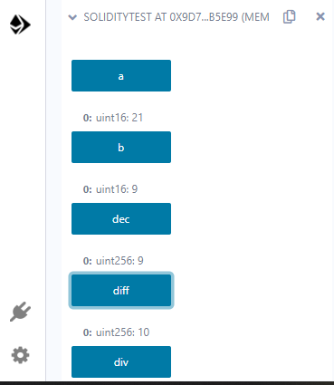

**2.Relational Operator**

// Solidity program to demonstrate

// Relational Operator

pragma solidity ^0.5.0;

// Creating a contract

contract SolidityTest {

// Declaring variables

uint16 public a = 20;

uint16 public b = 10;

// Initializing a variable

// with bool equal result

bool public eq = a == b;

// Initializing a variable

// with bool not equal result

bool public noteq = a != b;

// Initializing a variable

// with bool greater than result

bool public gtr = a > b;

// Initializing a variable

// with bool less than result

bool public les = a < b;

// Initializing a variable

// with bool greater than equal to result

bool public gtreq = a >= b;

// Initializing a variable

// bool less than equal to result

bool public leseq = a <= b;

}

**3.Logical Operators**

// Solidity program to demonstrate

// Logical Operators

pragma solidity ^0.5.0;

// Creating a contract

contract logicalOperator{

// Defining function to demonstrate

// Logical operator

function Logic(

bool a, bool b) public view returns(

bool, bool, bool){

// Logical AND operator

bool and = a&&b;

// Logical OR operator

bool or = a||b;

// Logical NOT operator

bool not = !a;

return (and, or, not);

}

}

**4.Bitwise Operators**

// Solidity program to demonstrate

// Bitwise Operator

pragma solidity ^0.5.0;

// Creating a contract

contract SolidityTest {

// Declaring variables

uint16 public a = 20;

uint16 public b = 10;

// Initializing a variable

// to '&' value

uint16 public and = a & b;

// Initializing a variable

// to '|' value

uint16 public or = a | b;

// Initializing a variable

// to '^' value

uint16 public xor = a ^ b;

// Initializing a variable

// to '<<' value

uint16 public leftshift = a << b;

// Initializing a variable

// to '>>' value

uint16 public rightshift = a >> b;

// Initializing a variable

// to '~' value

uint16 public not = ~a ;

}

**5.Assignment Operator**

// Solidity program to demonstrate

// Assignment Operator

pragma solidity ^0.5.0;

// Creating a contract

contract SolidityTest {

// Declaring variables

uint16 public assignment = 20;

uint public assignment_add = 50;

uint public assign_sub = 50;

uint public assign_mul = 10;

uint public assign_div = 50;

uint public assign_mod = 32;

// Defining function to

// demonstrate Assignment Operator

function getResult() public{

assignment_add += 10;

assign_sub -= 20;

assign_mul *= 10;

assign_div /= 10;

assign_mod %= 20;

return ;

}

}

6**.Conditional Operators**

// Solidity program to demonstrate

// Conditional Operator

pragma solidity ^0.5.0;

// Creating a contract

contract SolidityTest{

// Defining function to demonstrate

// conditional operator

function sub(

uint a, uint b) public view returns(

uint){

uint result = (a > b? a-b : b-a);

return result;

}

}

**C)Loops:**

1.While loop: The most basic loop in Solidity is the **while** loop which would be discussed in this chapter. The purpose of a **while** loop is to execute a statement or code block repeatedly as long as an **expression** is true. Once the expression becomes **false,** the loop terminates.

2.do-while loop: The **do...while** loop is similar to the **while** loop except that the condition check happens at the end of the loop. This means that the loop will always be executed at least once, even if the condition is **false**.

3.for loop: The **for** loop is the most compact form of looping. It includes the following three important parts −

The **loop initialization** where we initialize our counter to a starting value. The initialization statement is executed before the loop begins.

The **test statement** which will test if a given condition is true or not. If the condition is true, then the code given inside the loop will be executed, otherwise the control will come out of the loop.

The **iteration statement** where you can increase or decrease your counter.

4.loop control: Solidity provides full control to handle loops and switch statements. There may be a situation when you need to come out of a loop without reaching its bottom. There may also be a situation when you want to skip a part of your code block and start the next iteration of the loop.To handle all such situations, Solidity provides **break** and **continue** statements. These statements are used to immediately come out of any loop or to start the next iteration of any loop respectively.

**1.While Loop**

pragma solidity ^0.5.0;

contract SolidityTest {

uint storedData;

constructor() public{

storedData = 10;

}

function getResult() public view returns(string memory){

uint a = 10;

uint b = 2;

uint result = a + b;

return integerToString(result);

}

function integerToString(uint _i) internal pure

returns (string memory) {

if (_i == 0) {

return "0";

}

uint j = _i;

uint len;

while (j != 0) {

len++;

j /= 10;

}

bytes memory bstr = new bytes(len);

uint k = len - 1;

while (_i != 0) { // while loop

bstr[k--] = byte(uint8(48 + _i % 10));

_i /= 10;

}

return string(bstr);

}

}

**2.Do-while loop:**

pragma solidity ^0.5.0;

contract SolidityTest {

uint storedData;

constructor() public{

storedData = 10;

}

function getResult() public view returns(string memory){

uint a = 10;

uint b = 2;

uint result = a + b;

return integerToString(result);

}

function integerToString(uint _i) internal pure

returns (string memory) {

if (_i == 0) {

return "0";

}

uint j = _i;

uint len;

while (j != 0) {

len++;

j /= 10;

}

bytes memory bstr = new bytes(len);

uint k = len - 1;

do {                   // do while loop

bstr[k--] = byte(uint8(48 + _i % 10));

_i /= 10;

}

while (_i != 0);

return string(bstr);

}

}

**3.For Loop:**

pragma solidity ^0.5.0;

contract SolidityTest {

uint storedData;

constructor() public{

storedData = 10;

}

function getResult() public view returns(string memory){

uint a = 10;

uint b = 2;

uint result = a + b;

return integerToString(result);

}

function integerToString(uint _i) internal pure

returns (string memory) {

if (_i == 0) {

return "0";

}

uint j=0;

uint len;

for (j = _i; j != 0; j /= 10) {  //for loop example

len++;

}

bytes memory bstr = new bytes(len);

uint k = len - 1;

while (_i != 0) {

bstr[k--] = byte(uint8(48 + _i % 10));

_i /= 10;

}

return string(bstr);//access local variable

}}

**4.loop Control: (Break statement)**

pragma solidity ^0.5.0;

contract SolidityTest {

uint storedData;

constructor() public{

storedData = 10;

}

function getResult() public view returns(string memory){

uint a = 1;

uint b = 2;

uint result = a + b;

return integerToString(result);

}

function integerToString(uint _i) internal pure

returns (string memory) {

if (_i == 0) {

return "0";

}

uint j = _i;

uint len;

while (true) {

len++;

j /= 10;

if(j==0){

break;   //using break statement

}

}

bytes memory bstr = new bytes(len);

uint k = len - 1;

while (_i != 0) {

bstr[k--] = byte(uint8(48 + _i % 10));

_i /= 10;

}

return string(bstr);

}

}

**(continue statement)**

pragma solidity ^0.5.0;

contract SolidityTest {

uint storedData;

constructor() public{

storedData = 10;

}

function getResult() public view returns(string memory){

uint n = 1;

uint sum = 0;

while( n < 10){

n++;

if(n == 5){

continue; // skip n in sum when it is 5.

}

sum = sum + n;

}

return integerToString(sum);

}

function integerToString(uint _i) internal pure

returns (string memory) {

if (_i == 0) {

return "0";

}

uint j = _i;

uint len;

while (true) {

len++;

j /= 10;

if(j==0){

break;   //using break statement

}

}

bytes memory bstr = new bytes(len);

uint k = len - 1;

while (_i != 0) {

bstr[k--] = byte(uint8(48 + _i % 10));

_i /= 10;

}

return string(bstr);

}

}

**D) Decision Making:**

While writing a program, there may be a situation when you need to adopt one out of a given set of paths. In such cases, you need to use conditional statements that allow your program to make correct decisions and perform right actions.Solidity supports conditional statements which are used to perform different actions based on different conditions. Here we will explain the **if..else** statement.

1.if statement: The **if** statement is the fundamental control statement that allows Solidity to make decisions and execute statements conditionally.

pragma solidity ^0.5.0;

contract SolidityTest {

uint storedData;

constructor() public {

storedData = 10;

}

function getResult() public view returns(string memory){

uint a = 1;

uint b = 2;

uint result = a + b;

return integerToString(result);

}

function integerToString(uint _i) internal pure

returns (string memory) {

if (_i == 0) {   // if statement

return "0";

}

uint j = _i;

uint len;

while (j != 0) {

len++;

j /= 10;

}

bytes memory bstr = new bytes(len);

uint k = len - 1;

while (_i != 0) {

bstr[k--] = byte(uint8(48 + _i % 10));

_i /= 10;

}

return string(bstr);//access local variable

}}

**2.if-else statement:** The **'if...else'** statement is the next form of control statement that allows Solidity to execute statements in a more controlled way.

pragma solidity ^0.5.0;

// Creating a contract

contract Types {

// Declaring state variables

uint i = 10;

bool even;

// Defining function to

// demonstrate the use of

// 'if...else statement'

function decision_making(

) public payable returns(bool){

if (i%2 == 0){

even = true;

}

else{

even = false;

}

return even;

}

}

**3.if-else..if statement**: The **if...else if...** statement is an advanced form of **if...else** that allows Solidity to make a correct decision out of several conditions.

pragma solidity ^0.5.0;

// Creating a contract

contract Types {

// Declaring state variables

uint i = 12;

string result;

// Defining function to

// demonstrate the use

// of 'if...else if...else

// statement'

function decision_making (

) public returns(string memory){

if(i<10){

result = "less than 10";

}

else if(i == 10){

result = "equal to 10";

}

else{

result = "greater than 10";

}

return result;

}

}

**String:**

// Solidity program to demonstrate

// how to create a contract

pragma solidity ^0.4.23;

// Creating a contract

contract Test {

// Declaring variable

string  str;

// Defining a constructor

constructor(string str_in){

str = str_in;

}

// Defining a function to

// return value of variable 'str'

function str_out() public view returns(string memory){

return str;

}

}

**Practical 3**

**AIM: write a solidity program for variables, operators, loops, decision making and string.**

**A) String:**

Solidity supports String literal using both double quote (") and single quote ('). It provides string as a data type to declare a variable of type String.(Int to str)

pragma solidity ^0.5.0;

contract SolidityTest {

constructor() public{

}

function getResult() public view returns(string memory){

uint a = 1;

uint b = 2;

uint result = a + b;

return integerToString(result);

}

function integerToString(uint _i) internal pure

returns (string memory) {

if (_i == 0) {

return "0";

}

uint j = _i;

uint len;

while (j != 0) {

len++;

j /= 10;

}

bytes memory bstr = new bytes(len);

uint k = len - 1;

while (_i != 0) {

bstr[k--] = byte(uint8(48 + _i % 10));

_i /= 10;

}

return string(bstr);

}

}

**B)Array:**

Array is a data structure, which stores a fixed-size sequential collection of elements of the same type. An array is used to store a collection of data, but it is often more useful to think of an array as a collection of variables of the same type.

// Solidity program to demonstrate

// accessing elements of an array

pragma solidity ^0.5.0;

// Creating a contract

contract Types {

// Declaring an array

uint[6] data;

uint x;

// Defining function to

// assign values to array

function array_example() public returns (uint[6] memory)

{

data  = [uint(10), 20, 30, 40, 50, 60];

}

function result() public view returns(uint[6] memory){

return data;

}

// Defining function to access

// values from the array

// from a specific index

function array_element() public view returns (uint){

uint x = data[2];

return x;

}

}

**C)Enums:**

Enums restrict a variable to have one of only a few predefined values. The values in this enumerated list are called enums. With the use of enums it is possible to reduce the number of bugs in your code.

// Solidity program to demonstrate

// how to use 'enumerator'

pragma solidity ^0.5.0;

// Creating a contract

contract Types {

// Creating an enumerator

enum week_days

{

Monday,

Tuesday,

Wednesday,

Thursday,

Friday,

Saturday,

Sunday

}

// Declaring variables of

// type enumerator

week_days week;

week_days choice;

// Setting a default value

week_days constant default_value

= week_days.Sunday;

// Defining a function to

// set value of choice

function set_value() public {

choice = week_days.Thursday;

}

// Defining a function to

// return value of choice

function get_choice(

) public view returns (week_days) {

return choice;

}

// Defining function to

// return default value

function getdefaultvalue(

) public pure returns(week_days) {

return default_value;

}

}

**D)Structure:**

Struct types are used to represent a record.

pragma solidity ^0.5.0;

contract test {

struct Book {

string title;

string author;

uint book_id;

}

Book book;

function setBook() public {

book = Book('Learn Java', 'TP', 1);

}

function getBookId() public view returns (uint) {

return book.book_id;

}

}

**E)Mappings:**

Mapping is a reference type as arrays and structs. Following is the syntax to declare a mapping type.

mapping(_KeyType => _ValueType) where ,

**_KeyType** − can be any built-in types plus bytes and string. No reference type or complex objects are allowed.

**_ValueType** − can be any type.

pragma solidity ^0.5.0;

contract LedgerBalance {

mapping(address => uint)  balance;

function updateBalance() public  returns(uint) {

balance[msg.sender]=30;

return balance[msg.sender];

}

}

**Mapping program for String.**

pragma solidity ^0.5.0;

contract LedgerBalance {

mapping(address => string)  name;

function updateBalance() public returns(string memory){

name[msg.sender] = "Mrunali";

return name[msg.sender];

}

function printsender() public view returns(address) {

return msg.sender;

}

}

**3B. WRITE A SOLIDITY PROGRAM FOR FUNCTION, VIEW FUNCTION, PURE**

**FUNCTION & FALLBACK FUNCTION.**

**A)Function:**

A function is a group of reusable code which can be called anywhere in your program. This eliminates the need of writing the same code again and again. It helps programmers in writing modular codes. Functions allow a programmer to divide a big program into a number of small and manageable functions.

pragma solidity ^0.5.0;

contract SolidityTest {

constructor() public{

}

function getResult() public view returns(string memory){

uint a = 1;

uint b = 2;

uint result = a + b;

return integerToString(result);

}

function integerToString(uint _i) internal pure

returns (string memory) {

if (_i == 0) {

return "0";

}

uint j = _i;

uint len;

while (j != 0) {

len++;

j /= 10;

}

bytes memory bstr = new bytes(len);

uint k = len - 1;

while (_i != 0) {

bstr[k--] = byte(uint8(48 + _i % 10));

_i /= 10;

}

return string(bstr);//access local variable

}

}

**B)View Function:**

View functions ensure that they will not modify the state. A function can be declared as **view**. Getter method are by default view functions.

pragma solidity ^0.5.0;

contract Test {

function getResult() public view returns(uint product, uint sum){

uint a = 1; // local variable

uint b = 2;

product = a * b;

sum = a + b;

}

}

**C)Pure Function:**

Pure functions ensure that they not read or modify the state. A function can be declared as **pure**. Pure functions can use the revert() and require() functions to revert potential state changes if an error occurs.

pragma solidity ^0.5.0;

contract Test {

function getResult() public pure returns(uint product, uint sum){

uint a = 1;

uint b = 2;

product = a * b;

sum = a + b;

}

}

**D)Fallback Function:**

Fallback function is a special function available to a contract.

pragma solidity ^0.5.0;

contract Test {

uint public x ;

function() external { x = 1; }

}

contract Sink {

function() external payable { }

}

contract Caller {

function callTest(Test test) public returns (bool) {

(bool success,) = address(test).call(abi.encodeWithSignature("nonExistingFunction()"));

require(success);

// test.x is now 1

address payable testPayable = address(uint160(address(test)));

// Sending ether to Test contract,

// the transfer will fail, i.e. this returns false here.

return (testPayable.send(2 ether));

}

function callSink(Sink sink) public returns (bool) {

address payable sinkPayable = address(sink);

return (sinkPayable.send(2 ether));

}

}

**Practical 4**

**A. write a solidity program for function overloading, mathematical function & cryptographic functions**

**Function Overloading:**

The definition of the function must differ from each other by the types and/or the number of arguments in the argument list. You cannot overload function declarations that differ only by return type.

pragma solidity ^0.5.0;

contract Test {

function getSum(uint a, uint b) public pure returns(uint){

return a + b;

}

function getSum(uint a, uint b, uint c ) public pure returns(uint){

return a + b + c;

}

function callSumWithTwoArguments() public pure returns(uint){

return getSum(2,2);

}

function callSumWithThreeArguments() public pure returns(uint){

return getSum(1,2,4);

}

}

**Mathematical Function:**

Solidity provides inbuilt mathematical functions as well.

pragma solidity ^0.5.0;

contract Test {

function callAddMod() public pure returns(uint){

return addmod(4, 5, 3);

}

function callMulMod() public pure returns(uint){

return mulmod(4, 5, 3);

}

}

**Cryptographic Function:**

Solidity provides inbuilt cryptographic functions as well.

pragma solidity ^0.5.0;

contract Test {

function callKeccak256() public pure returns(bytes32 result){

return keccak256("ABC");

}

}

**4B. WRITE A SOLIDITY PROGRAM FOR CONTRACT, INHERITANCE, CONSTRUCTORS, ABSTRACT CONTRACTS, INTERFACES, LIBRARIES, ASSEMBLY, EVENTS, ERROR HANDLING.**

**A)Contract:**

Contract in Solidity is similar to a Class in C++. A Contract have following properties.

**Constructor** − A special function declared with constructor keyword which will be executed once per contract and is invoked when a contract is created.

**State Variables** − Variables per Contract to store the state of the contract.

**Functions** − Functions per Contract which can modify the state variables to alter the state of a contract.

// Calling function from external contract

pragma solidity ^0.5.0;

contract C {

//private state variable

uint private data;

//public state variable

uint public info;

//constructor

constructor() public {

info = 10;

}

//private function

function increment(uint a) private pure returns(uint) { return a + 1; }

//public function

function updateData(uint a) public { data = a; }

function getData() public view returns(uint) { return data; }

function compute(uint a, uint b) internal pure returns (uint) { return a + b; }

}

//Derived Contract

contract E is C {

uint private result;

C private c;

constructor() public {

c = new C();

}

function getComputedResult() public {

result = compute(3, 5);

}

function getResult() public view returns(uint) { return result; }

function getData() public view returns(uint) { return c.info(); }

}

**B)Inheritance:**

Inheritance is a way to extend functionality of a contract. Solidity supports both single as well as multiple inheritance.

// Solidity program to

// demonstrate

// Single Inheritance

pragma solidity >=0.4.22 <0.6.0;

// Defining contract

contract parent{

// Declaring internal

// state variable

uint internal sum;

// Defining external function

// to set value of internal

// state variable sum

function setValue() external {

uint a = 20;

uint b = 20;

sum = a + b;

}

}

// Defining child contract

contract child is parent{

// Defining external function

// to return value of

// internal state variable sum

function getValue() external view returns(uint) {

return sum;

}

}

// Defining calling contract

contract caller {

// Creating child contract object

child cc = new child();

// Defining function to call

// setValue and getValue functions

function testInheritance() public {

cc.setValue();

}

function result() public view returns(uint ){

return cc.getValue();

}

}

**C)Constructors:**

Constructor is a special function declared using constructor keyword. It is an optional function and is used to initialize state variables of a contract. Following are the key characteristics of a constructor.

A contract can have only one constructor.

A constructor code is executed once when a contract is created and it is used to initialize contract state.

A constructor can be either public or internal.

An internal constructor marks the contract as abstract.

In case, no constructor is defined, a default constructor is present in the contract.

pragma solidity ^0.5.0;

contract Base {

uint data;

constructor(uint _data) public {

data = _data;

}

function getresult()public view returns(uint){

return data;

}

}

contract Derived is Base (5) {

constructor() public {}

}

**// Indirect Initialization of Base Constructor**

pragma solidity ^0.5.0;

contract Base {

uint data;

constructor(uint _data) public {

data = _data;

}

function getresult()public view returns(uint){

return data;

}

}

contract Derived is Base {

constructor(uint _info) Base(_info * _info) public {}

}

**D)Abstract Contracts:**

Abstract Contract is one which contains at least one function without any implementation. Such a contract is used as a base contract. Generally an abstract contract contains both implemented as well as abstract functions. Derived contract will implement the abstract function and use the existing functions as and when required.

pragma solidity ^0.5.0;

contract Calculator {

function getResult() public view returns(uint);

}

contract Test is Calculator {

function getResult() public view returns(uint) {

uint a = 4;

uint b = 2;

uint result = a + b;

return result;

}

}

**E)Interfaces:**

Interfaces are similar to abstract contracts and are created using interface keyword. Following are the key characteristics of an interface.

Interface can not have any function with implementation.

Functions of an interface can be only of type external.

Interface can not have constructor.

Interface can not have state variables.

pragma solidity ^0.5.0;

interface Calculator {

function getResult() external view returns(uint);

}

contract Test is Calculator {

constructor() public {}

function getResult() external view returns(uint){

uint a = 5;

uint b = 2;

uint result = a + b;

return result;

}

}

**F)Libraries:**

Libraries are similar to Contracts but are mainly intended for reuse. A Library contains functions which other contracts can call. Solidity have certain restrictions on use of a Library.

pragma solidity ^0.5.0;

library Search {

function indexOf(uint[] storage self, uint value) public view returns (uint) {

for (uint i = 0; i < self.length; i++)

if (self[i] == value) return i;

return uint(-1);}

}

contract Test {

uint[] data;

uint value;

uint index;

constructor() public {

data.push(6);

data.push(7);

data.push(8);

data.push(9);

data.push(10);

}

function isValuePresent() external {

value = 9;

//search if value is present in the array using Library function

index = Search.indexOf(data, value);

}

function getresult() public view returns(uint){

return index;

}}

**G)Assembly:**

Solidity provides an option to use assembly language to write inline assembly within Solidity source code. We can also write a standalone assembly code which then be converted to bytecode. Standalone Assembly is an intermediate language for a Solidity compiler and it converts the Solidity code into a Standalone Assembly and then to byte code. We can used the same language used in Inline Assembly to write code in a Standalone assembly.

pragma solidity ^0.5.0;

library Sum {

function sumUsingInlineAssembly(uint[] memory _data) public pure returns (uint o_sum) {

for (uint i = 0; i < _data.length; ++i) {

assembly {

o_sum := add(o_sum, mload(add(add(_data, 0x20), mul(i, 0x20))))

}}

}

}

contract Test {

uint[] data;

constructor() public {

data.push(1);

data.push(2);

data.push(3);

data.push(4);

data.push(5);

}

function sum() external view returns(uint){

return Sum.sumUsingInlineAssembly(data);

}

}

**H)Events:**

Event is an inheritable member of a contract. An event is emitted, it stores the arguments passed in transaction logs. These logs are stored on blockchain and are accessible using address of the contract till the contract is present on the blockchain. An event generated is not accessible from within contracts, not even the one which have created and emitted them.

// Solidity program to demonstrate

// creating an event

pragma solidity ^0.4.21;

// Creating a contract

contract eventExample {

// Declaring state variables

uint256 public value = 0;

// Declaring an event

event Increment(address owner);

// Defining a function for logging event

function getValue(uint _a, uint _b) public {

emit Increment(msg.sender);

value = _a + _b;

}

}

**I)Error Handling:**

Solidity provides various functions for error handling. Generally when an error occurs, the state is reverted back to its original state. Other checks are to prevent unauthorized code access.

**Solidity program to demonstrate require statement.**

// Solidity program to

// demonstrate require

// statement

pragma solidity ^0.5.0;

// Creating a contract

contract requireStatement {

// Defining function to

// check input

function checkInput(uint8 _input) public view returns(string memory){

require(_input >= 0, "invalid uint");

require(_input <= 255, "invalid uint8");

return "Input is Uint8";

}

// Defining function to

// use require statement

function Odd(uint _input) public view returns(bool){

require(_input % 2 != 0);

return true;

}

}

**Solidity program to demonstrate assert statement.**

// Solidity program to

// demonstrate assert

// statement

pragma solidity ^0.5.0;

// Creating a contract

contract assertStatement {

// Defining a state variable

bool result;

// Defining a function

// to check condition

function checkOverflow(uint8 _num1, uint8 _num2) public {

uint8 sum = _num1 + _num2;

assert(sum<=255);

result = true;

}

// Defining a function to

// print result of assert

// statement

function getResult() public view returns(string memory){

if(result == true){

return "No Overflow";

}

else{

return "Overflow exist";

}

}

}

**Solidity program to demonstrate revert statement.**

// Solidity program to

// demonstrate revert

pragma solidity ^0.5.0;

// Creating a contract

contract revertStatement {

// Defining a function

// to check condition

function checkOverflow(uint _num1, uint _num2) public view returns(

string memory, uint) {

uint sum = _num1 + _num2;

if(sum < 0 || sum > 255){

revert(" Overflow Exist");

}

else{

return ("No Overflow", sum);

}

}

}

**Practical 5**

**Aim: Install hyperledger-Irhoa**

Step 1: install docker

**sudo apt-get install curl**

**curl -fsSL https://download.docker.com/linux/ubuntu/gpg | sudo apt-key add -**

**sudo add-apt-repository "deb [arch=amd64] https://download.docker.com/linux/ubuntu $(lsb_release -cs) stable"**

**sudo apt-get update**

**apt-cache policy docker-ce**

**sudo apt-get install -y docker-ce**

Step 2: create docker network

**sudo docker network create mithilesh-iroha-network**

Step 3:add PostgreSQL to our network

**sudo docker run --name some-postgres -e POSTGRES_USER=postgres -e POSTGRES_PASSWORD=mysecretpassword -p 5432:5432 --network=mithilesh-iroha-network -d postgres:9.5**

Step 4:create a volume of persistant storage named "blockstore" to store the blocks for our blockchain

**sudo docker volume create blockstore**

Step 5: Download the Iroha code from github.

**sudo apt-get install git**

**git clone -b develop https://github.com/hyperledger/iroha --depth=1**

Step 6: run the Iroha docker container

**sudo docker run -it --name iroha \**

**-p 50051:50051 \**

**-v $(pwd)/iroha/example:/opt/iroha_data \**

**-v blockstore:/tmp/block_store \**

**--network=mithilesh-iroha-network \**

**--entrypoint=/bin/bash \**

**hyperledger/iroha:latest**

Step 7: run Iroha

**irohad --config config.docker --genesis_block genesis.block --keypair_name node0**

Step 8:Open a new terminal

Step 9:attach the docker container to our terminal

**sudo docker exec -it iroha /bin/bash**

Step 10:Launch the iroha-cli tool and login as admin@test.

**iroha-cli -account_name admin@test**

Select 1 – for new transaction

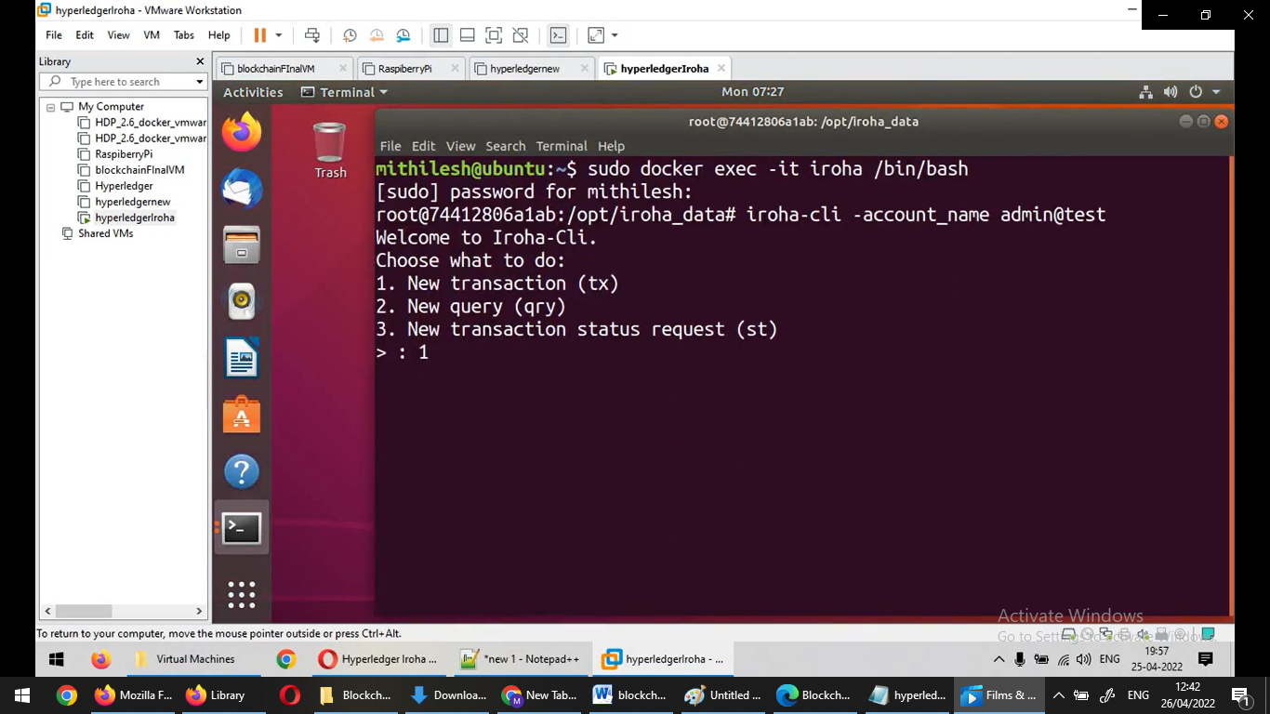

Select 14- for creating new coin

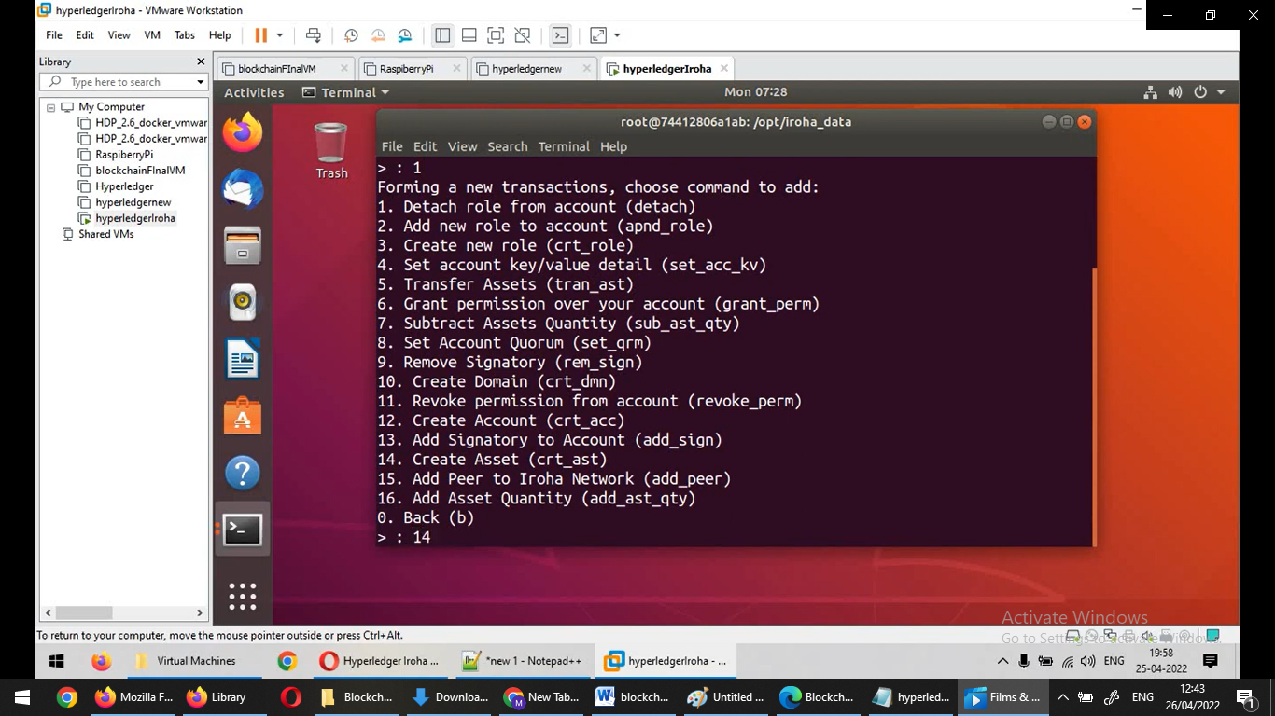

Now type Asset name: mscit

Domain id: test

Asset precision: 2

And select option 3 to add more command

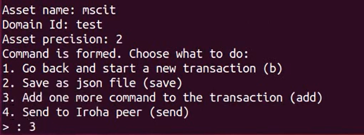

Now select option 16 to add asset quantity

Asset id: mscit#test

Amount: 16.35

Select option 4- send request to Iroha peer

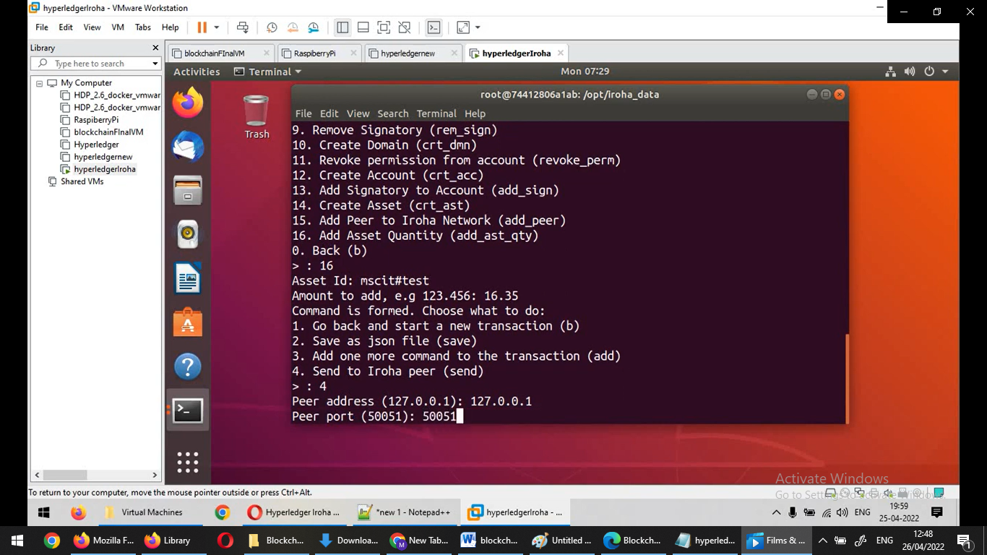

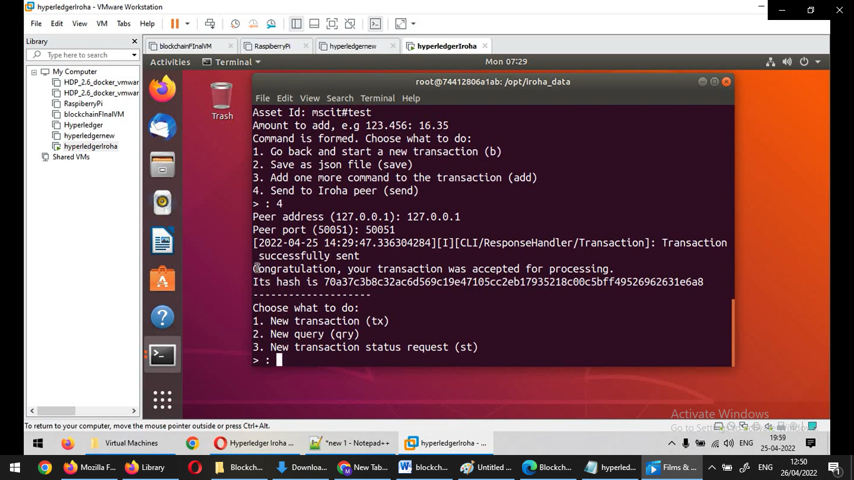

Select option 2 –for query

Select option 8- for assets

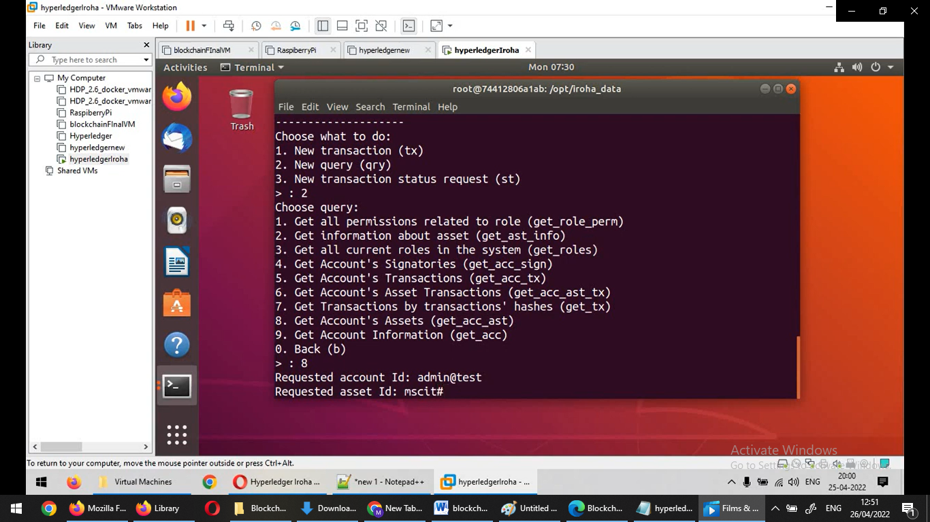

Select option 1

Enter peer : 127.0.0.1

Port: 50051

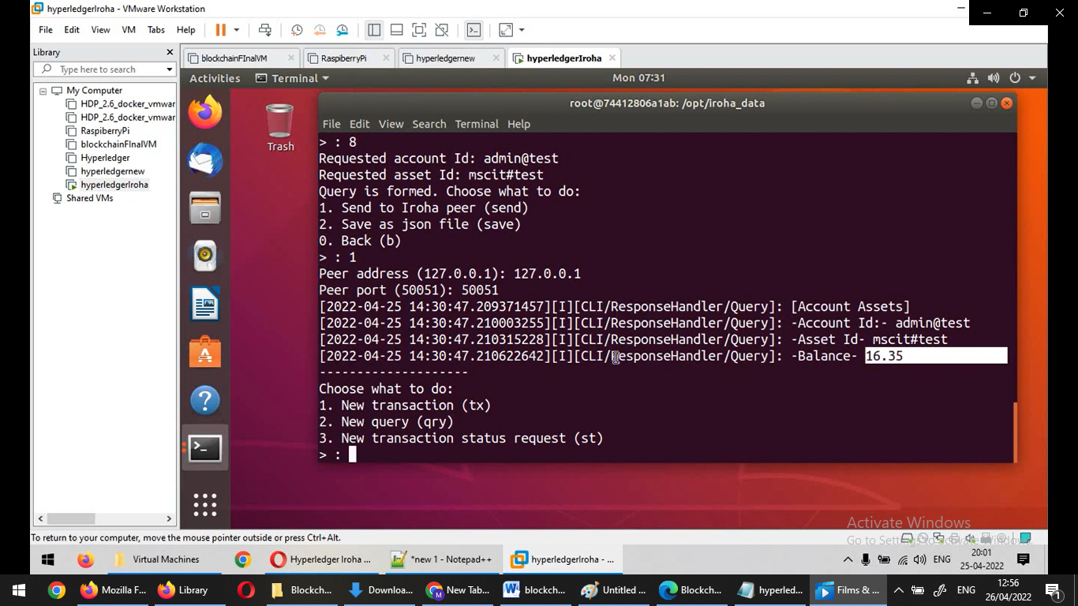

Aim: Demonstrate the use of Bitcoin Core API.

#pip install bitcoinlib

from bitcoinlib.wallets import Wallet

w = Wallet.create('Wallet1')

key1 = w.get_key()

print(key1.address)

w.scan()

print(w.info())

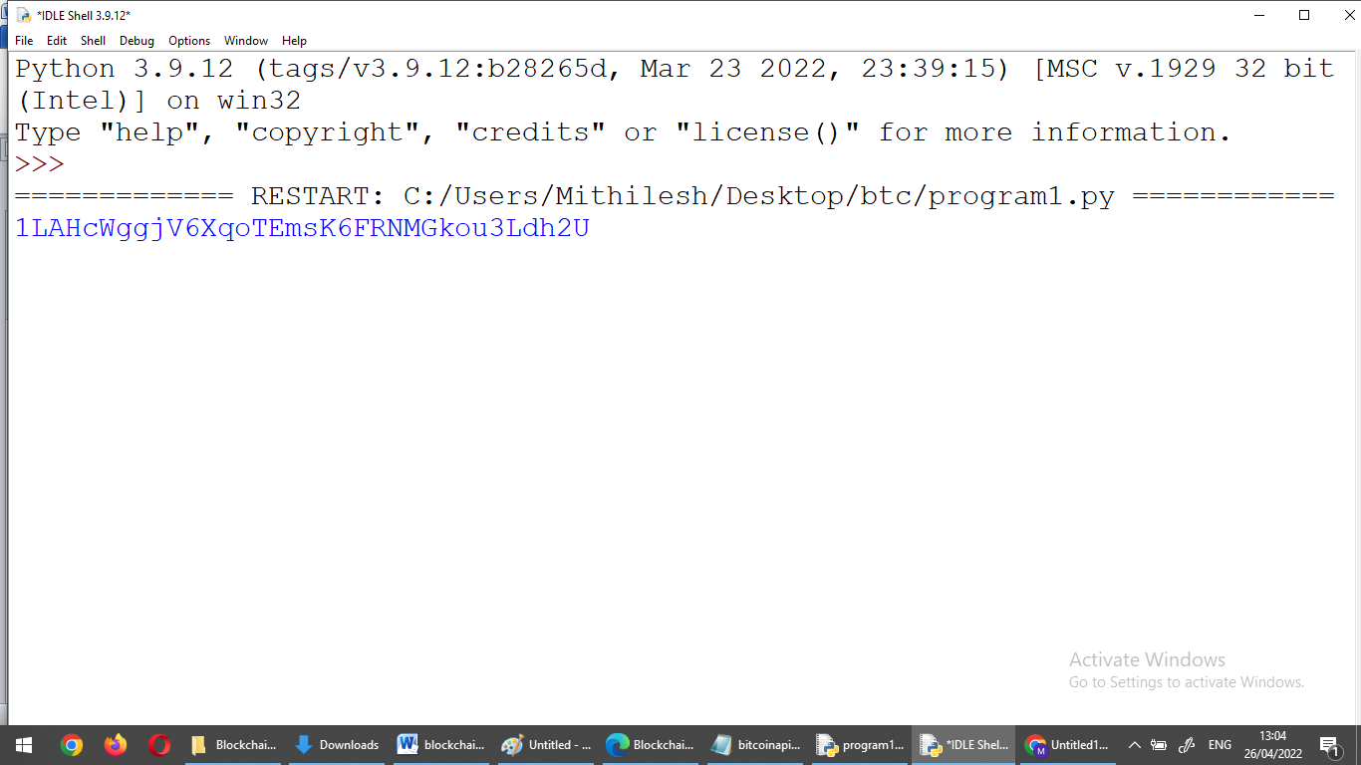

More detail on: https://pypi.org/project/bitcoinlib/

**Practical 6**

Aim: Create your own blockchain and demonstrate its use.

Install on Ubuntu via PPAs

The easiest way to install go-ethereum on Ubuntu-based distributions is with the built-in launchpad PPAs (Personal Package Archives). We provide a single PPA repository that contains both our stable and development releases for Ubuntu versions trusty, xenial, zesty and artful.

linux:

To enable our launchpad repository run:

Step 1: open new terminal

Step 2: on terminal type this command

**sudo add-apt-repository -y ppa:ethereum/ethereum**

#if above command gives error then run

#sudo apt-get install --reinstall ca-certificates

Step 3: install the stable version of go-ethereum:

**sudo apt-get update**

**sudo apt-get install ethereum**

Step 4: create new directory for storing blockchain data

**mkdir myblockchain**

**cd myblockchain**

Step 5:Create genesis.json file

**sudo nano genesis.json**

{

"config": {

"chainId": 10,

"homesteadBlock": 0,

"eip155Block": 0,

"eip158Block": 0,

"eip150Block": 0,

"eip150Hash": "0x0000000000000000000000000000000000000000000000000000000000000000"

},

"alloc": {},

"coinbase": "0x0000000000000000000000000000000000000000",

"difficulty": "0x02000000",

"extraData": "",

"gasLimit": "0x2fefd8",

"nonce": "0x0000000000000042",

"mixhash": "0x0000000000000000000000000000000000000000000000000000000000000000",

"parentHash": "0x0000000000000000000000000000000000000000000000000000000000000000",

"timestamp": "0x00"

}

save the file -> ctrl +o to write -> {enter} save -> ctrl +x exit

Step 6: initialize the block

**sudo geth --datadir TestChain init genesis.json**

Step 7: create network

**sudo geth –datadir TestChain –networkid 1234**

[do not close this terminal]

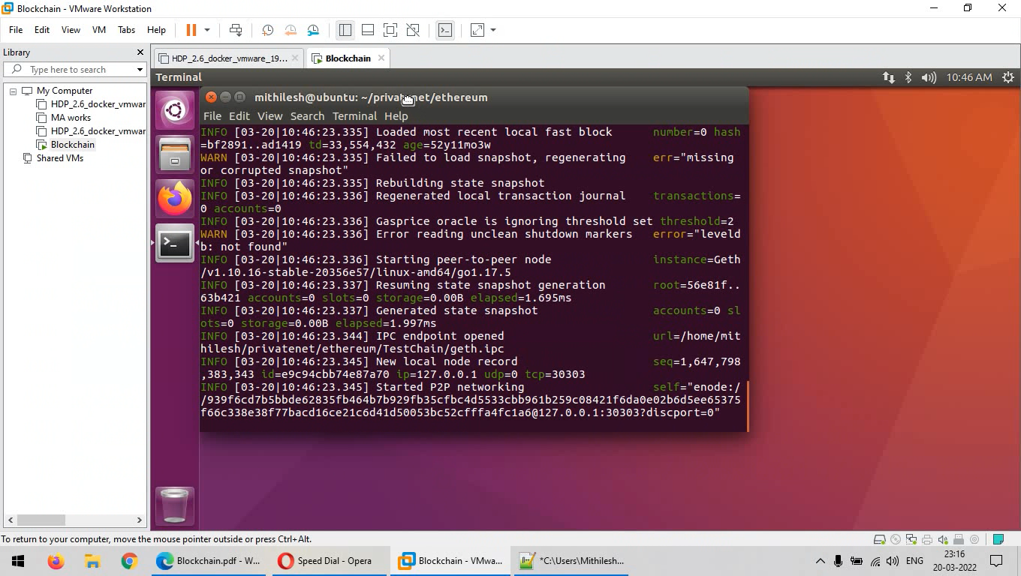

//////////////////////////////////////////////////////////////////////

**Step 8: open new terminal 2:**

**cd myblockchain**

Step 9: attach geth to the network

**sudo geth attach TestChain/geth.ipc**

Step 10: on geth terminal type these commands

**personal.newAccount("123456")**

**miner.start()**

**miner.setEtherbase(eth.accounts[0])**

**admin.addPeer(admin.nodeInfo.enode)**

**Step 10: Wait for 10-20 minutes and check balance**

**eth.getBalance(eth.accounts[0])**

if ether balance is 0 wait for 10-20minutes for mining process to get complete and run **eth.getBalance(eth.accounts[0]) again.**

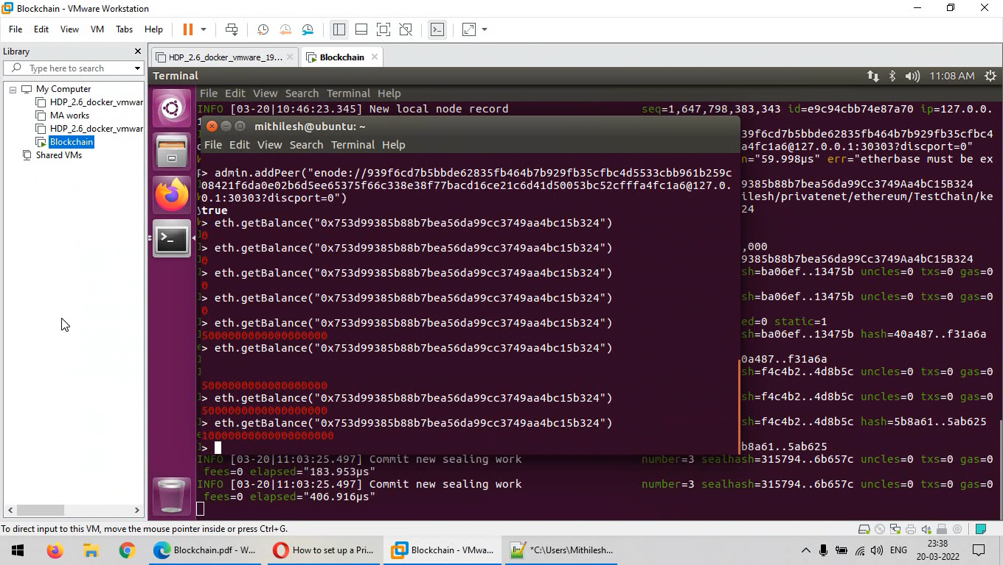

After balance is updated you can check current block height

**eth.blockNumber**

**Practical 7**

**Aim: Demonstrate the running of the blockchain node.**

Step 1: Visit: <https://bitcoin.org/en/download>

Step 2: Download windows setup [use and try with Linux version as well]

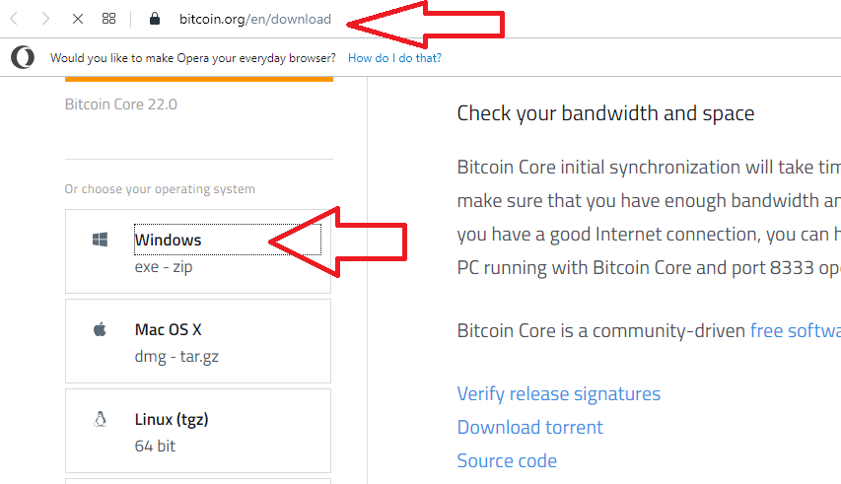

Step 3: Run the setup file-> click next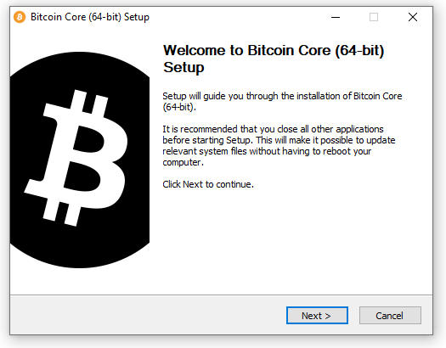

Step 4: Click Next

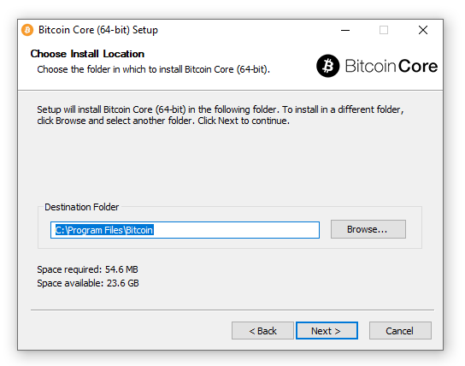

Step 5: Finally click on Install

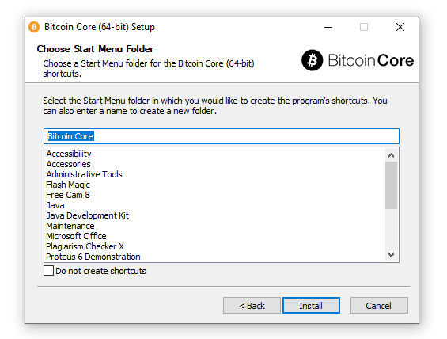

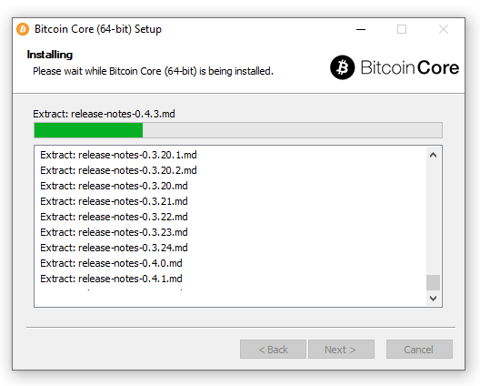

Launch Bitcoin Core-> Click OK.

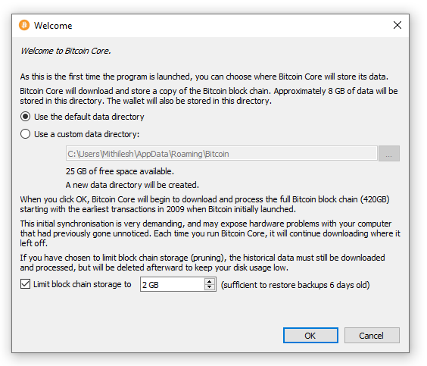

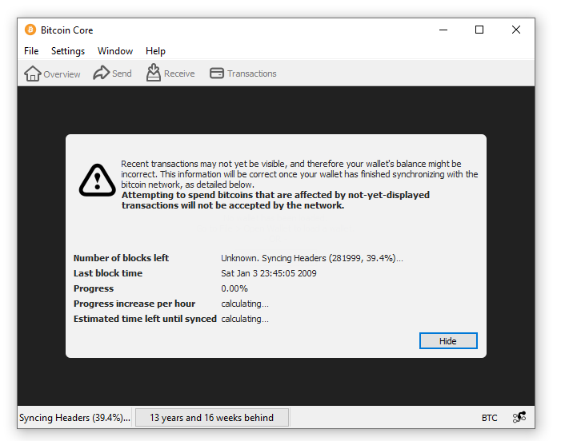

Click on Hide button [Synchronization take place in background]

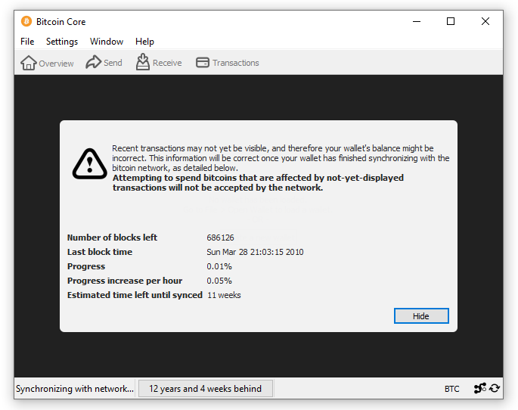



You can create a wallet -> Create a new wallet

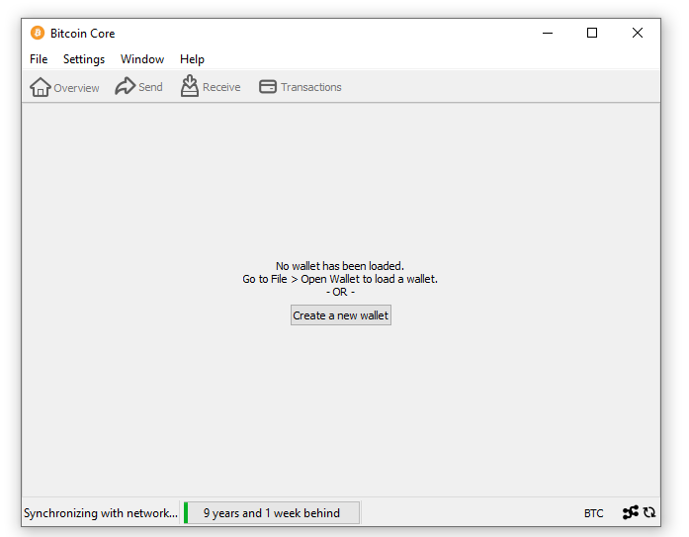

Enter Wallet name

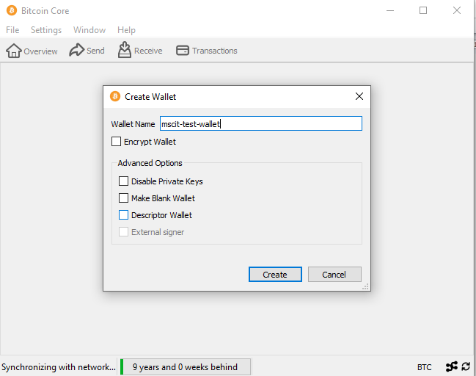

Finally Account is setup

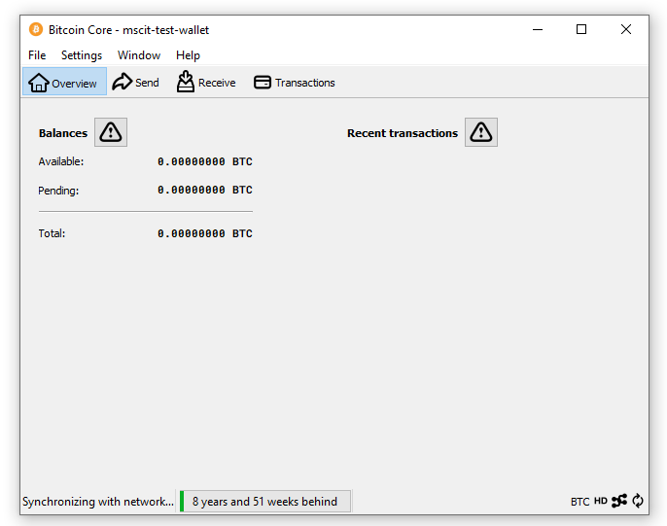

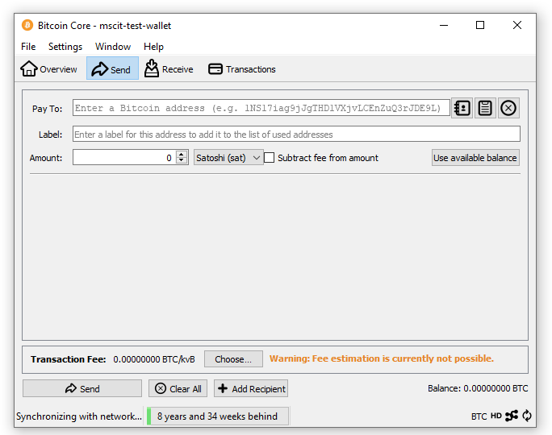

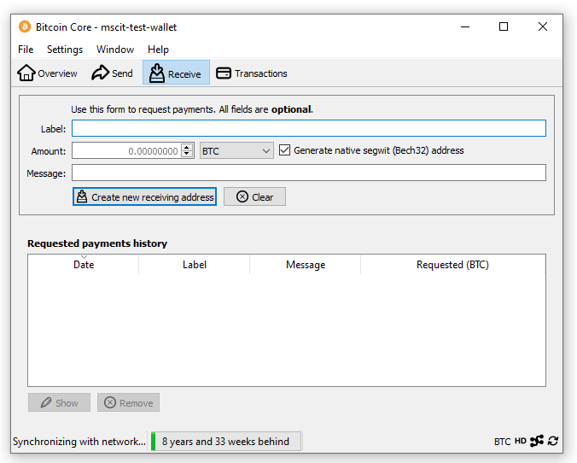

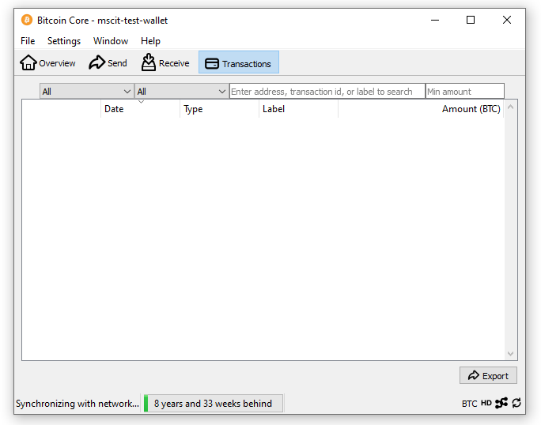

**Practical 8**

**Aim: Demonstrate the use of Bitcoin Core API.**

Open Python IDLE and create new Script.

########################

from bitcoinlib.wallets import Wallet

w = Wallet.create('Wallet6')

key1 = w.get_key()

print('Wallet Address:',key1.address)

w.scan()

print(w.info())

####################

Open CMD and install bitcoinlib package

**pip install bitcoinlib**

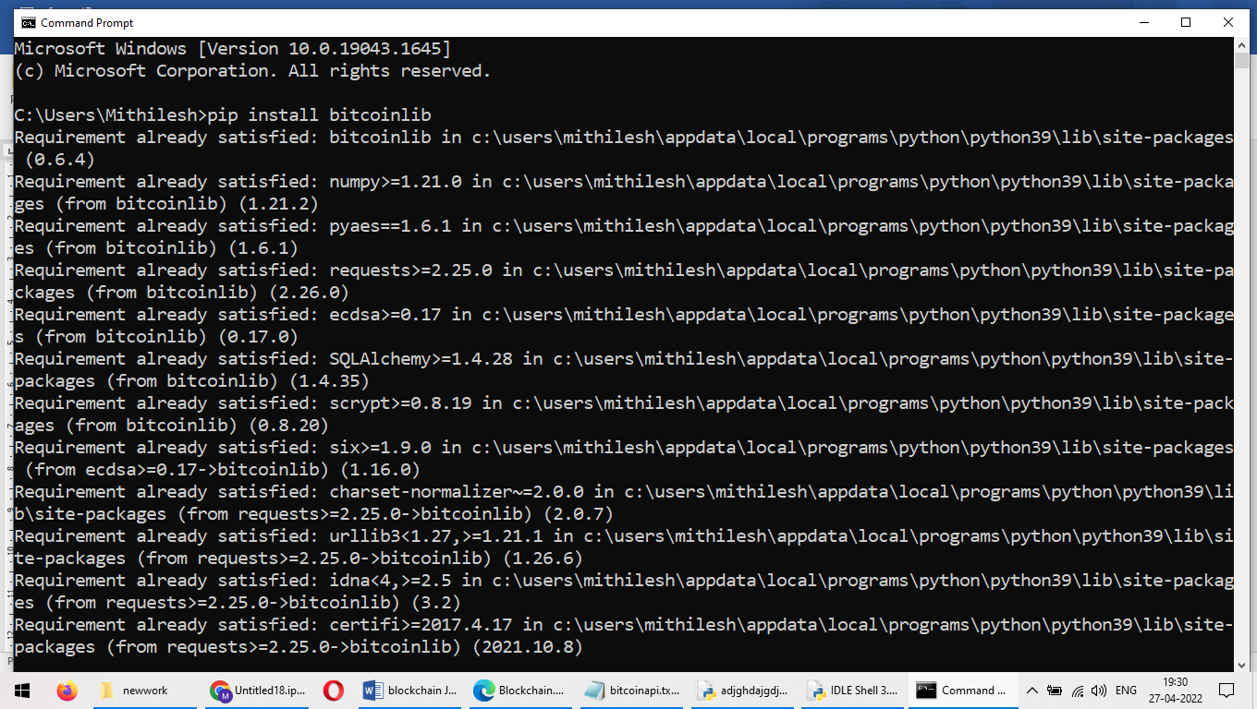

After installing package run the program from Python IDLE

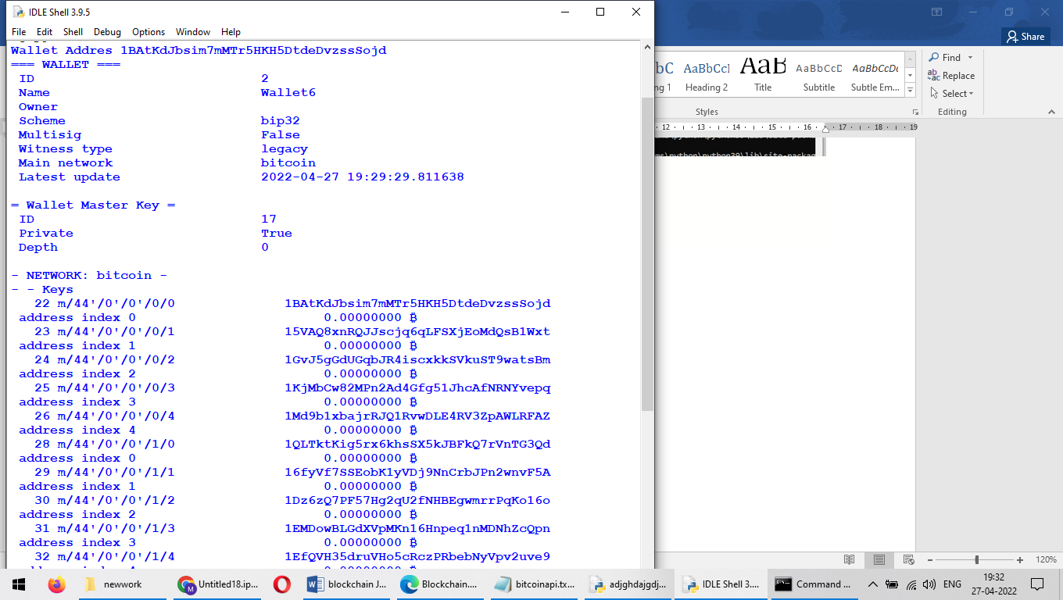

More Detail: <https://pypi.org/project/bitcoinlib/>

**Practical 9**

**Aim: Build Dapps with angular[using truffle and ganache cli]**

Step 1:Install the required package –on new **terminal 1** type these commands

**sudo apt-get -y install curl git vim build-essential**

**sudo apt-get install curl software-properties-common**

**sudo apt install npm**

**sudo npm install -g web3**

**sudo apt-get install nodejs**

**sudo apt install python3.9**

**curl -sL https://deb.nodesource.com/setup_10.x | sudo bash -**

**sudo npm install --global node-sass@latest**

**sudo npm install -g truffle@latest**

**sudo npm install -g ganache-cli**

export NODE_OPTIONS=--openssl-legacy-provider

Step 2: Create a new directory

**mkdir myproject**

**cd myproject**

Step 3:Initialize the project folder

**truffle init**

########################

////to update npm//

sudo npm cache clean -f

sudo npm install -g n

sudo n latest

######################

Step 4: Now create a new contract

**nano contracts/HelloWorld.sol**

Step 5:Add the following code in HelloWorld.sol

pragma solidity ^0.8.0;

contract HelloWorld {

function sayHello() public pure returns(string memory){

return("hello world");

}

}

Step 6:Edit default configuration file

**nano migrations/1_initial_migration.js**

Step 7: Edit this line in the file

**const Migrations = artifacts.require("HelloWorld");**

module.exports = function (deployer) {

deployer.deploy(Migrations,"hello");

};

Step 8: Edit network configuration file

**sudo nano truffle-config.js**

Remove all line(press CTRL +K) from the file and add the following lines

#########################

**module.exports = {**

**networks: {**

**development: {**

**host: "127.0.0.1",**

**port: 8545,**

**network_id: "*",**

**}**

**}**

**}**

#########################

Step 9: start ganache-cli –Switch/Open to **terminal 2**

**ganache-cli**

Step 10: deploy the truffle deploy- On **terminal 1**

**truffle deploy**

[Note contract address]

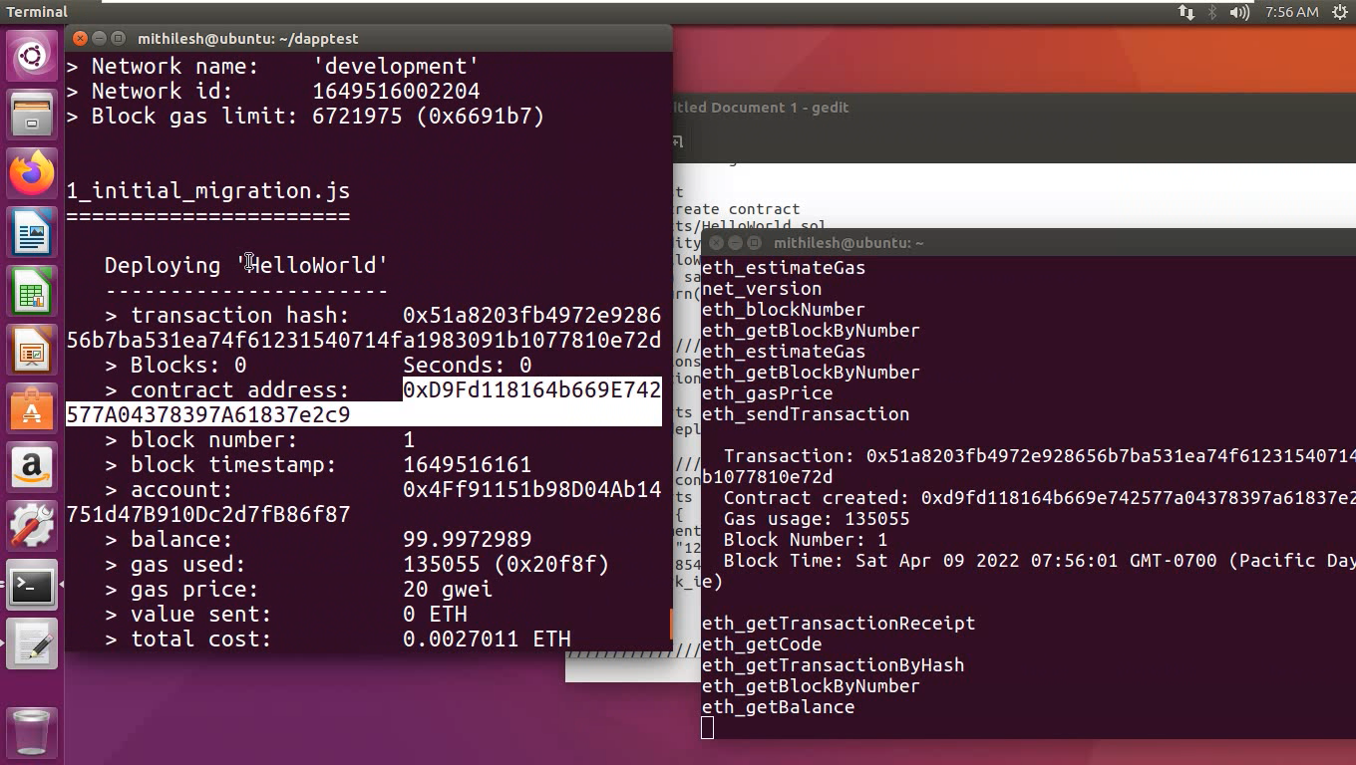

Step 11: Open truffle console - On **terminal 1**

**truffle console**

Step 11: Get reference of contact

**contract = await HelloWorld.at('0x2C403EE1b30F56C0c773089c1Eb9DddF1499C969')**

[Replace '0x2C403EE1b30F56C0c773089c1Eb9DddF1499C969' with your contact address; every time you compile/deploy a new contract address will be generated]

Step 12: Call the function from the contract

**a = await contract.sayHello()**

Step 13:Print output on the screen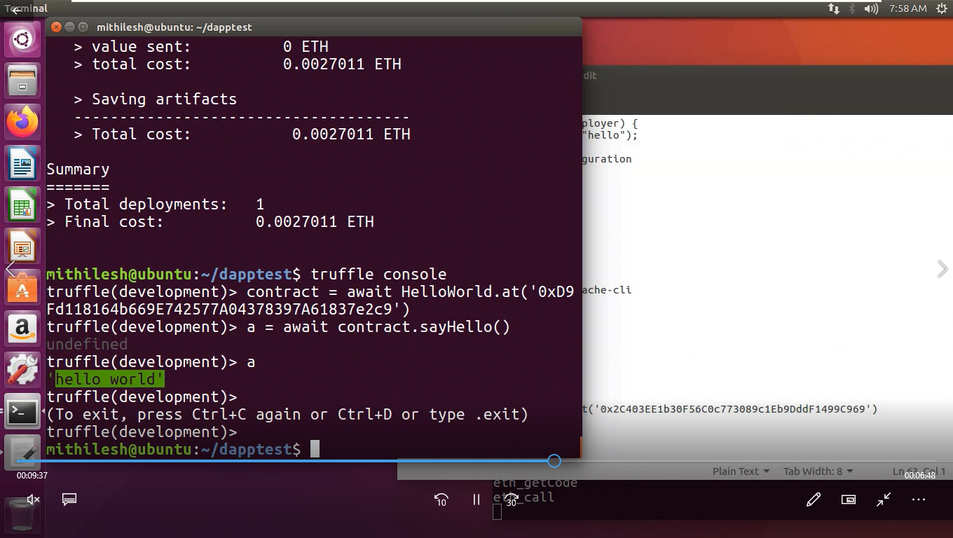

**[In case you are getting any error for version; change the solidity version in HelloWorld.sol]**

Example 2:

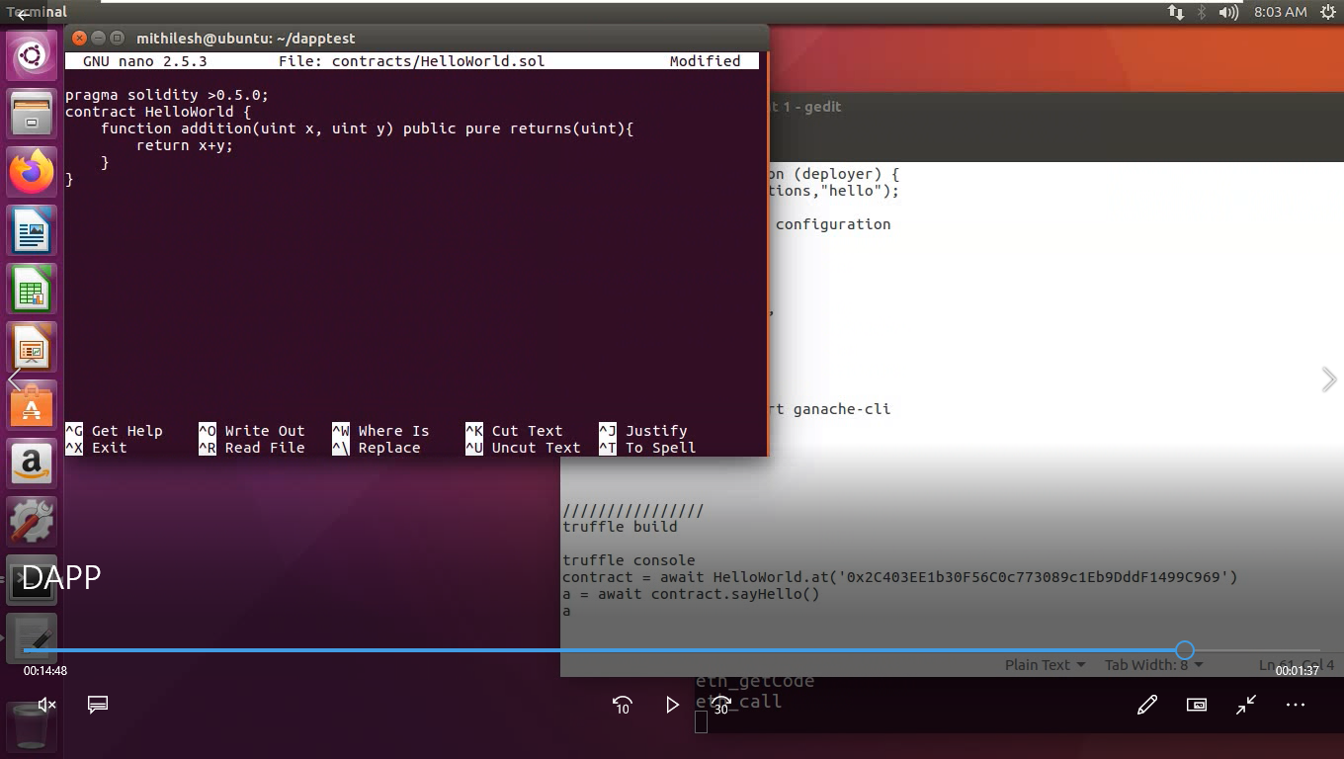

Save-> Deploy ->Open console

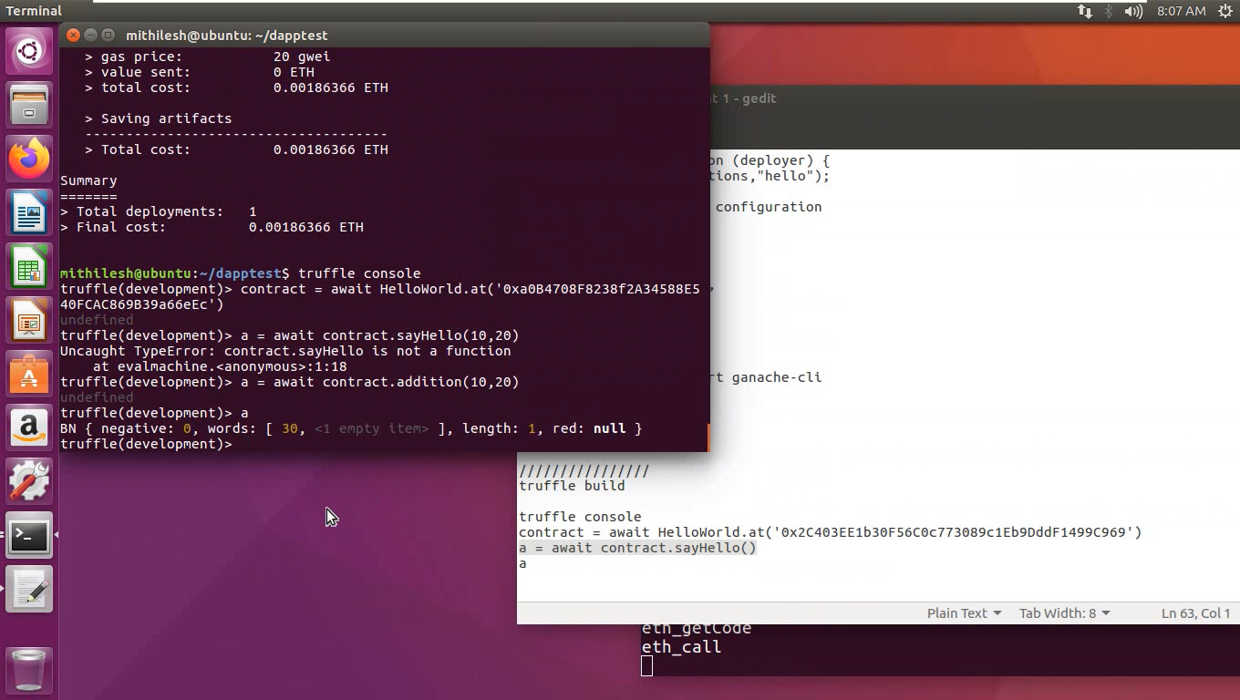

Natural Language

Processing

**Index**

|  |  |  |  |
| --- | --- | --- | --- |
| **Sr. No** | **Title** | **Date** | **Sign** |
| 1. | A. Install NLTK.  B. Convert the given text to speech.  C. Convert audio file Speech to Text.  D. Create a blockchain, a genesis block and execute it.  E. Create a mining function and test it.  F. Add blocks to the miner and dump the blockchain. |  |  |
| 2. | A. Study of various Corpus – Brown, Inaugural, Reuters, udhr with various methods like fields, raw, words, sents, categories.  B. Create and use your own corpora (plaintext, categorical).  C. Study Conditional frequency distributions  Study of tagged corpora with methods like tagged_sents, tagged_words.  D. Write a program to find the most frequent noun tags.  E. Map Words to Properties Using Python Dictionaries  F. Study DefaultTagger, Regular expression tagger, UnigramTagger  G. Find different words from a given plain text without any space by comparing this text with a given corpus of words. Also find the score of words. |  |  |
| 3. | A. Study of Wordnet Dictionary with methods as synsets, definitions, examples, antonyms.  B. Study lemmas, hyponyms, hypernyms, entailments.  C. Write a program using python to find synonym and antonym of word "active" using Wordnet.  D. Compare two nouns.  E. Handling stopword.  Using nltk Adding or Removing Stop Words in NLTK's Default Stop Word List.  Using Gensim Adding and Removing Stop Words in Default Gensim Stop Words List.  Using Spacy Adding and Removing Stop Words in Default Spacy Stop Words List. |  |  |
| 4. | Text Tokenization  A. Tokenization using Python’s split() function.  B. Tokenization using Regular Expressions (RegEx).  C. Tokenization using NLTK.  D. Tokenization using the spaCy library.  E. Tokenization using Keras.  F. Tokenization using Gensim. |  |  |
| 5. | Important NLP Libraries for Indian Languages and perform:  A. word tokenization in Hindi.  B. Generate similar sentences from a given Hindi text input.  C. Identify the Indian language of a text. |  |  |
| 6. | Illustrate part of speech tagging.  A. Part of speech Tagging and chunking of user defined text.  B. Named Entity recognition of user defined text.  C. Named Entity recognition with diagram using NLTK corpus – treebank. |  |  |
| 7. | A. Define grammer using nltk. Analyze a sentence using the same.  B. Accept the input string with Regular expression of FA: 101+  C. Accept the input string with Regular expression of FA: (a+b)*bba  D. Implementation of Deductive Chart Parsing using context free grammar and a given sentence. |  |  |
| 8. | Study PorterStemmer, LancasterStemmer, RegexpStemmer, SnowballStemmer Study WordNetLemmatizer. |  |  |
| 9. | Implement Naive Bayes classifier. |  |  |
| 10. | Speech Tagging:  A. Speech tagging using spacy  B. Speech tagging using nktl  Statistical parsing:  A. Usage of Give and Gave in the Penn Treebank sample  B. probabilistic parser  Malt parsing:  Parse a sentence and draw a tree using malt parsing. |  |  |
| 11. | A. Multiword Expressions in NLP  B. Normalized Web Distance and Word Similarity  C. Word Sense Disambiguation |  |  |

**Practical No. 1**

1. **Install NLTK**

**Python 3.9.2 Installation on Windows**

Step 1) **Go to link** <https://www.python.org/downloads/>, **and select the latest version for windows.**

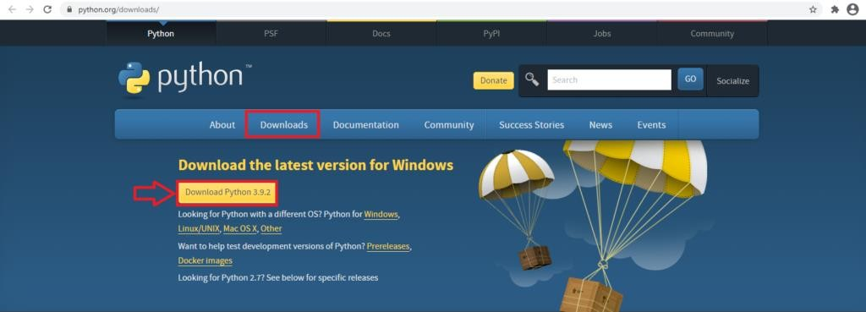

**Note**: If you don't want to download the latest version, you can visit the download tab and see all releases.

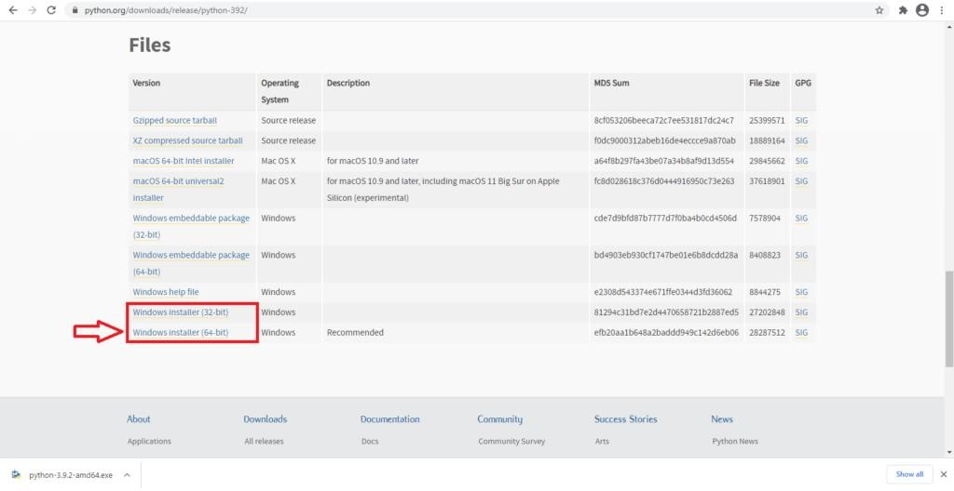

**Step 2)** Click on the Windows installer (64 bit)

**Step 3)** Select Customize Installation

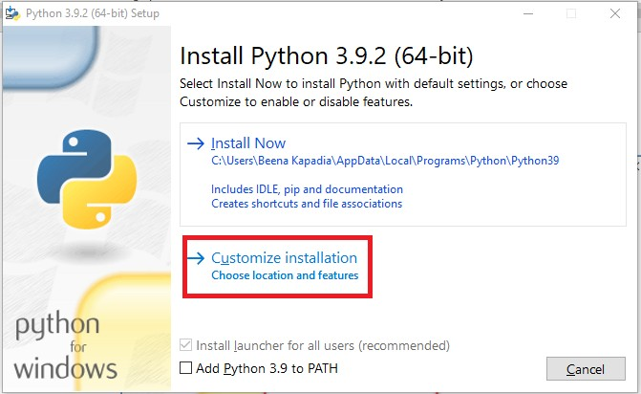

**Step 4)** Click NEXT

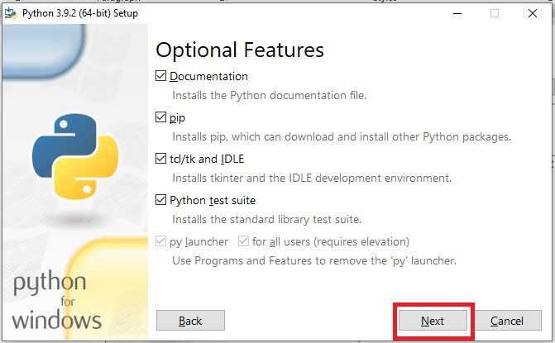

**Step 5)** In next screen

* 1. Select the advanced options
  2. Give a Custom install location. Keep the default folder as c:\Program files\Python39
  3. Click Install

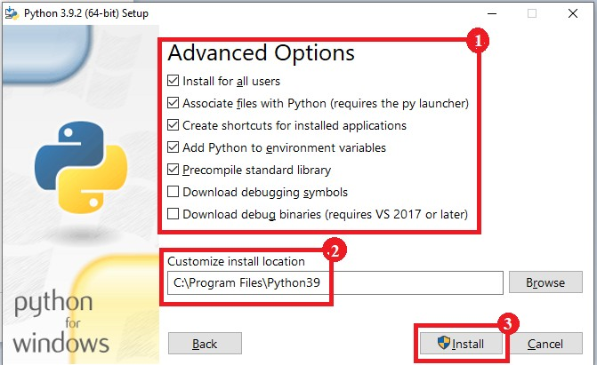

**Step 6)** Click Close button once install is done.

**Step 7) open** command prompt window and run the following commands: C:\Users\Beena Kapadia>pip install --upgrade pip

C:\Users\Beena Kapadia> pip install --user -U nltk C:\Users\Beena Kapadia> >pip install --user -U numpy C:\Users\Beena Kapadia>python

>>> import nltk

>>>

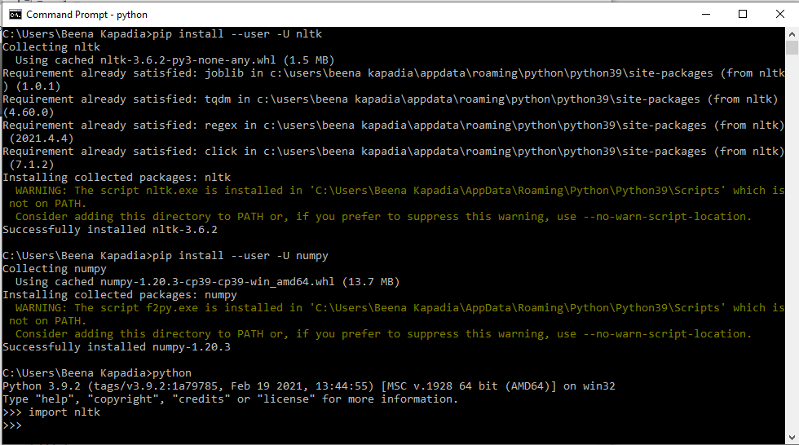

(Browse https:/[/www.nltk.org/install.html](http://www.nltk.org/install.html) for more details)

1. **Convert the given text to speech. Source code:**

# text to speech # pip install gtts

# pip install playsound

from playsound import playsound

# import required for text to speech conversion from gtts import gTTS

mytext = "Welcome to Natural Language programming" language = "en"

myobj = gTTS(text=mytext, lang=language, slow=False) myobj.save("myfile.mp3")

playsound("myfile.mp3")

**Output:**

welcomeNLP.mp3 audio file is getting created and it plays the file with playsound() method, while running the program.

1. **Convert audio file Speech to Text. Source code:**

Note: required to store the input file "male.wav" in the current folder before running the program.

#pip3 install SpeechRecognition pydub

import speech_recognition as sr filename = "male.wav"

# initialize the recognizer r = sr.Recognizer()

# open the file

with sr.AudioFile(filename) as source:

# listen for the data (load audio to memory) audio_data = r.record(source)

# recognize (convert from speech to text) text = r.recognize_google(audio_data) print(text)

Input:

male.wav (any wav file)

**Output:**

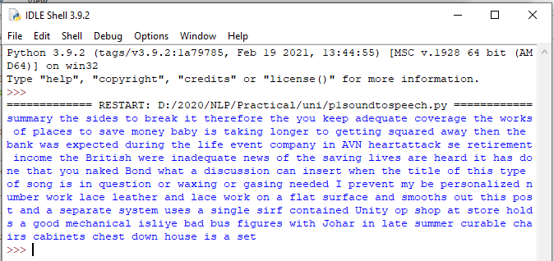

**Practical No. 2**

1. **Study of various Corpus – Brown, Inaugural, Reuters, udhr with various methods like filelds, raw, words, sents, categories.**
2. **Create and use your own corpora (plaintext, categorical)**
3. **Study Conditional frequency distributions**
4. **Study of tagged corpora with methods like tagged_sents, tagged_words.**
5. **Write a program to find the most frequent noun tags.**
6. **Map Words to Properties Using Python Dictionaries**
7. **Study DefaultTagger, Regular expression tagger, UnigramTagger**
8. **Find different words from a given plain text without any space by comparing this text with a given corpus of words. Also find the score of words.**
9. **Study of various Corpus – Brown, Inaugural, Reuters, udhr with various methods like fields, raw, words, sents, categories,**

**source code:**

'''NLTK includes a small selection of texts from the Project brown electronic text archive, which contains some 25,000 free electronic books, hosted at [http://www.brown.org/.](http://www.brown.org/) We begin by getting the Python interpreter to load the NLTK package, then ask to see nltk.corpus.brown.fileids(), the file identifiers in this corpus:'''

import nltk

from nltk.corpus import brown

print ('File ids of brown corpus\n',brown.fileids())

'''Let’s pick out the first of these texts — Emma by Jane Austen — and give it a short name, emma, then find out how many words it contains:'''

ca01 = brown.words('ca01')

# display first few words

print('\nca01 has following words:\n',ca01)

# total number of words in ca01 print('\nca01 has',len(ca01),'words')

#categories or files

print ('\n\nCategories or file in brown corpus:\n') print (brown.categories())

'''display other information about each text, by looping over all the values of fileid corresponding to the brown file identifiers listed earlier and then computing statistics for each text.'''

print ('\n\nStatistics for each text:\n') print

('AvgWordLen\tAvgSentenceLen\tno.ofTimesEachWordAppearsOnAvg\t\tFileName') for fileid in brown.fileids():

num_chars = len(brown.raw(fileid)) num_words = len(brown.words(fileid)) num_sents = len(brown.sents(fileid))

num_vocab = len(set([w.lower() for w in brown.words(fileid)]))

print (int(num_chars/num_words),'\t\t\t', int(num_words/num_sents),'\t\t\t', int(num_words/num_vocab),'\t\t\t', fileid)

**output:**

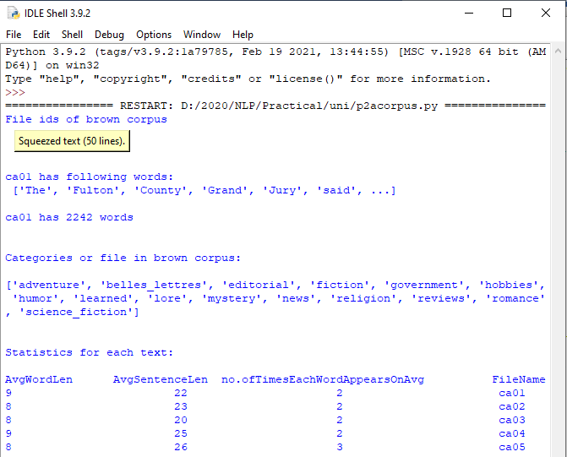

1. **Create and use your own corpora (plaintext, categorical) source code:**

'''NLTK includes a small selection of texts from the Project filelist electronic text archive, which contains some 25,000 free electronic books, hosted at [http://www.filelist.org/.](http://www.filelist.org/) We begin by getting the Python interpreter to load the NLTK package, then ask to see nltk.corpus.filelist.fileids(), the file identifiers in this corpus:'''

import nltk

from nltk.corpus import PlaintextCorpusReader

corpus_root = 'D:/2020/NLP/Practical/uni'

filelist = PlaintextCorpusReader(corpus_root, '.*') print ('\n File list: \n')

print (filelist.fileids()) print (filelist.root)

'''display other information about each text, by looping over all the values of fileid corresponding to the filelist file identifiers listed earlier and then computing statistics for each text.'''

print ('\n\nStatistics for each text:\n') print

('AvgWordLen\tAvgSentenceLen\tno.ofTimesEachWordAppearsOnAvg\tFileName') for fileid in filelist.fileids():

num_chars = len(filelist.raw(fileid)) num_words = len(filelist.words(fileid)) num_sents = len(filelist.sents(fileid))

num_vocab = len(set([w.lower() for w in filelist.words(fileid)]))

print (int(num_chars/num_words),'\t\t\t', int(num_words/num_sents),'\t\t\t', int(num_words/num_vocab),'\t\t', fileid)

**output:**

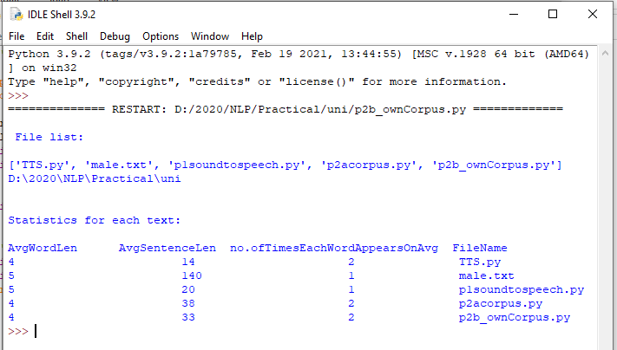

1. **Study Conditional frequency distributions source code:**

#process a sequence of pairs

text = ['The', 'Fulton', 'County', 'Grand', 'Jury', 'said', ...]

pairs = [('news', 'The'), ('news', 'Fulton'), ('news', 'County'), ...] import nltk

from nltk.corpus import brown fd = nltk.ConditionalFreqDist(

(genre, word)

for genre in brown.categories()

for word in brown.words(categories=genre))

genre_word = [(genre, word)

for genre in ['news', 'romance']

for word in brown.words(categories=genre)] print(len(genre_word))

print(genre_word[:4]) print(genre_word[-4:])

cfd = nltk.ConditionalFreqDist(genre_word) print(cfd)

print(cfd.conditions())

print(cfd['news']) print(cfd['romance']) print(list(cfd['romance']))

from nltk.corpus import inaugural cfd = nltk.ConditionalFreqDist(

(target, fileid[:4])

for fileid in inaugural.fileids() for w in inaugural.words(fileid) for target in ['america', 'citizen'] if w.lower().startswith(target))

from nltk.corpus import udhr

languages = ['Chickasaw', 'English', 'German_Deutsch', 'Greenlandic_Inuktikut', 'Hungarian_Magyar', 'Ibibio_Efik']

cfd = nltk.ConditionalFreqDist( (lang, len(word))

for lang in languages

for word in udhr.words(lang + '-Latin1'))

cfd.tabulate(conditions=['English', 'German_Deutsch'], samples=range(10), cumulative=True)

**output:**

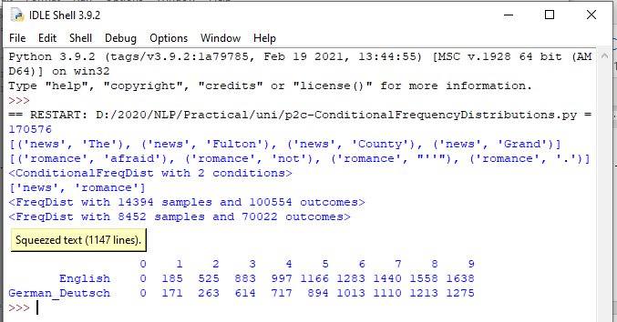

1. **Study of tagged corpora with methods like tagged_sents, tagged_words.**

**Source code**:

import nltk

from nltk import tokenize nltk.download('punkt') nltk.download('words')

para = "Hello! My name is Beena Kapadia. Today you'll be learning NLTK." sents = tokenize.sent_tokenize(para)

print("\nsentence tokenization\n===================\n",sents)

# word tokenization

print("\nword tokenization\n===================\n") for index in range(len(sents)):

words = tokenize.word_tokenize(sents[index]) print(words)

**output:**

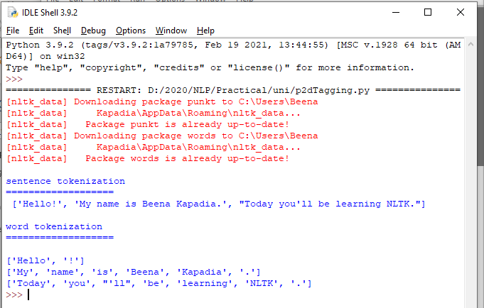

1. **Write a program to find the most frequent noun tags. Code:**

import nltk

from collections import defaultdict

text = nltk.word_tokenize("Nick likes to play football. Nick does not like to play cricket.")

tagged = nltk.pos_tag(text) print(tagged)

# checking if it is a noun or not addNounWords = []

count=0

for words in tagged:

val = tagged[count][1]

if(val == 'NN' or val == 'NNS' or val == 'NNPS' or val == 'NNP'): addNounWords.append(tagged[count][0])

count+=1

print (addNounWords) temp = defaultdict(int)

# memoizing count

for sub in addNounWords: for wrd in sub.split(): temp[wrd] += 1

# getting max frequency

res = max(temp, key=temp.get)

# printing result

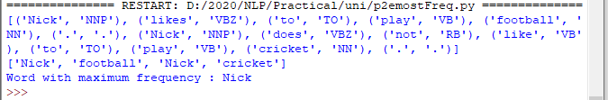print("Word with maximum frequency : " + str(res)) output:

1. **Map Words to Properties Using Python Dictionaries code:**

#creating and printing a dictionay by mapping word with its properties thisdict = {

"brand": "Ford",

"model": "Mustang", "year": 1964

}

print(thisdict) print(thisdict["brand"]) print(len(thisdict)) print(type(thisdict))

**output:**

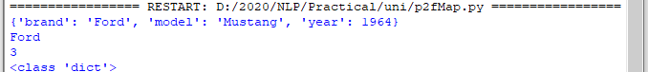

1. **Study i) DefaultTagger, ii) Regular expression tagger, iii) UnigramTagger**
2. **DefaultTagger code:**

import nltk

from nltk.tag import DefaultTagger exptagger = DefaultTagger('NN') from nltk.corpus import treebank

testsentences = treebank.tagged_sents() [1000:] print(exptagger.evaluate (testsentences))

#Tagging a list of sentences import nltk

from nltk.tag import DefaultTagger exptagger = DefaultTagger('NN')

print(exptagger.tag_sents([['Hi', ','], ['How', 'are', 'you', '?']]))

**output**

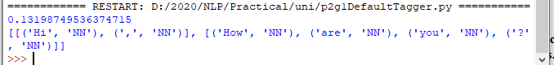

1. **Regular expression tagger, code:**

from nltk.corpus import brown from nltk.tag import RegexpTagger

test_sent = brown.sents(categories='news')[0] regexp_tagger = RegexpTagger(

[(r'^-?[0-9]+(.[0-9]+)?$', 'CD'), # cardinal numbers (r'(The|the|A|a|An|an)$', 'AT'), # articles (r'.*able$', 'JJ'), # adjectives

(r'.*ness$', 'NN'), # nouns formed from adjectives (r'.*ly$', 'RB'), # adverbs

(r'.*s$', 'NNS'), # plural nouns

(r'.*ing$', 'VBG'), # gerunds

(r'.*ed$', 'VBD'), # past tense verbs (r'.*', 'NN') # nouns (default)

])

print(regexp_tagger) print(regexp_tagger.tag(test_sent)) **output:**

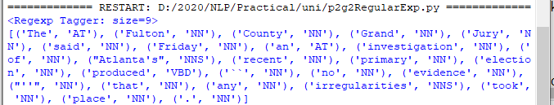

1. **UnigramTagger code:**

# Loading Libraries

from nltk.tag import UnigramTagger from nltk.corpus import treebank

# Training using first 10 tagged sentences of the treebank corpus as data. # Using data

train_sents = treebank.tagged_sents()[:10]

# Initializing

tagger = UnigramTagger(train_sents)

# Lets see the first sentence

# (of the treebank corpus) as list print(treebank.sents()[0]) print('\n',tagger.tag(treebank.sents()[0]))

#Finding the tagged results after training. tagger.tag(treebank.sents()[0])

#Overriding the context model

tagger = UnigramTagger(model ={'Pierre': 'NN'}) print('\n',tagger.tag(treebank.sents()[0]))

**output:**

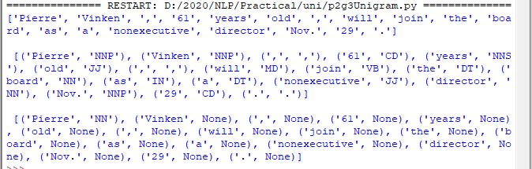

1. **Find different words from a given plain text without any space by comparing this text with a given corpus of words. Also find the score of words.**

**Question:**

Initialize the hash tag test data or URL test data and convert to plain text without any space.. Read a text file of different words and compare the plain text data with the words exist in that text file and find out different words available in that plain text. Also find out how many words could be found. (for example, text = "#whatismyname" or text = [www.whatismyname.com.](http://www.whatismyname.com/) Convert that to plain text without space as: whatismyname and read text file as words.txt. Now compare plain text with words given in a file and find the words form the plain text and the count of words which could be found)

**Source code:**

from future import with_statement #with statement for reading file import re # Regular expression

words = [] # corpus file words testword = [] # test words

ans = [] # words matches with corpus

print("MENU")

print(" ")

print(" 1 . Hash tag segmentation ") print(" 2 . URL segmentation ")

print("enter the input choice for performing word segmentation") choice = int(input())

if choice == 1:

text = "#whatismyname" # hash tag test data to segment print("input with HashTag",text) pattern=re.compile("[^\w']")

a = pattern.sub('', text) elif choice == 2:

text = "[www.whatismyname.com](http://www.whatismyname.com/)" # url test data to segment print("input with URL",text)

a=re.split('\s|(?<!\d)[,.](?!\d)', text)

splitwords = ["www","com","in"] # remove the words which is containg in the list a ="".join([each for each in a if each not in splitwords])

else:

print("wrong choice...try again") print(a)

for each in a:

testword.append(each) #test word

test_lenth = len(testword) # lenth of the test data

# Reading the corpus

with open('words.txt', 'r') as f: lines = f.readlines()

words =[(e.strip()) for e in lines]

def Seg(a,lenth): ans =[]

for k in range(0,lenth+1): # this loop checks char by char in the corpus

if a[0:k] in words:

print(a[0:k],"-appears in the corpus") ans.append(a[0:k])

break if ans != []:

g = max(ans,key=len) return g

test_tot_itr = 0 #each iteration value

answer = [] # Store the each word contains the corpus Score = 0 # initial value for score

N = 37 # total no of corpus M = 0

C = 0

while test_tot_itr < test_lenth: ans_words = Seg(a,test_lenth) if ans_words != 0:

test_itr = len(ans_words) answer.append(ans_words) a = a[test_itr:test_lenth] test_tot_itr += test_itr

Aft_Seg = " ".join([each for each in answer]) # print segmented words in the list print("output")

print(" ")

print(Aft_Seg) # print After segmentation the input

# Calculating Score C = len(answer)

score = C * N / N # Calculate the score print("Score",score)

**Input:**

**Words.txt**

check domain big rocks name cheap being human current rates ought to

go down apple domains honesty hour follow

back social media 30

seconds earth this

is insane it time what is

my name let

us go

**Output:**

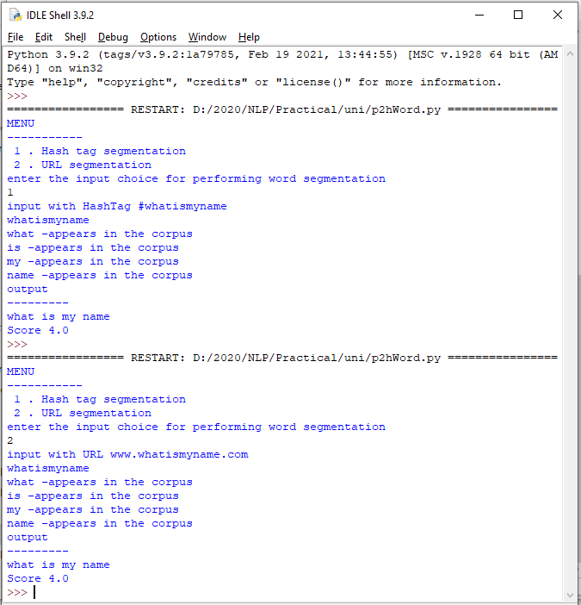

Practical No. 3

a. **Study of Wordnet Dictionary with methods as synsets, definitions, examples, antonyms**

**Source code:**

'''WordNet provides synsets which is the collection of synonym words also called “lemmas”'''

import nltk

from nltk.corpus import wordnet print(wordnet.synsets("computer"))

# definition and example of the word ‘computer’ print(wordnet.synset("computer.n.01").definition())

#examples

print("Examples:", wordnet.synset("computer.n.01").examples())

#get Antonyms print(wordnet.lemma('buy.v.01.buy').antonyms())

**output:**

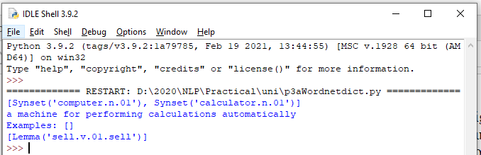

1. **Study lemmas, hyponyms, hypernyms. Source code:**

import nltk

from nltk.corpus import wordnet print(wordnet.synsets("computer")) print(wordnet.synset("computer.n.01").lemma_names()) #all lemmas for each synset.

for e in wordnet.synsets("computer"): print(f'{e} --> {e.lemma_names()}')

#print all lemmas for a given synset print(wordnet.synset('computer.n.01').lemmas())

#get the synset corresponding to lemma print(wordnet.lemma('computer.n.01.computing_device').synset())

#Get the name of the lemma print(wordnet.lemma('computer.n.01.computing_device').name())

#Hyponyms give abstract concepts of the word that are much more specific #the list of hyponyms words of the computer

syn = wordnet.synset('computer.n.01') print(syn.hyponyms)

print([lemma.name() for synset in syn.hyponyms() for lemma in synset.lemmas()]) #the semantic similarity in WordNet

vehicle = wordnet.synset('vehicle.n.01') car = wordnet.synset('car.n.01')

print(car.lowest_common_hypernyms(vehicle))

**Output:**

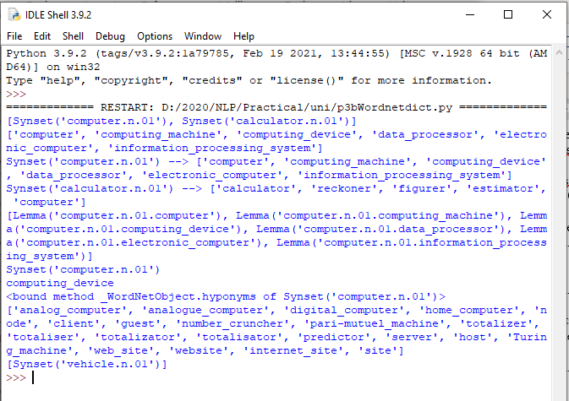

1. **Write a program using python to find synonym and antonym of word "active" using Wordnet.**

**Source code:**

from nltk.corpus import wordnet print( wordnet.synsets("active"))

print(wordnet.lemma('active.a.01.active').antonyms())

**Output:**

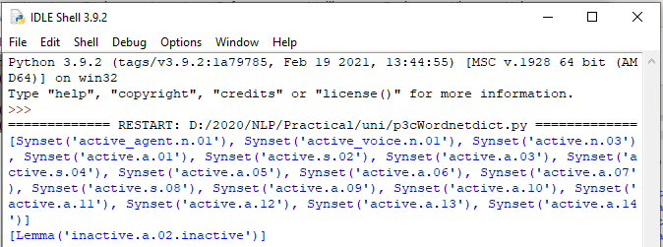

1. **Compare two nouns source code:**

import nltk

from nltk.corpus import wordnet

syn1 = wordnet.synsets('football') syn2 = wordnet.synsets('soccer')

# A word may have multiple synsets, so need to compare each synset of word1 with synset of word2

for s1 in syn1: for s2 in syn2:

print("Path similarity of: ")

print(s1, '(', s1.pos(), ')', '[', s1.definition(), ']')

print(s2, '(', s2.pos(), ')', '[', s2.definition(), ']') print(" is", s1.path_similarity(s2))

print()

**output:**

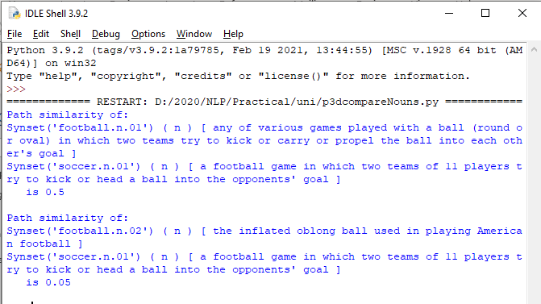

1. **Handling stopword:**
   1. **Using nltk Adding or Removing Stop Words in NLTK's Default Stop Word List**

**code:**

import nltk

from nltk.corpus import stopwords nltk.download('stopwords')

from nltk.tokenize import word_tokenize

text = "Yashesh likes to play football, however he is not too fond of tennis." text_tokens = word_tokenize(text)

tokens_without_sw = [word for word in text_tokens if not word in stopwords.words()]

print(tokens_without_sw)

#add the word play to the NLTK stop word collection all_stopwords = stopwords.words('english') all_stopwords.append('play')

text_tokens = word_tokenize(text)

tokens_without_sw = [word for word in text_tokens if not word in all_stopwords] print(tokens_without_sw)

#remove ‘not’ from stop word collection all_stopwords.remove('not')

text_tokens = word_tokenize(text)

tokens_without_sw = [word for word in text_tokens if not word in all_stopwords] print(tokens_without_sw)

**output**

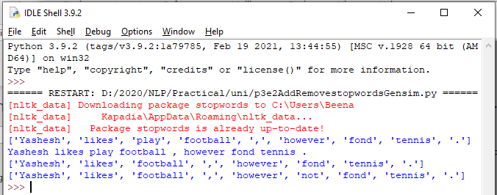

* 1. **Using Gensim Adding and Removing Stop Words in Default Gensim Stop Words List**

**code:**

#pip install gensim import gensim

from gensim.parsing.preprocessing import remove_stopwords

text = "Yashesh likes to play football, however he is not too fond of tennis." filtered_sentence = remove_stopwords(text)

print(filtered_sentence)

all_stopwords = gensim.parsing.preprocessing.STOPWORDS print(all_stopwords)

'''The following script adds likes and play to the list of stop words in Gensim:''' from gensim.parsing.preprocessing import STOPWORDS all_stopwords_gensim = STOPWORDS.union(set(['likes', 'play']))

text = "Yashesh likes to play football, however he is not too fond of tennis." text_tokens = word_tokenize(text)

tokens_without_sw = [word for word in text_tokens if not word in all_stopwords_gensim]

print(tokens_without_sw) '''Output:

['Yashesh', 'football', ',', 'fond', 'tennis', '.']

The following script removes the word "not" from the set of stop words in Gensim:'''

from gensim.parsing.preprocessing import STOPWORDS all_stopwords_gensim = STOPWORDS

sw_list = {"not"}

all_stopwords_gensim = STOPWORDS.difference(sw_list)

text = "Yashesh likes to play football, however he is not too fond of tennis." text_tokens = word_tokenize(text)

tokens_without_sw = [word for word in text_tokens if not word in all_stopwords_gensim]

print(tokens_without_sw)

**output**

Microsoft Visual C++ 14.0 is required. Get it with "Build Tools for Visual Studio": <https://visualstudio.microsoft.com/downloads/>

* 1. **Using Spacy Adding and Removing Stop Words in Default Spacy Stop Words List**

**code:**

#pip install spacy

#python -m spacy download en_core_web_sm #python -m spacy download en

import spacy import nltk

from nltk.tokenize import word_tokenize sp = spacy.load('en_core_web_sm')

#add the word play to the NLTK stop word collection all_stopwords = sp.Defaults.stop_words all_stopwords.add("play")

text = "Yashesh likes to play football, however he is not too fond of tennis." text_tokens = word_tokenize(text)

tokens_without_sw = [word for word in text_tokens if not word in all_stopwords] print(tokens_without_sw)

#remove 'not' from stop word collection all_stopwords.remove('not')

tokens_without_sw = [word for word in text_tokens if not word in all_stopwords] print(tokens_without_sw)

**output:**

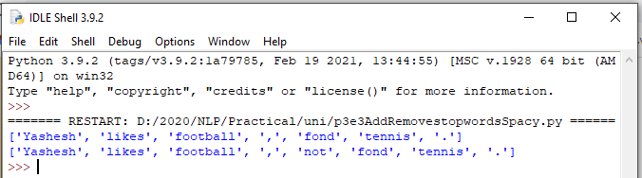

**Practical No. 4**

**Text Tokenization**

* 1. **Tokenization using Python’s split() function code:**

text = """ This tool is an a beta stage. Alexa developers can use Get Metrics API to seamlessly analyse metric. It also supports custom skill model, prebuilt Flash Briefing model, and the Smart Home Skill API. You can use this tool for creation of monitors, alarms, and dashboards that spotlight changes. The release of these three tools will enable developers to create visual rich skills for Alexa devices with screens. Amazon describes these tools as the collection of tech and tools for creating visually rich and interactive voice experiences. """

data = text.split('.') for i in data:

print (i)

**output:**

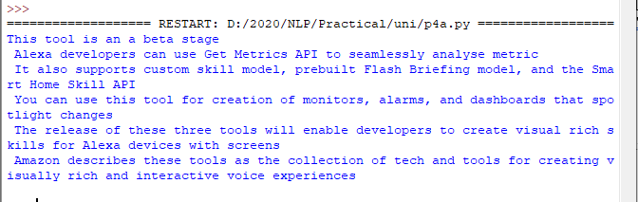

* 1. **Tokenization using Regular Expressions (RegEx) code:**

import nltk

# import RegexpTokenizer() method from nltk from nltk.tokenize import RegexpTokenizer

# Create a reference variable for Class RegexpTokenizer tk = RegexpTokenizer('\s+', gaps = True)

# Create a string input

str = "I love to study Natural Language Processing in Python"

# Use tokenize method tokens = tk.tokenize(str)

print(tokens)

**output:**

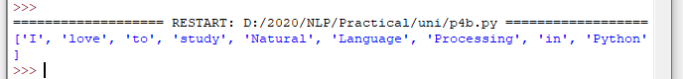

* 1. **Tokenization using NLTK**

**code:**

import nltk

from nltk.tokenize import word_tokenize

# Create a string input

str = "I love to study Natural Language Processing in Python"

# Use tokenize method print(word_tokenize(str))

**output:**



* 1. **Tokenization using the spaCy library code:**

import spacy

nlp = spacy.blank("en")

# Create a string input

str = "I love to study Natural Language Processing in Python"

# Create an instance of document;

# doc object is a container for a sequence of Token objects. doc = nlp(str)

# Read the words; Print the words #

words = [word.text for word in doc] print(words)

**output:**

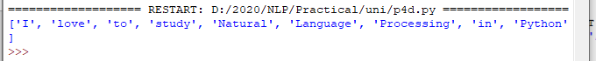

* 1. **Tokenization using Keras code:**

#pip install keras

#pip install tensorflow import keras

from keras.preprocessing.text import text_to_word_sequence # Create a string input

str = "I love to study Natural Language Processing in Python"

# tokenizing the text

tokens = text_to_word_sequence(str) print(tokens)

**output:**



* 1. **Tokenization using Gensim code:**

#pip install gensim

from gensim.utils import tokenize # Create a string input

str = "I love to study Natural Language Processing in Python"

# tokenizing the text list(tokenize(str))

**output:**

Microsoft Visual C++ 14.0 is required. Get it with "Build Tools for Visual Studio": <https://visualstudio.microsoft.com/downloads/>

**Practical No. 5**

**Import NLP Libraries for Indian Languages and perform:**

Note: Execute this practical in https://colab.research.google.com/

1. **word tokenization in Hindi Source code:**

!pip install torch==1.3.1+cpu -f <https://download.pytorch.org/whl/torch_stable.html>

!pip install inltk

!pip install tornado==4.5.3

from inltk.inltk import setup setup('hi')

from inltk.inltk import tokenize

hindi_text = """प्राकृ तिक भाषा सीखना बहुि तिलचस्प है।"""

# tokenize(input text, language code) tokenize(hindi_text, "hi")

**output**

['▁प्राकृ तिक', '▁भाषा', '▁सीखना', '▁बहुि', '▁तिलचस्प', '▁है', '।']

1. **Generate similar sentences from a given Hindi text input Source code:**

!pip install torch==1.3.1+cpu -f <https://download.pytorch.org/whl/torch_stable.html>

!pip install inltk

!pip install tornado==4.5.3

from inltk.inltk import setup setup('hi')

from inltk.inltk import get_similar_sentences

# get similar sentences to the one given in hindi

output = get_similar_sentences('मैं आज बहुि खुश हूं', 5, 'hi') print(output)

**Output:**

['मैं आजकल बहुि खुश हूं', 'मैं आज अत्यतिक खुश हूं', 'मैं अभी बहुि खुश हूं', 'मैं वितमान बहुि खुश हूं', 'मैं वितमान बहुि खुश हूं']

1. **Identify the Indian language of a text Source code:**

!pip install torch==1.3.1+cpu -f <https://download.pytorch.org/whl/torch_stable.html>

!pip install inltk

!pip install tornado==4.5.3

from inltk.inltk import setup setup('gu')

from inltk.inltk import identify_language #Identify the Lnaguage of given text identify_language('બીના કાપડિયા')

**Output:**

gujarati

**Practical No. 6**

**Illustrate part of speech tagging.**

* 1. **Part of speech Tagging and chunking of user defined text.**
  2. **Named Entity recognition of user defined text.**
  3. **Named Entity recognition with diagram using NLTK corpus – treebank**

**POS Tagging, chunking and NER:**

1. **sentence tokenization, word tokenization, Part of speech Tagging and chunking of user defined text.**

**Source code:**

import nltk

from nltk import tokenize nltk.download('punkt') from nltk import tag from nltk import chunk

nltk.download('averaged_perceptron_tagger') nltk.download('maxent_ne_chunker') nltk.download('words')

para = "Hello! My name is Beena Kapadia. Today you'll be learning NLTK." sents = tokenize.sent_tokenize(para)

print("\nsentence tokenization\n===================\n",sents)

# word tokenization

print("\nword tokenization\n===================\n") for index in range(len(sents)):

words = tokenize.word_tokenize(sents[index]) print(words)

# POS Tagging tagged_words = []

for index in range(len(sents)): tagged_words.append(tag.pos_tag(words))

print("\nPOS Tagging\n===========\n",tagged_words)

# chunking tree = []

for index in range(len(sents)): tree.append(chunk.ne_chunk(tagged_words[index])) print("\nchunking\n========\n")

print(tree)

**Output:**

sentence tokenization

===================

['Hello!', 'My name is Beena Kapadia.', "Today you'll be learning NLTK."]

word tokenization

===================

['Hello', '!']

['My', 'name', 'is', 'Beena', 'Kapadia', '.']

['Today', 'you', "'ll", 'be', 'learning', 'NLTK', '.']

POS Tagging

===========

[[('Today', 'NN'), ('you', 'PRP'), ("'ll", 'MD'), ('be', 'VB'), ('learning', 'VBG'), ('NLTK',

'NNP'), ('.', '.')], [('Today', 'NN'), ('you', 'PRP'), ("'ll", 'MD'), ('be', 'VB'), ('learning',

'VBG'), ('NLTK', 'NNP'), ('.', '.')], [('Today', 'NN'), ('you', 'PRP'), ("'ll", 'MD'), ('be', 'VB'), ('learning', 'VBG'), ('NLTK', 'NNP'), ('.', '.')]]

chunking

========

[Tree('S', [('Today', 'NN'), ('you', 'PRP'), ("'ll", 'MD'), ('be', 'VB'), ('learning', 'VBG'),

Tree('ORGANIZATION', [('NLTK', 'NNP')]), ('.', '.')]), Tree('S', [('Today', 'NN'), ('you',

'PRP'), ("'ll", 'MD'), ('be', 'VB'), ('learning', 'VBG'), Tree('ORGANIZATION', [('NLTK', 'NNP')]), ('.', '.')]), Tree('S', [('Today', 'NN'), ('you', 'PRP'), ("'ll", 'MD'), ('be', 'VB'), ('learning', 'VBG'), Tree('ORGANIZATION', [('NLTK', 'NNP')]), ('.', '.')])]

1. **Named Entity recognition using user defined text. Source code:**

!pip install -U spacy

!python -m spacy download en_core_web_sm import spacy

# Load English tokenizer, tagger, parser and NER nlp = spacy.load("en_core_web_sm")

# Process whole documents

text = ("When Sebastian Thrun started working on self-driving cars at " "Google in 2007, few people outside of the company took him " "seriously. “I can tell you very senior CEOs of major American "

"car companies would shake my hand and turn away because I wasn’t " "worth talking to,” said Thrun, in an interview with Recode earlier " "this week.")

doc = nlp(text)

# Analyse syntax

print("Noun phrases:", [chunk.text for chunk in doc.noun_chunks]) print("Verbs:", [token.lemma_ for token in doc if token.pos_ == "VERB"])

**Output:**

Noun phrases: ['Sebastian Thrun', 'self-driving cars', 'Google', 'few people', 'the company', 'him', 'I', 'you', 'very senior CEOs', 'major American car companies', 'my hand', 'I', 'Thrun', 'an interview', 'Recode']

Verbs: ['start', 'work', 'drive', 'take', 'tell', 'shake', 'turn', 'be', 'talk', 'say']

1. **Named Entity recognition with diagram using NLTK corpus – treebank. Source code:**

Note: It runs on Python IDLE

import nltk nltk.download('treebank')

from nltk.corpus import treebank_chunk treebank_chunk.tagged_sents()[0]

treebank_chunk.chunked_sents()[0] treebank_chunk.chunked_sents()[0].draw()

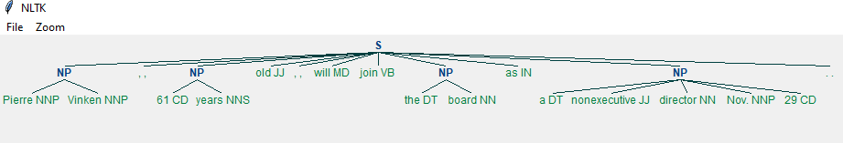**Output:**

**Practical No. 7**

**Finite state automata**

1. **Define grammar using nltk. Analyze a sentence using the same. Code:**

import nltk

from nltk import tokenize

grammar1 = nltk.CFG.fromstring(""" S -> VP

VP -> VP NP NP -> Det NP

Det -> 'that'

NP -> singular Noun NP -> 'flight'

VP -> 'Book' """)

sentence = "Book that flight"

for index in range(len(sentence)):

all_tokens = tokenize.word_tokenize(sentence) print(all_tokens)

parser = nltk.ChartParser(grammar1) for tree in parser.parse(all_tokens):

print(tree) tree.draw()

output:

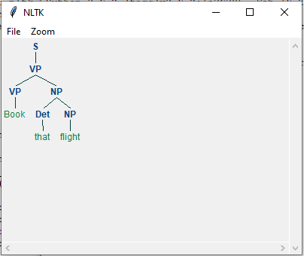

1. **Accept the input string with Regular expression of Finite Automaton: 101+. Source code:**

def FA(s):

#if the length is less than 3 then it can't be accepted, Therefore end the process. if len(s)<3:

return "Rejected"

#first three characters are fixed. Therefore, checking them using index if s[0]=='1':

if s[1]=='0':

if s[2]=='1':

# After index 2 only "1" can appear. Therefore break the process if any other character is detected

for i in range(3,len(s)): if s[i]!='1':

return "Rejected"

return "Accepted" # if all 4 nested if true return "Rejected" # else of 3rd if

return "Rejected" # else of 2nd if return "Rejected" # else of 1st if

inputs=['1','10101','101','10111','01010','100','','10111101','1011111']

for i in inputs: print(FA(i))

**Output:**

Rejected Rejected Accepted Accepted Rejected Rejected Rejected Rejected Accepted

1. **Accept the input string with Regular expression of FA: (a+b)*bba. Code:**

def FA(s): size=0

#scan complete string and make sure that it contains only 'a' & 'b' for i in s:

if i=='a' or i=='b': size+=1

else:

return "Rejected"

#After checking that it contains only 'a' & 'b' #check it's length it should be 3 atleast

if size>=3:

#check the last 3 elements if s[size-3]=='b':

if s[size-2]=='b':

if s[size-1]=='a':

return "Accepted" # if all 4 if true return "Rejected" # else of 4th if

return "Rejected" # else of 3rd if return "Rejected" # else of 2nd if

return "Rejected" # else of 1st if

inputs=['bba', 'ababbba', 'abba','abb', 'baba','bbb',''] for i in inputs:

print(FA(i))

**output:**

Rejected Rejected Accepted Accepted Rejected Rejected Rejected Rejected Accepted

1. **Implementation of Deductive Chart Parsing using context free grammar and a given sentence.**

**Source code:**

import nltk

from nltk import tokenize

grammar1 = nltk.CFG.fromstring(""" S -> NP VP

PP -> P NP

NP -> Det N | Det N PP | 'I' VP -> V NP | VP PP

Det -> 'a' | 'my'

N -> 'bird' | 'balcony' V -> 'saw'

P -> 'in'

""")

sentence = "I saw a bird in my balcony"

for index in range(len(sentence)):

all_tokens = tokenize.word_tokenize(sentence) print(all_tokens)

# all_tokens = ['I', 'saw', 'a', 'bird', 'in', 'my', 'balcony'] parser = nltk.ChartParser(grammar1)

for tree in parser.parse(all_tokens): print(tree)

tree.draw()

**output:**

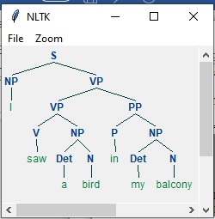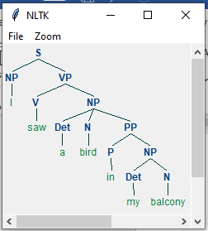

**Practical No. 8**

**Study PorterStemmer, LancasterStemmer, RegexpStemmer, SnowballStemmer Study WordNetLemmatizer**

**Code:**

# **PorterStemmer**

import nltk

from nltk.stem import PorterStemmer word_stemmer = PorterStemmer() print(word_stemmer.stem('writing')) **Output:**



**#LancasterStemmer**

import nltk

from nltk.stem import LancasterStemmer Lanc_stemmer = LancasterStemmer() print(Lanc_stemmer.stem('writing')) **Output:**



**#RegexpStemmer**

import nltk

from nltk.stem import RegexpStemmer

Reg_stemmer = RegexpStemmer('ing$|s$|e$|able$', min=4) print(Reg_stemmer.stem('writing'))

**output**



**#SnowballStemmer**

import nltk

from nltk.stem import SnowballStemmer english_stemmer = SnowballStemmer('english') print(english_stemmer.stem ('writing'))

**output**



**#WordNetLemmatizer**

from nltk.stem import WordNetLemmatizer lemmatizer = WordNetLemmatizer()

print("word :\tlemma")

print("rocks :", lemmatizer.lemmatize("rocks")) print("corpora :", lemmatizer.lemmatize("corpora"))

# a denotes adjective in "pos"

print("better :", lemmatizer.lemmatize("better", pos ="a"))

**Output:**

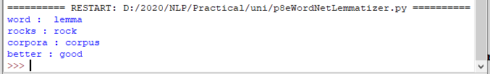

Practical No. 9

Implement Naive Bayes classifier

**Code:**

#pip install pandas #pip install

sklearn

import pandas as pd import numpy as np

sms_data = pd.read_csv("spam.csv", encoding='latin-1') import re

import nltk

from nltk.corpus import stopwords

from nltk.stem.porter import PorterStemmer

stemming = PorterStemmer() corpus = []

for i in range (0,len(sms_data)):

s1 = re.sub('[^a-zA-Z]',repl = ' ',string = sms_data['v2'][i]) s1.lower()

s1 = s1.split()

s1 = [stemming.stem(word) for word in s1 if word not in set(stopwords.words('english'))]

s1 = ' '.join(s1) corpus.append(s1)

from sklearn.feature_extraction.text import CountVectorizer countvectorizer =CountVectorizer()

x = countvectorizer.fit_transform(corpus).toarray() print(x)

y = sms_data['v1'].values print(y)

from sklearn.model_selection import train_test_split x_train,x_test,y_train,y_test = train_test_split(x,y,test_size = 0.3, stratify=y,random_state=2)

#Multinomial Naïve Bayes.

from sklearn.naive_bayes import MultinomialNB multinomialnb = MultinomialNB() multinomialnb.fit(x_train,y_train)

# Predicting on test data:

y_pred = multinomialnb.predict(x_test) print(y_pred)

#Results of our Models

from sklearn.metrics import classification_report, confusion_matrix from sklearn.metrics import accuracy_score

print(classification_report(y_test,y_pred)) print("accuracy_score: ",accuracy_score(y_test,y_pred))

**input:**

spam.csv file from github

**output:**

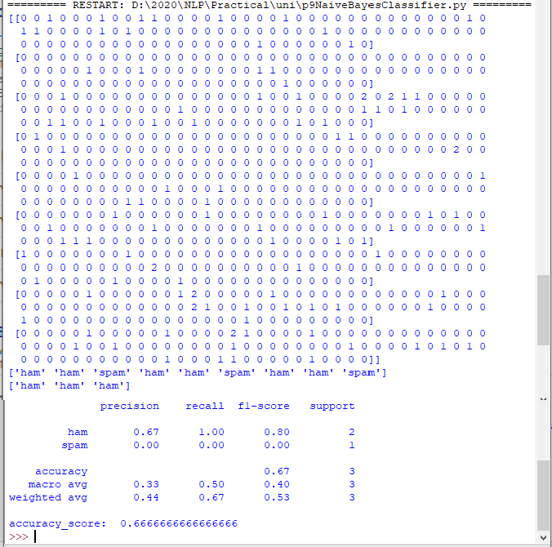

**Practical No. 10**

**a. Speech Tagging:**

1. **Speech tagging using spacy**

**code**

import spacy

sp = spacy.load('en_core_web_sm')

sen = sp(u"I like to play football. I hated it in my childhood though") print(sen.text)

print(sen[7].pos_) print(sen[7].tag_) print(spacy.explain(sen[7].tag_)) for word in sen:

print(f'{word.text:{12}} {word.pos_:{10}} {word.tag_:{8}}

{spacy.explain(word.tag_)}')

sen = sp(u'Can you google it?') word = sen[2]

print(f'{word.text:{12}} {word.pos_:{10}} {word.tag_:{8}}

{spacy.explain(word.tag_)}')

sen = sp(u'Can you search it on google?') word = sen[5]

print(f'{word.text:{12}} {word.pos_:{10}} {word.tag_:{8}}

{spacy.explain(word.tag_)}')

#Finding the Number of POS Tags

sen = sp(u"I like to play football. I hated it in my childhood though")

num_pos = sen.count_by(spacy.attrs.POS) num_pos

for k,v in sorted(num_pos.items()): print(f'{k}. {sen.vocab[k].text:{8}}: {v}')

#Visualizing Parts of Speech Tags from spacy import displacy

sen = sp(u"I like to play football. I hated it in my childhood though") displacy.serve(sen, style='dep', options={'distance': 120})

**output**:

To view the dependency tree, type the following address in your browser: http://127.0.0.1:5000/. You will see the following dependency tree:

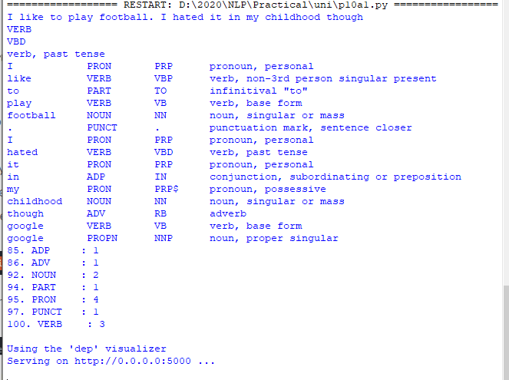

1. **Speech tagging using nktl code:**

import nltk

from nltk.corpus import state_union

from nltk.tokenize import PunktSentenceTokenizer

#create our training and testing data:

train_text = state_union.raw("2005-GWBush.txt") sample_text = state_union.raw("2006-GWBush.txt")

#train the Punkt tokenizer like:

custom_sent_tokenizer = PunktSentenceTokenizer(train_text)

# tokenize:

tokenized = custom_sent_tokenizer.tokenize(sample_text)

def process_content(): try:

for i in tokenized[:2]:

words = nltk.word_tokenize(i) tagged = nltk.pos_tag(words)

print(tagged)

except Exception as e: print(str(e))

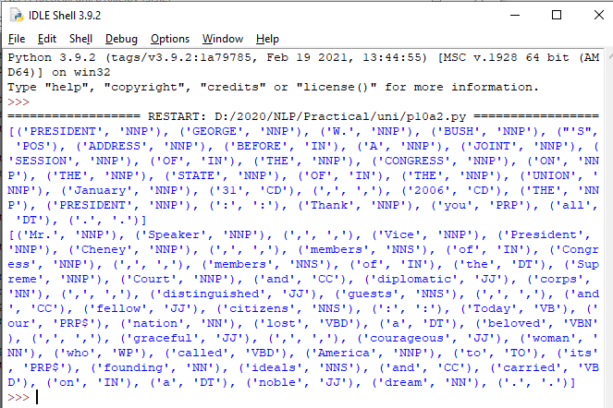process_content() output:

**b. Statistical parsing:**

1. **Usage of Give and Gave in the Penn Treebank sample Source code:**

#probabilitistic parser

#Usage of Give and Gave in the Penn Treebank sample

import nltk

import nltk.parse.viterbi import nltk.parse.pchart

def give(t):

return t.label() == 'VP' and len(t) > 2 and t[1].label() == 'NP'\ and (t[2].label() == 'PP-DTV' or t[2].label() == 'NP')\

and ('give' in t[0].leaves() or 'gave' in t[0].leaves())

def sent(t):

return ' '.join(token for token in t.leaves() if token[0] not in '*-0')

def print_node(t, width):

output = "%s %s: %s / %s: %s" %\

(sent(t[0]), t[1].label(), sent(t[1]), t[2].label(), sent(t[2])) if len(output) > width:

output = output[:width] + "..." print (output)

for tree in nltk.corpus.treebank.parsed_sents(): for t in tree.subtrees(give):

print_node(t, 72)

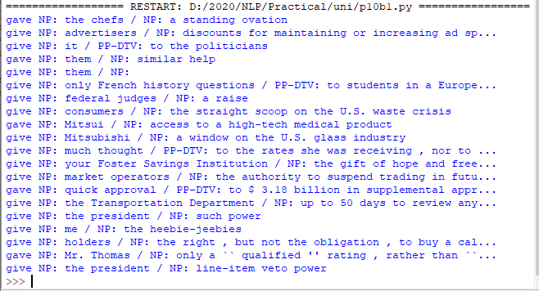**Output:**

**ii. probabilistic parser**

**Source code:**

import nltk

from nltk import PCFG

grammar = PCFG.fromstring('''

NP -> NNS [0.5] | JJ NNS [0.3] | NP CC NP [0.2]

NNS -> "men" [0.1] | "women" [0.2] | "children" [0.3] | NNS CC NNS [0.4] JJ -> "old" [0.4] | "young" [0.6]

CC -> "and" [0.9] | "or" [0.1] ''')

print(grammar)

viterbi_parser = nltk.ViterbiParser(grammar) token = "old men and women".split()

obj = viterbi_parser.parse(token)

print("Output: ") for x in obj:

print(x)

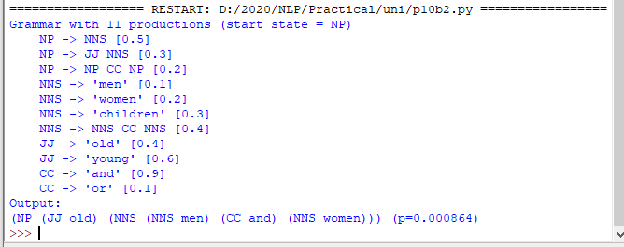**Output:**

**c. Malt parsing:**

**Parse a sentence and draw a tree using malt parsing.**

Note: 1) Java should be installed.

1. maltparser-1.7.2 zip file should be copied in C:\Users\Beena Kapadia\AppData\Local\Programs\Python\Python39 folder and should be extracted in the same folder.
2. engmalt.linear-1.7.mco file should be copied to C:\Users\Beena Kapadia\AppData\Local\Programs\Python\Python39 folder **Source code:**

# copy maltparser-1.7.2(unzipped version) and engmalt.linear-1.7.mco files to C:\Users\Beena Kapadia\AppData\Local\Programs\Python\Python39 folder

# java should be installed

# environment variables should be set - MALT_PARSER - C:\Users\Beena Kapadia\AppData\Local\Programs\Python\Python39\maltparser-1.7.2 and MALT_MODEL - C:\Users\Beena Kapadia\AppData\Local\Programs\Python\Python39\engmalt.linear-1.7.mco

from nltk.parse import malt

mp = malt.MaltParser('maltparser-1.7.2', 'engmalt.linear-1.7.mco')#file t = mp.parse_one('I saw a bird from my window.'.split()).tree()

print(t) t.draw()

**Output:**

(saw I (bird a (from (window. my))))

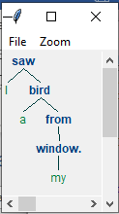

Practical No. 11

**a) Multiword Expressions in NLP Source code:**

# Multiword Expressions in NLP

from nltk.tokenize import MWETokenizer from nltk import sent_tokenize, word_tokenize

s = '''Good cake cost Rs.1500\kg in Mumbai. Please buy me one of them.\n\nThanks.''' mwe = MWETokenizer([('New', 'York'), ('Hong', 'Kong')], separator='_')

for sent in sent_tokenize(s): print(mwe.tokenize(word_tokenize(sent)))

**Output:**

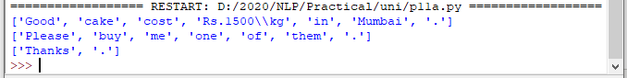

1. **Normalized Web Distance and Word Similarity Source code:**

# Normalized Web Distance and Word Similarity #convert

#Reliance supermarket #Reliance hypermarket #Reliance

#Reliance

#Reliance downtown #Relianc market #Mumbai

#Mumbai Hyper #Mumbai dxb #mumbai airport #k.m trading #KM Trading #KM trade #K.M. Trading #KM.Trading

#into

#Reliance #Reliance #Reliance #Reliance #Reliance #Reliance #Mumbai #Mumbai #Mumbai #Mumbai

#KM Trading #KM Trading #KM Trading #KM Trading #KM Trading

import numpy as np import re

import textdistance # pip install textdistance # we will need scikit-learn>=0.21

import sklearn #pip install sklearn

from sklearn.cluster import AgglomerativeClustering

texts = [

'Reliance supermarket', 'Reliance hypermarket', 'Reliance', 'Reliance', 'Reliance downtown', 'Relianc market',

'Mumbai', 'Mumbai Hyper', 'Mumbai dxb', 'mumbai airport',

'k.m trading', 'KM Trading', 'KM trade', 'K.M. Trading', 'KM.Trading'

]

def normalize(text):

""" Keep only lower-cased text and numbers""" return re.sub('[^a-z0-9]+', ' ', text.lower())

def group_texts(texts, threshold=0.4):

""" Replace each text with the representative of its cluster""" normalized_texts = np.array([normalize(text) for text in texts]) distances = 1 - np.array([

[textdistance.jaro_winkler(one, another) for one in normalized_texts] for another in normalized_texts

])

clustering = AgglomerativeClustering(

distance_threshold=threshold, # this parameter needs to be tuned carefully affinity="precomputed", linkage="complete", n_clusters=None

).fit(distances) centers = dict()

for cluster_id in set(clustering.labels_):

index = clustering.labels_ == cluster_id

centrality = distances[:, index][index].sum(axis=1) centers[cluster_id] = normalized_texts[index][centrality.argmin()] return [centers[i] for i in clustering.labels_]

print(group_texts(texts))

**Output:**

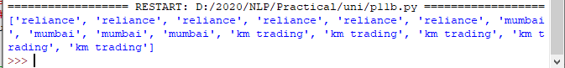

1. **Word Sense Disambiguation Source code:**

#Word Sense Disambiguation

from nltk.corpus import wordnet as wn

def get_first_sense(word, pos=None): if pos:

synsets = wn.synsets(word,pos) else:

synsets = wn.synsets(word) return synsets[0]

best_synset = get_first_sense('bank')

print ('%s: %s' % (best_synset.name, best_synset.definition)) best_synset = get_first_sense('set','n')

print ('%s: %s' % (best_synset.name, best_synset.definition)) best_synset = get_first_sense('set','v')

print ('%s: %s' % (best_synset.name, best_synset.definition))

**Output:**

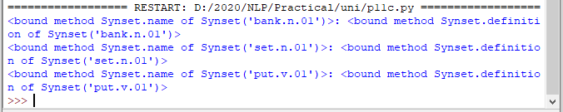

Deep Learning

**Index**

|  |  |  |  |
| --- | --- | --- | --- |
| Sr. No | Title | Date | Sign |
| 1. | Performing matrix multiplication and finding eigen vectors and eigen values using TensorFlow. |  |  |
| 2. | Solving XOR problem using deep feed forward network. |  |  |
| 3. | Implementing deep neural network for performing binary classification task |  |  |
| 4. | a) Aim: Using deep feed forward network with two hidden layers for performing multiclass classification and predicting the class.  b) Aim: Using a deep feed forward network with two hidden layers for performing classification and predicting the probability of class.  c) Aim: Using a deep feed forward network with two hidden layers for performing linear regression and predicting values. |  |  |
| 5. | Evaluating feed forward deep network for regression using KFold cross validation. |  |  |
| 6. | Implementing regularization to avoid overfitting in binary classification. |  |  |
| 7. | Demonstrate recurrent neural network that learns to perform sequence analysis. |  |  |
| 8. | Performing encoding & decoding of images autoencoder. |  |  |
| 9. | Implementation of convolutional neural network to predict numbers from number images |  |  |
| 10. | Denoising of images using autoencoder. |  |  |

**Practical No: 1**

**Aim:** Performing matrix multiplication and finding eigen vectors and eigen values using TensorFlow.

**Code:**

import tensorflow as tf

print("Matrix Multiplication Demo")

x=tf.constant([1,2,3,4,5,6],shape=[2,3])

print(x)

y=tf.constant([7,8,9,10,11,12],shape=[3,2])

print(y)

z=tf.matmul(x,y)

print("Product:",z)

e_matrix_A=tf.random.uniform([2,2],minval=3,maxval=10,dtype=tf.float32,name="matrixA")

print("Matrix A:\n{}\n\n".format(e_matrix_A))

eigen_values_A,eigen_vectors_A=tf.linalg.eigh(e_matrix_A)

print("Eigen Vectors:\n{}\n\nEigen Values:\n{}\n".format(eigen_vectors_A,eigen_values_A))

**Output:**

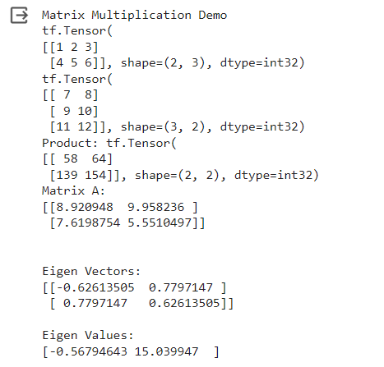

**Practical No: 2**

**Aim:** Solving XOR problem using deep feed forward network.

**Code:**

import numpy as np

def unitStep(v):

if v >= 0:

return 1

else:

return 0

def perceptronModel(x, w, b):

v = np.dot(w, x) + b

y = unitStep(v)

return y

def NOT_logicFunction(x):

wNOT = -1

bNOT = 0.5

return perceptronModel(x, wNOT, bNOT)

def AND_logicFunction(x):

w = np.array([1, 1])

bAND = -1.5

return perceptronModel(x, w, bAND)

def OR_logicFunction(x):

w = np.array([1, 1])

bOR = -0.5

return perceptronModel(x, w, bOR)

def XOR_logicFunction(x):

y1 = AND_logicFunction(x)

y2 = OR_logicFunction(x)

y3 = NOT_logicFunction(y1)

final_x = np.array([y2, y3])

finalOutput = AND_logicFunction(final_x)

y3 = NOT_logicFunction(y1)

return finalOutput

test1 = np.array([0, 1])

test2 = np.array([1, 1])

test3 = np.array([0, 0])

test4 = np.array([1, 0])

print("XOR({}, {}) = {}".format(0, 1, XOR_logicFunction(test1)))

print("XOR({}, {}) = {}".format(1, 1, XOR_logicFunction(test2)))

print("XOR({}, {}) = {}".format(0, 0, XOR_logicFunction(test3)))

print("XOR({}, {}) = {}".format(1, 0, XOR_logicFunction(test4)))

**Output:**

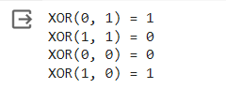

**Practical No: 3**

**Aim:** Implementing deep neural network for performing binary classification task.

**Code:**

import pandas as pd

from keras.models import Sequential

from keras.layers import Dense

from scikeras.wrappers import KerasClassifier

from sklearn.model_selection import cross_val_score

from sklearn.preprocessing import LabelEncoder

from sklearn.model_selection import StratifiedKFold

from sklearn.preprocessing import StandardScaler

from sklearn.pipeline import Pipeline

# load dataset

dataframe = pd.read_csv("//content//sonar.all-data", header=None)

dataset = dataframe.values

# split into input (X) and output (Y) variables

X = dataset[:,0:60].astype(float)

Y = dataset[:,60]

# encode class values as integers

encoder = LabelEncoder()

encoder.fit(Y)

encoded_Y = encoder.transform(Y)

# baseline model

def create_baseline():

# create model

model = Sequential()

model.add(Dense(60, input_dim=60, activation='relu'))

model.add(Dense(1, activation='sigmoid'))

# Compile model

model.compile(loss='binary_crossentropy', optimizer='adam', metrics=['accuracy'])

return model

# evaluate model with standardized dataset

estimator = KerasClassifier(build_fn=create_baseline, epochs=100, batch_size=5, verbose=0)

kfold = StratifiedKFold(n_splits=10, shuffle=True)

results = cross_val_score(estimator, X, encoded_Y, cv=kfold)

print("Baseline: %.2f%% (%.2f%%)" % (results.mean()*100, results.std()*100))

# evaluate baseline model with standardized dataset

estimators = []

estimators.append(('standardize', StandardScaler()))

estimators.append(('mlp', KerasClassifier(build_fn=create_baseline, epochs=100, batch_size=5, verbose=0)))

pipeline = Pipeline(estimators)

kfold = StratifiedKFold(n_splits=10, shuffle=True)

results = cross_val_score(pipeline, X, encoded_Y, cv=kfold)

print("Standardized: %.2f%% (%.2f%%)" % (results.mean()*100, results.std()*100))

def create_smaller():

# create model

model = Sequential()

model.add(Dense(30, input_dim=60, activation='relu'))

model.add(Dense(1, activation='sigmoid'))

model.compile(loss='binary_crossentropy', optimizer='adam', metrics=['accuracy'])

return model

estimators = []

estimators.append(('standardize', StandardScaler()))

estimators.append(('mlp', KerasClassifier(build_fn=create_smaller, epochs=100, batch_size=5, verbose=0)))

pipeline = Pipeline(estimators)

kfold = StratifiedKFold(n_splits=10, shuffle=True)

results = cross_val_score(pipeline, X, encoded_Y, cv=kfold)

print("Smaller: %.2f%% (%.2f%%)" % (results.mean()*100, results.std()*100))

# larger model

def create_larger():

# create model

model = Sequential()

model.add(Dense(60, input_dim=60, activation='relu'))

model.add(Dense(30, activation='relu'))

model.add(Dense(1, activation='sigmoid'))

# Compile model

model.compile(loss='binary_crossentropy', optimizer='adam', metrics=['accuracy'])

return model

estimators = []

estimators.append(('standardize', StandardScaler()))

estimators.append(('mlp', KerasClassifier(build_fn=create_larger, epochs=100, batch_size=5, verbose=0)))

pipeline = Pipeline(estimators)

kfold = StratifiedKFold(n_splits=10, shuffle=True)

results = cross_val_score(pipeline, X, encoded_Y, cv=kfold)

print("Larger: %.2f%% (%.2f%%)" % (results.mean()*100, results.std()*100))

**Output:**

Baseline: 82.69% (9.24%)

Standardized: 87.52% (7.73%)

Smaller: 83.12% (5.11%)

Larger: 86.10% (7.49%)

**Practical No: 4**

**Aim:** A]Using deep feed forward network with two hidden layers for performing multiclass classification and predicting the class.

**Code:**

from keras.models import Sequential

from keras.layers import Dense

from sklearn.datasets import make_blobs

from sklearn.preprocessing import MinMaxScaler

X,Y=make_blobs(n_samples=100,centers=2,n_features=2,random_state=1)

scalar=MinMaxScaler()

scalar.fit(X)

X=scalar.transform(X)

model=Sequential()

model.add(Dense(4,input_dim=2,activation='relu'))

model.add(Dense(4,activation='relu'))

model.add(Dense(1,activation='sigmoid'))

model.compile(loss='binary_crossentropy',optimizer='adam')

model.summary()

model.fit(X,Y,epochs=200)

Xnew,Yreal=make_blobs(n_samples=3,centers=2,n_features=2,random_state=1)

Xnew=scalar.transform(Xnew)

Yclass=model.predict(Xnew)

import numpy as np

def predict_prob(number):

return [number[0],1-number[0]]

y_prob = np.array(list(map(predict_prob, model.predict(Xnew))))

y_prob

for i in range(len(Xnew)):

print("X=%s,Predicted_probability=%s,Predicted_class=%s"%(Xnew[i],y_prob[i],Yclass[i]))

#second way

predict_prob=model.predict([Xnew])

predict_classes=np.argmax(predict_prob,axis=1)

predict_classes

**Output:**

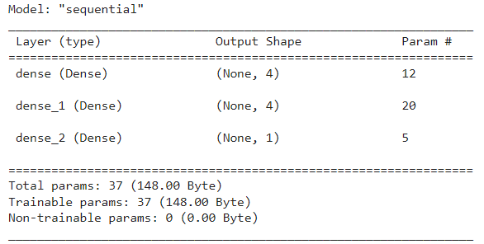







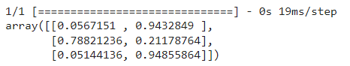



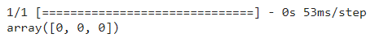

**Aim:** B]Using a deep feed forward network with two hidden layers for performing classification and predicting the probability of class.

**Code:**

from keras.models import Sequential

from keras.layers import Dense

from sklearn.datasets import make_blobs

from sklearn.preprocessing import MinMaxScaler

X,Y=make_blobs(n_samples=100,centers=2,n_features=2,random_state=1)

scalar=MinMaxScaler()

scalar.fit(X)

X=scalar.transform(X)

model=Sequential()

model.add(Dense(4,input_dim=2,activation='relu'))

model.add(Dense(4,activation='relu'))

model.add(Dense(1,activation='sigmoid'))

model.compile(loss='binary_crossentropy',optimizer='adam')

model.fit(X,Y,epochs=500)

Xnew,Yreal=make_blobs(n_samples=3,centers=2,n_features=2,random_state=1)

Xnew=scalar.transform(Xnew)

Ynew=model.predict(Xnew)

for i in range(len(Xnew)):

print("X=%s,Predicted=%s,Desired=%s"%(Xnew[i],Ynew[i],Yreal[i]))

**Output:**

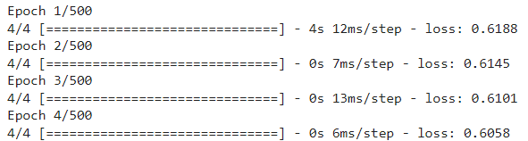

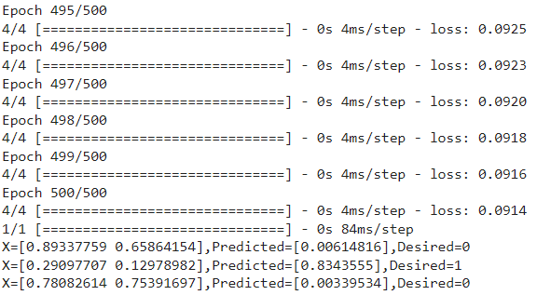

**Aim:** C]Using a deep feed forward network with two hidden layers for performing linear regression and predicting values.

**Code:**

from keras.models import Sequential

from keras.layers import Dense

from sklearn.datasets import make_regression

from sklearn.preprocessing import MinMaxScaler

X,Y=make_regression(n_samples=100,n_features=2,noise=0.1,random_state=1)

scalarX,scalarY=MinMaxScaler(),MinMaxScaler()

scalarX.fit(X)

scalarY.fit(Y.reshape(100,1))

X=scalarX.transform(X)

Y=scalarY.transform(Y.reshape(100,1))

model=Sequential()

model.add(Dense(4,input_dim=2,activation='relu'))

model.add(Dense(4,activation='relu'))

model.add(Dense(1,activation='sigmoid'))

model.compile(loss='mse',optimizer='adam')

model.fit(X,Y,epochs=1000,verbose=0)

Xnew,a=make_regression(n_samples=3,n_features=2,noise=0.1,random_state=1)

Xnew=scalarX.transform(Xnew)

Ynew=model.predict(Xnew)

for i in range(len(Xnew)):

print("X=%s,Predicted=%s"%(Xnew[i],Ynew[i]))

**Output:**

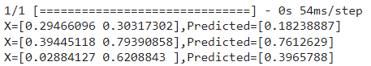

**Practical No: 5**

**Aim:** Evaluating feed forward deep network for regression using KFold cross validation.

**Code:**

from tensorflow.keras.datasets import cifar10

from tensorflow.keras.models import Sequential

from tensorflow.keras.layers import Dense, Flatten, Conv2D, MaxPooling2D

from tensorflow.keras.losses import sparse_categorical_crossentropy

from tensorflow.keras.optimizers import Adam

import matplotlib.pyplot as plt

# Model configuration

batch_size = 50

img_width, img_height, img_num_channels = 32, 32, 3

loss_function = sparse_categorical_crossentropy

no_classes = 100

no_epochs = 10 # you can increase it to 20,50,70, 100

optimizer = Adam()

verbosity = 1

# Load CIFAR-10 data

(input_train, target_train), (input_test, target_test) = cifar10.load_data()

# Determine shape of the data

input_shape = (img_width, img_height, img_num_channels)

# Parse numbers as floats

input_train = input_train.astype('float32')

input_test = input_test.astype('float32')

# Normalize data

input_train = input_train / 255

input_test = input_test / 255

# Create the model

model = Sequential()

model.add(Conv2D(32, kernel_size=(3, 3), activation='relu', input_shape=input_shape))

model.add(MaxPooling2D(pool_size=(2, 2)))

model.add(Conv2D(64, kernel_size=(3, 3), activation='relu'))

model.add(MaxPooling2D(pool_size=(2, 2)))

model.add(Flatten())

model.add(Dense(256, activation='relu'))

model.add(Dense(128, activation='relu'))

model.add(Dense(no_classes, activation='softmax'))

model.summary()

# Compile the model

model.compile(loss=loss_function, optimizer=optimizer,metrics=['accuracy'])

# Fit data to model (this will take little time to train)

history = model.fit(input_train, target_train, batch_size=batch_size, epochs=no_epochs, verbose=verbosity)

# Generate generalization metrics

score = model.evaluate(input_test, target_test, verbose=0)

print(f'Test loss: {score[0]} / Test accuracy: {score[1]}')

# Visualize history

# Plot history: Loss

plt.plot(history.history['loss'])

plt.title('Validation loss history')

plt.ylabel('Loss value')

plt.xlabel('No. epoch')

plt.show()

# Plot history: Accuracy

plt.plot(history.history['accuracy'])

plt.title('Validation accuracy history')

plt.ylabel('Accuracy value (%)')

plt.xlabel('No. epoch')

plt.show()

# By Adding k fold cross validation

from tensorflow.keras.datasets import cifar10

from tensorflow.keras.models import Sequential

from tensorflow.keras.layers import Dense, Flatten, Conv2D, MaxPooling2D

from tensorflow.keras.losses import sparse_categorical_crossentropy

from tensorflow.keras.optimizers import Adam

from sklearn.model_selection import KFold

KFold

import numpy as np

# Model configuration

batch_size = 50

img_width, img_height, img_num_channels = 32, 32, 3

loss_function = sparse_categorical_crossentropy

no_classes = 100

no_epochs = 10

optimizer = Adam()

verbosity = 1

num_folds = 5

# Load CIFAR-10 data

(input_train, target_train), (input_test, target_test) = cifar10.load_data()

# Determine shape of the data

input_shape = (img_width, img_height, img_num_channels)

# Parse numbers as floats

input_train = input_train.astype('float32')

input_test = input_test.astype('float32')

# Normalize data

input_train = input_train / 255

input_test = input_test / 255

# Define per-fold score containers

acc_per_fold = []

loss_per_fold = []

# Merge inputs and targets

inputs = np.concatenate((input_train, input_test), axis=0)

targets = np.concatenate((target_train, target_test), axis=0)

# Define the K-fold Cross Validator

kfold = KFold(n_splits=num_folds, shuffle=True)

# K-fold Cross Validation model evaluation

fold_no = 1

for train, test in kfold.split(inputs, targets):

# Define the model architecture

model = Sequential()

model.add(Conv2D(32, kernel_size=(3, 3), activation='relu', input_shape=input_shape))

model.add(MaxPooling2D(pool_size=(2, 2)))

model.add(Conv2D(64, kernel_size=(3, 3), activation='relu'))

model.add(MaxPooling2D(pool_size=(2, 2)))

model.add(Flatten())

model.add(Dense(256, activation='relu'))

model.add(Dense(128, activation='relu'))

model.add(Dense(no_classes, activation='softmax'))

# Compile the model

model.compile(loss=loss_function,

optimizer=optimizer,

metrics=['accuracy'])

# Generate a print

print('------------------------------------------------------------------------')

print(f'Training for fold {fold_no} ...')

# Fit data to model

history = model.fit(inputs[train], targets[train],

batch_size=batch_size,

epochs=no_epochs,

verbose=verbosity)

# Generate generalization metrics

scores = model.evaluate(inputs[test], targets[test], verbose=0)

print(f'Score for fold {fold_no}: {model.metrics_names[0]} of {scores[0]}; {model.metrics_names[1]} of {scores[1]*100}%')

acc_per_fold.append(scores[1] * 100)

loss_per_fold.append(scores[0])

# Increase fold number

fold_no = fold_no + 1

# == Provide average scores ==

print('------------------------------------------------------------------------')

print('Score per fold')

for i in range(0, len(acc_per_fold)):

print('------------------------------------------------------------------------')

print(f'> Fold {i+1} - Loss: {loss_per_fold[i]} - Accuracy: {acc_per_fold[i]}%')

print('------------------------------------------------------------------------')

print('Average scores for all folds:')

print(f'> Accuracy: {np.mean(acc_per_fold)} (+- {np.std(acc_per_fold)})')

print(f'> Loss: {np.mean(loss_per_fold)}')

print('------------------------------------------------------------------------')

**Output:**

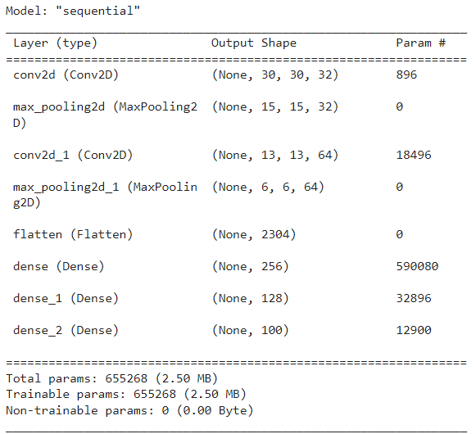



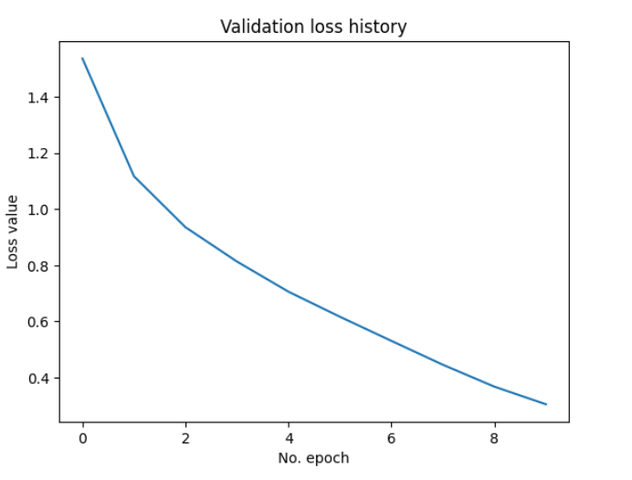

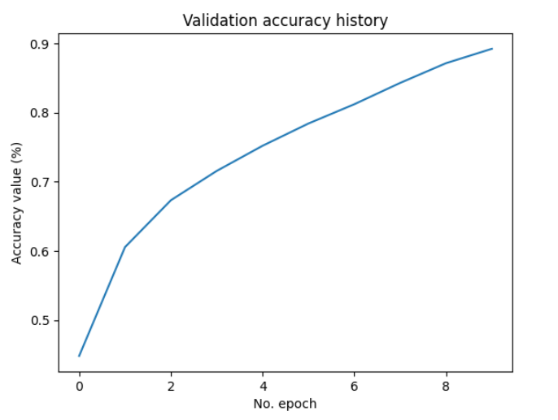

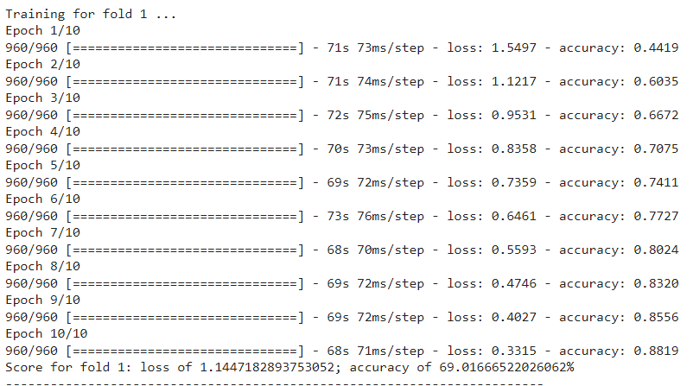

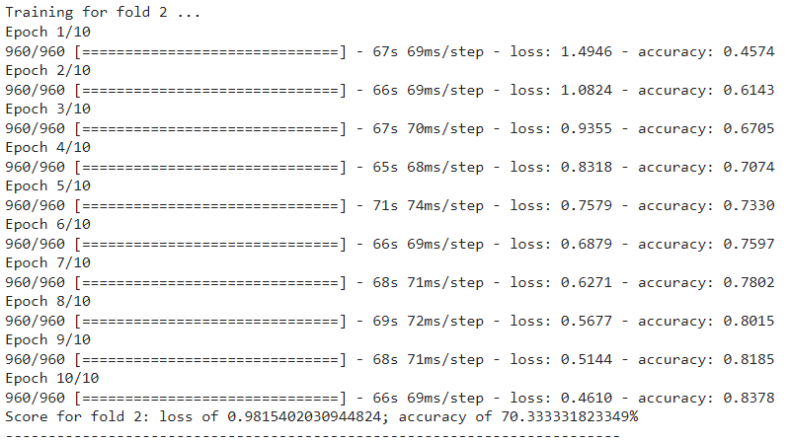

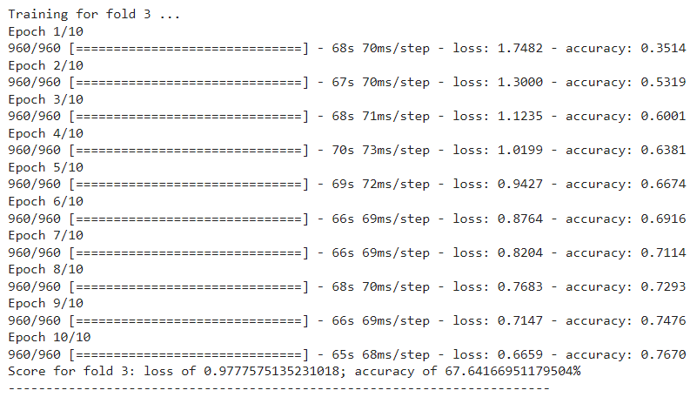

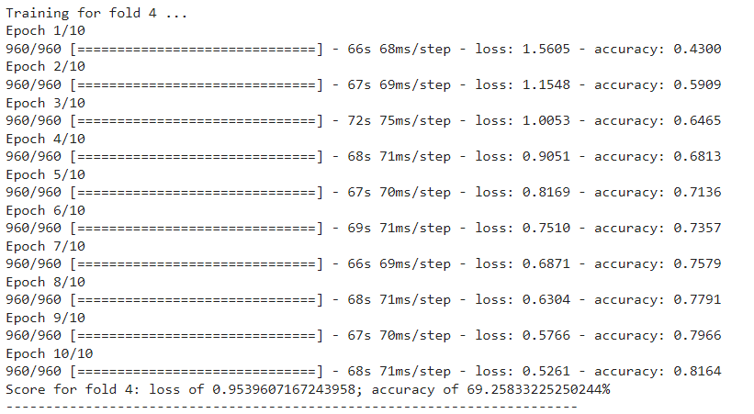

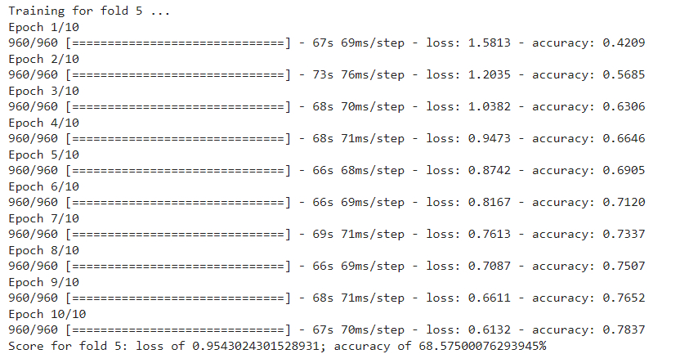

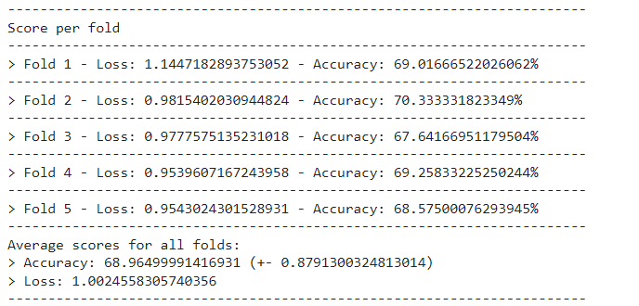

**Practical No: 6**

**Aim:** Implementing regularization to avoid overfitting in binary classification.

**Code:**

from matplotlib import pyplot

from sklearn.datasets import make_moons

from keras.models import Sequential

from keras.layers import Dense

X,Y=make_moons(n_samples=100,noise=0.2,random_state=1)

n_train=30

trainX,testX=X[:n_train,:],X[n_train:]

trainY,testY=Y[:n_train],Y[n_train:]

print(trainX.shape)

print(trainY.shape)

print(testX.shape)

print(testY.shape)

model=Sequential()

model.add(Dense(500,input_dim=2,activation='relu'))

model.add(Dense(1,activation='sigmoid'))

model.compile(loss='binary_crossentropy',optimizer='adam',metrics=['accuracy'])

model.summary()

history=model.fit(trainX,trainY,validation_data=(testX,testY),epochs=100)

pyplot.plot(history.history['accuracy'],label='train')

pyplot.plot(history.history['val_accuracy'],label='test')

pyplot.legend()

pyplot.show()

from keras.regularizers import l2

model=Sequential()

model.add(Dense(500,input_dim=2,activation='relu',kernel_regularizer=l2(0.001)))

model.add(Dense(1,activation='sigmoid'))

model.summary()

model.compile(loss='binary_crossentropy',optimizer='adam',metrics=['accuracy'])

history=model.fit(trainX,trainY,validation_data=(testX,testY),epochs=100)

pyplot.plot(history.history['accuracy'],label='train')

pyplot.plot(history.history['val_accuracy'],label='test')

pyplot.legend()

pyplot.show()

from keras.regularizers import l1_l2

model=Sequential()

model.add(Dense(500,input_dim=2,activation='relu',kernel_regularizer=l1_l2(l1=0.001,l2=0.001)))

model.add(Dense(1,activation='sigmoid'))

model.compile(loss='binary_crossentropy',optimizer='adam',metrics=['accuracy'])

model.summary()

history=model.fit(trainX,trainY,validation_data=(testX,testY),epochs=100)

pyplot.plot(history.history['accuracy'],label='train')

pyplot.plot(history.history['val_accuracy'],label='test')

pyplot.legend()

pyplot.show()

**Output:**

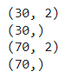

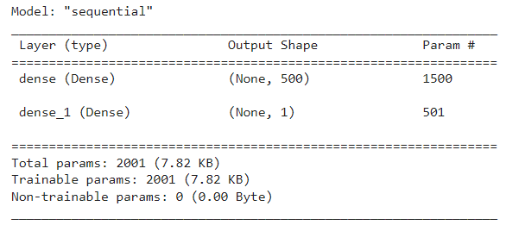

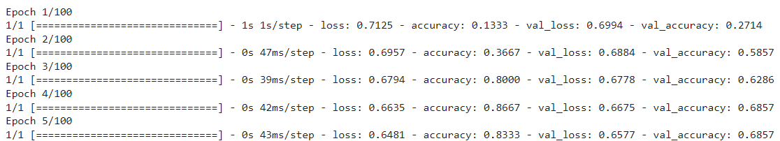

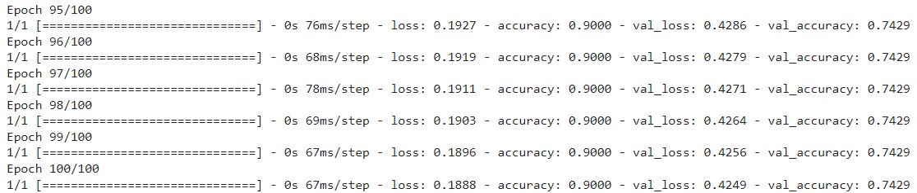

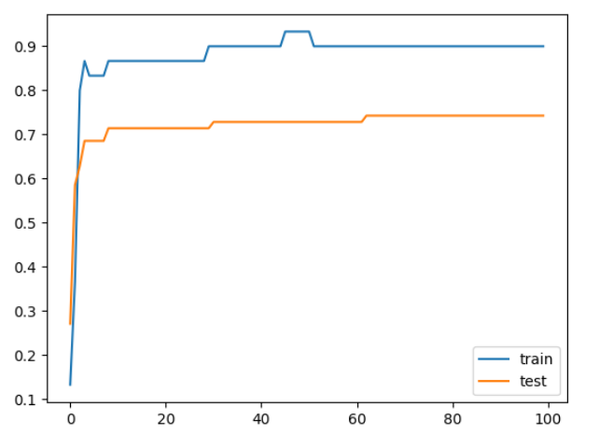

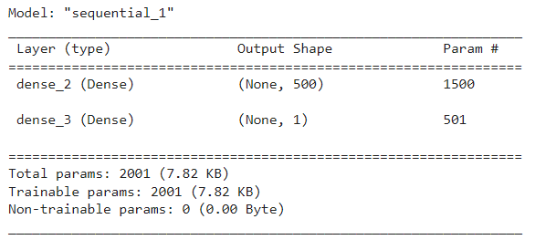

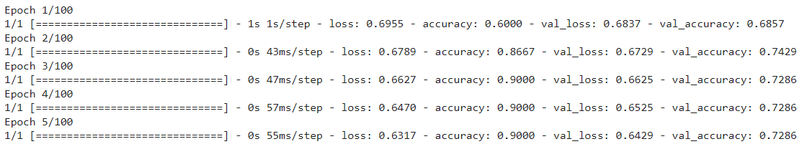

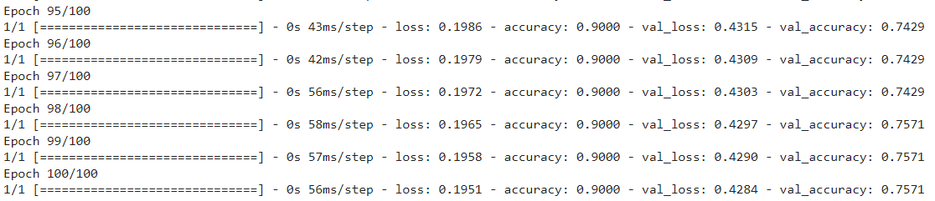

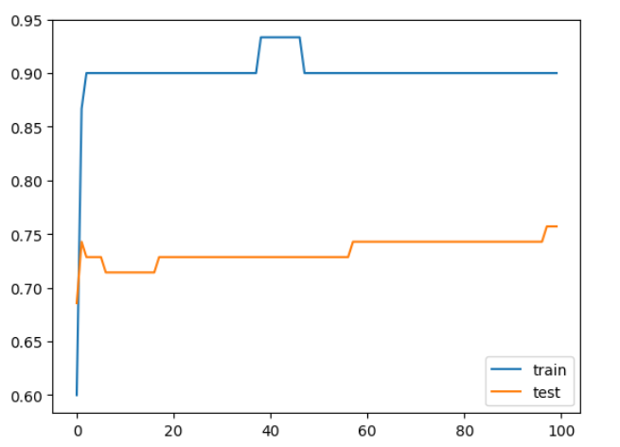

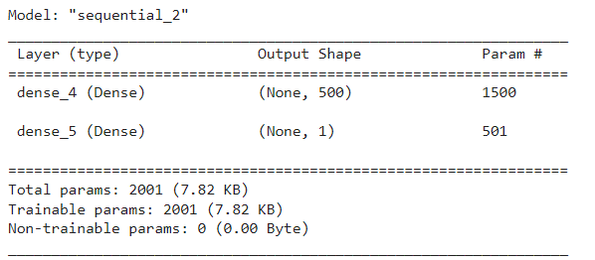

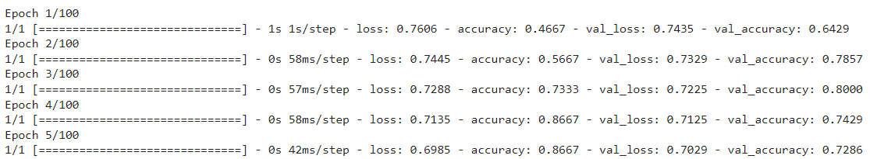

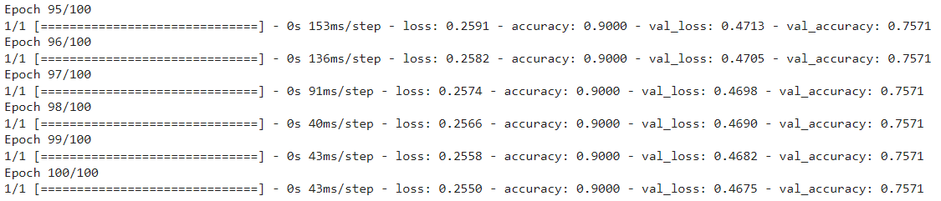

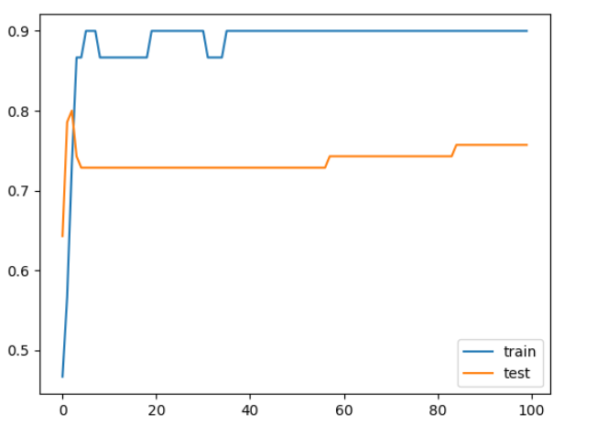

**Practical No: 7**

**Aim:** Demonstrate recurrent neural network that learns to perform sequence analysis.

**Code:**

import numpy as np

import tensorflow_datasets as tfds

import tensorflow as tf

tfds.disable_progress_bar()

import matplotlib.pyplot as plt

def plot_graphs(history, metric):

plt.plot(history.history[metric])

plt.plot(history.history['val_'+metric], '')

plt.xlabel("Epochs")

plt.ylabel(metric)

plt.legend([metric, 'val_'+metric])

dataset, info = tfds.load('imdb_reviews', with_info=True,

as_supervised=True)

train_dataset, test_dataset = dataset['train'], dataset['test']

train_dataset.element_spec

for example, label in train_dataset.take(5):

print('text: ', example.numpy())

print('label: ', label.numpy())

BUFFER_SIZE = 10000

BATCH_SIZE = 64

train_dataset = train_dataset.shuffle(BUFFER_SIZE).batch(BATCH_SIZE).prefetch(tf.data.AUTOTUNE)

test_dataset = test_dataset.batch(BATCH_SIZE).prefetch(tf.data.AUTOTUNE)

for example, label in train_dataset.take(1):

print('texts: ', example.numpy()[:3])

print()

print('labels: ', label.numpy()[:3])

VOCAB_SIZE = 1000

encoder = tf.keras.layers.TextVectorization(max_tokens=VOCAB_SIZE)

encoder.adapt(train_dataset.map(lambda text, label: text))

vocab = np.array(encoder.get_vocabulary())

vocab[:20]

encoded_example = encoder(example)[:3].numpy()

encoded_example

for n in range(3):

print("Original: ", example[n].numpy())

print("Round-trip: ", " ".join(vocab[encoded_example[n]]))

print()

model = tf.keras.Sequential([

encoder,

tf.keras.layers.Embedding(

input_dim=len(encoder.get_vocabulary()),

output_dim=64,

# Use masking to handle the variable sequence lengths

mask_zero=True),

tf.keras.layers.Bidirectional(tf.keras.layers.LSTM(64)),

tf.keras.layers.Dense(64, activation='relu'),

tf.keras.layers.Dense(1)

])

print([layer.supports_masking for layer in model.layers])

# predict on a sample text without padding.

sample_text = ('The movie was cool. The animation and the graphics '

'were out of this world. I would recommend this movie.')

predictions = model.predict(np.array([sample_text]))

print(predictions[0])

# predict on a sample text with padding

padding = "the " * 2000

predictions = model.predict(np.array([sample_text, padding]))

print(predictions[0])

model.compile(loss=tf.keras.losses.BinaryCrossentropy(from_logits=True),

optimizer=tf.keras.optimizers.Adam(1e-4),

metrics=['accuracy'])

history = model.fit(train_dataset, epochs=10,

validation_data=test_dataset,

validation_steps=30)

test_loss, test_acc = model.evaluate(test_dataset)

print('Test Loss:', test_loss)

print('Test Accuracy:', test_acc)

plt.figure(figsize=(16, 8))

plt.subplot(1, 2, 1)

plot_graphs(history, 'accuracy')

plt.ylim(None, 1)

plt.subplot(1, 2, 2)

plot_graphs(history, 'loss')

plt.ylim(0, None)

sample_text = ('The movie was cool. The animation and the graphics '

'were out of this world. I would recommend this movie.')

predictions = model.predict(np.array([sample_text]))

predictions

model = tf.keras.Sequential([

encoder,

tf.keras.layers.Embedding(len(encoder.get_vocabulary()), 64, mask_zero=True),

tf.keras.layers.Bidirectional(tf.keras.layers.LSTM(64, return_sequences=True)),

tf.keras.layers.Bidirectional(tf.keras.layers.LSTM(32)),

tf.keras.layers.Dense(64, activation='relu'),

tf.keras.layers.Dropout(0.5),

tf.keras.layers.Dense(1)

])

model.compile(loss=tf.keras.losses.BinaryCrossentropy(from_logits=True),

optimizer=tf.keras.optimizers.Adam(1e-4),

metrics=['accuracy'])

history = model.fit(train_dataset, epochs=10,

validation_data=test_dataset,

validation_steps=30)

test_loss, test_acc = model.evaluate(test_dataset)

print('Test Loss:', test_loss)

print('Test Accuracy:', test_acc)

# predict on a sample text without padding.

sample_text = ('The movie was not good. The animation and the graphics '

'were terrible. I would not recommend this movie.')

predictions = model.predict(np.array([sample_text]))

print(predictions)

plt.figure(figsize=(16, 6))

plt.subplot(1, 2, 1)

plot_graphs(history, 'accuracy')

plt.subplot(1, 2, 2)

plot_graphs(history, 'loss')

**Output:**

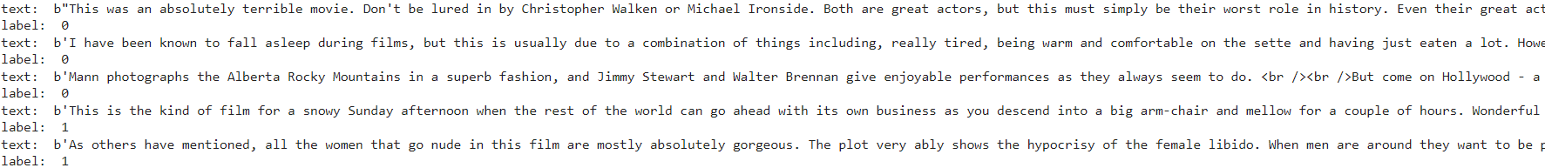

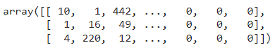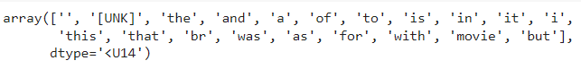



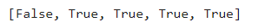



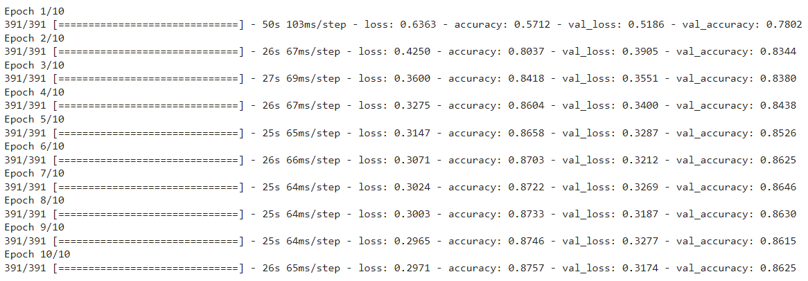



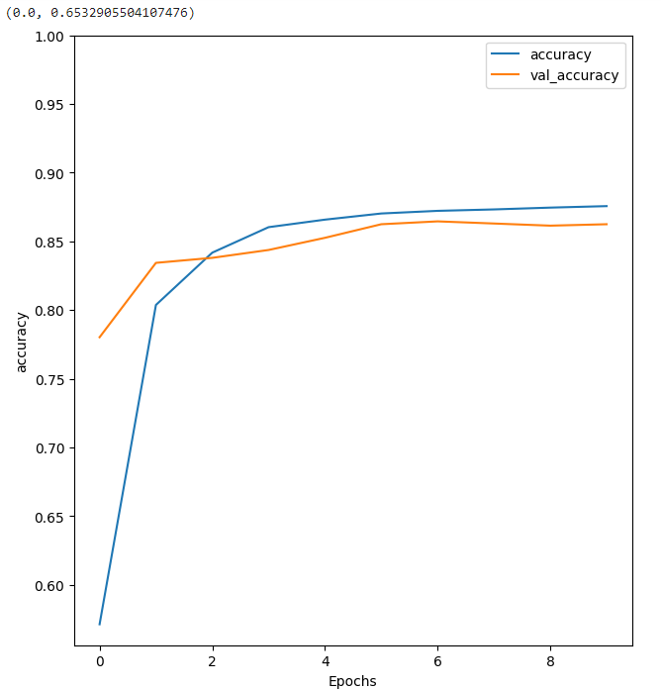

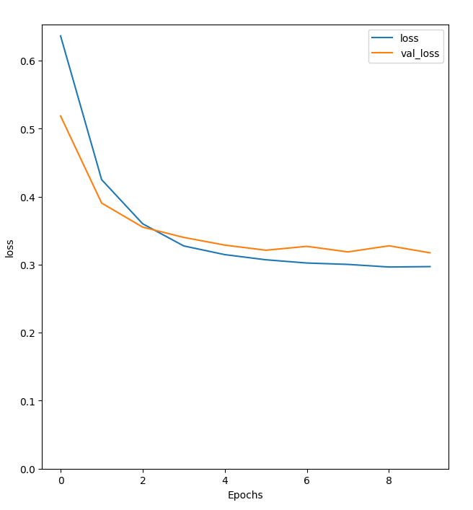

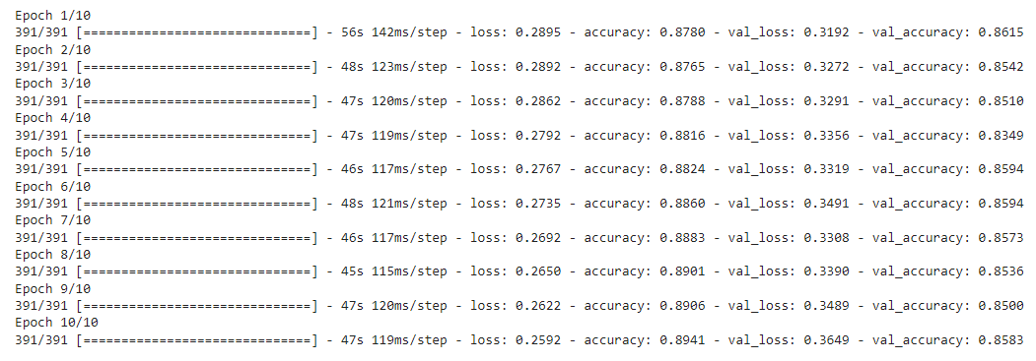



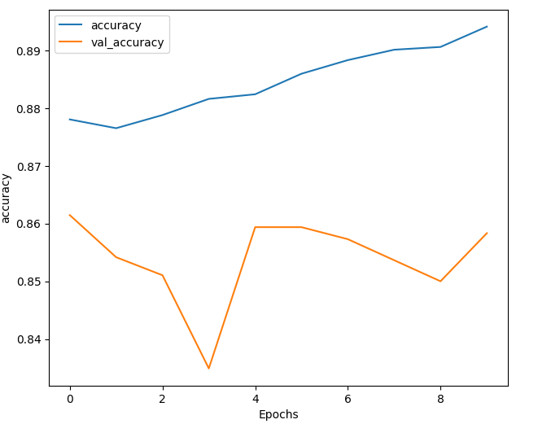

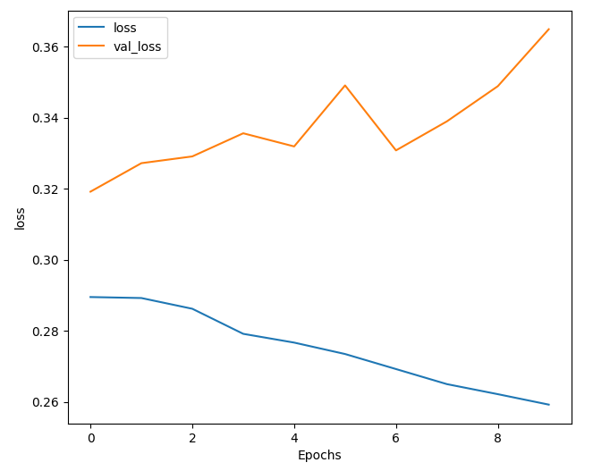

**Practical No: 8**

**Aim:** Performing encoding and decoding of images using deep autoencoder.

**Code:**

import keras

from keras import layers

from keras.datasets import mnist

import numpy as np

encoding_dim=32

#this is our input image

input_img=keras.Input(shape=(784,))

#"encoded" is the encoded representation of the input

encoded=layers.Dense(encoding_dim, activation='relu')(input_img)

#"decoded" is the lossy reconstruction of the input

decoded=layers.Dense(784, activation='sigmoid')(encoded)

#creating autoencoder model

autoencoder=keras.Model(input_img,decoded)

#create the encoder model

encoder=keras.Model(input_img,encoded)

encoded_input=keras.Input(shape=(encoding_dim,))

#Retrive the last layer of the autoencoder model

decoder_layer=autoencoder.layers[-1]

#create the decoder model

decoder=keras.Model(encoded_input,decoder_layer(encoded_input))

autoencoder.compile(optimizer='adam',loss='binary_crossentropy')

#scale and make train and test dataset

(X_train,_),(X_test,_)=mnist.load_data()

X_train=X_train.astype('float32')/255.

X_test=X_test.astype('float32')/255.

X_train=X_train.reshape((len(X_train),np.prod(X_train.shape[1:])))

X_test=X_test.reshape((len(X_test),np.prod(X_test.shape[1:])))

print(X_train.shape)

print(X_test.shape)

#train autoencoder with training dataset

autoencoder.fit(X_train,X_train,

epochs=50,

batch_size=256,

shuffle=True,

validation_data=(X_test,X_test))

encoded_imgs=encoder.predict(X_test)

decoded_imgs=decoder.predict(encoded_imgs)

import matplotlib.pyplot as plt

n = 10 # How many digits we will display

plt.figure(figsize=(40, 4))

for i in range(10):

# display original

ax = plt.subplot(3, 20, i + 1)

plt.imshow(X_test[i].reshape(28, 28))

plt.gray()

ax.get_xaxis().set_visible(False)

ax.get_yaxis().set_visible(False)

# display encoded image

ax = plt.subplot(3, 20, i + 1 + 20)

plt.imshow(encoded_imgs[i].reshape(8,4))

plt.gray()

ax.get_xaxis().set_visible(False)

ax.get_yaxis().set_visible(False)

# display reconstruction

ax = plt.subplot(3, 20, 2*20 +i+ 1)

plt.imshow(decoded_imgs[i].reshape(28, 28))

plt.gray()

ax.get_xaxis().set_visible(False)

ax.get_yaxis().set_visible(False)

plt.show()

**Output:**

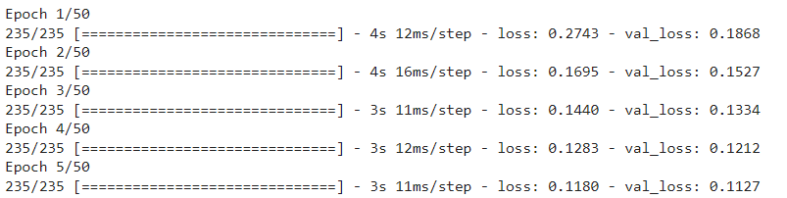

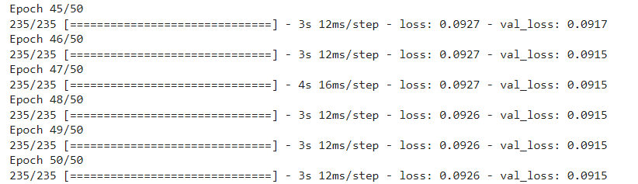

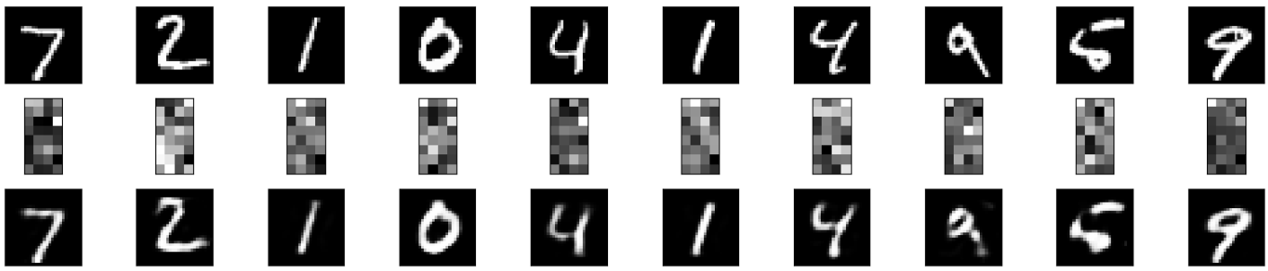

**Practical No: 9**

**Aim:** Implementation of convolutional neural network to predict numbers from number images.

**Code:**

import tensorflow as tf

mnist = tf.keras.datasets.mnist

(X_train, y_train), (X_test, y_test) = mnist.load_data()

X_train.shape

y_train.shape

X_test.shape

y_test.shape

import matplotlib.pyplot as plt

plt.imshow(X_train[2])

plt.show()

plt.imshow(X_train[2], cmap=plt.cm.binary)

X_train[2]

X_train = tf.keras.utils.normalize(X_train, axis=1)

X_test = tf.keras.utils.normalize(X_test, axis=1)

plt.imshow(X_train[2], cmap=plt.cm.binary)

print(X_train[2])

import tensorflow as tf

import tensorflow.keras.layers as KL

import tensorflow.keras.models as KM

inputs = KL.Input(shape=(28, 28, 1))

c = KL.Conv2D(32, (3, 3), padding="valid", activation=tf.nn.relu)(inputs)

m = KL.MaxPool2D((2, 2), (2, 2))(c)

d = KL.Dropout(0.5)(m)

c = KL.Conv2D(64, (3, 3), padding="valid", activation=tf.nn.relu)(d)

m = KL.MaxPool2D((2, 2), (2, 2))(c)

d = KL.Dropout(0.5)(m)

c = KL.Conv2D(128, (3, 3), padding="valid", activation=tf.nn.relu)(d)

f = KL.Flatten()(c)

outputs = KL.Dense(10, activation=tf.nn.softmax)(f)

model = KM.Model(inputs, outputs)

model.summary()

model.compile(optimizer="adam", loss="sparse_categorical_crossentropy", metrics=["accuracy"])

model.fit(X_train, y_train, epochs=5)

test_loss, test_acc = model.evaluate(X_test, y_test)

print("Test Loss: {0} - Test Acc: {1}".format(test_loss, test_acc))

**Output:**

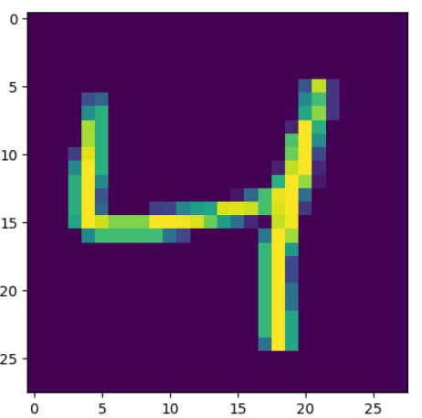

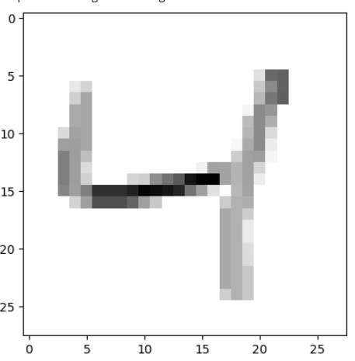

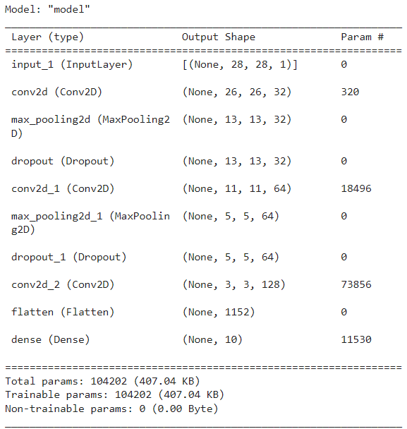

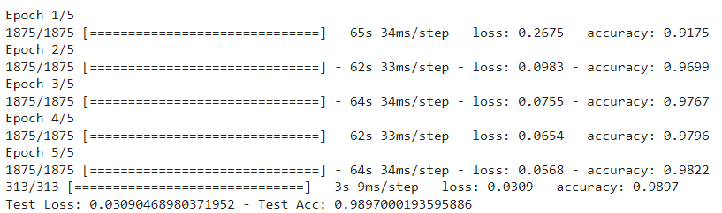

**Practical No: 10**

**Aim:** Denoising of images using autoencoder.

**Code:**

import keras

from keras.datasets import mnist

from keras import layers

import numpy as np

from keras.callbacks import TensorBoard

import matplotlib.pyplot as plt

(X_train, _), (X_test, _) = mnist.load_data()

X_train = X_train.astype('float32') / 255.

X_test = X_test.astype('float32') / 255.

X_train = np.reshape(X_train, (len(X_train), 28, 28, 1))

X_test = np.reshape(X_test, (len(X_test), 28, 28, 1))

noise_factor = 0.5

X_train_noisy = X_train + noise_factor * np.random.normal(loc=0.0, scale=1.0, size=X_train.shape)

X_test_noisy = X_test + noise_factor * np.random.normal(loc=0.0, scale=1.0, size=X_test.shape)

X_train_noisy = np.clip(X_train_noisy, 0., 1.)

X_test_noisy = np.clip(X_test_noisy, 0., 1.)

n = 10

plt.figure(figsize=(20, 2))

for i in range(1, n + 1):

ax = plt.subplot(1, n, i)

plt.imshow(X_test_noisy[i].reshape(28, 28))

plt.gray()

ax.get_xaxis().set_visible(False)

ax.get_yaxis().set_visible(False)

plt.show()

input_img = keras.Input(shape=(28, 28, 1))

x = layers.Conv2D(32, (3, 3), activation='relu', padding='same')(input_img)

x = layers.MaxPooling2D((2, 2), padding='same')(x)

x = layers.Conv2D(32, (3, 3), activation='relu', padding='same')(x)

encoded = layers.MaxPooling2D((2, 2), padding='same')(x)

x = layers.Conv2D(32, (3, 3), activation='relu', padding='same')(encoded)

x = layers.UpSampling2D((2, 2))(x)

x = layers.Conv2D(32, (3, 3), activation='relu', padding='same')(x)

x = layers.UpSampling2D((2, 2))(x)

decoded = layers.Conv2D(1, (3, 3), activation='sigmoid', padding='same')(x)

autoencoder = keras.Model(input_img, decoded)

autoencoder.compile(optimizer='adam', loss='binary_crossentropy')

autoencoder.fit(X_train_noisy, X_train,

epochs=3,

batch_size=128,

shuffle=True,

validation_data=(X_test_noisy, X_test),

callbacks=[TensorBoard(log_dir='/tmo/tb', histogram_freq=0, write_graph=False)])

predictions = autoencoder.predict(X_test_noisy)

m = 10

plt.figure(figsize=(20, 2))

for i in range(1, m + 1):

ax = plt.subplot(1, m, i)

plt.imshow(predictions[i].reshape(28, 28))

plt.gray()

ax.get_xaxis().set_visible(False)

ax.get_yaxis().set_visible(False)

plt.show()

**Output:**

